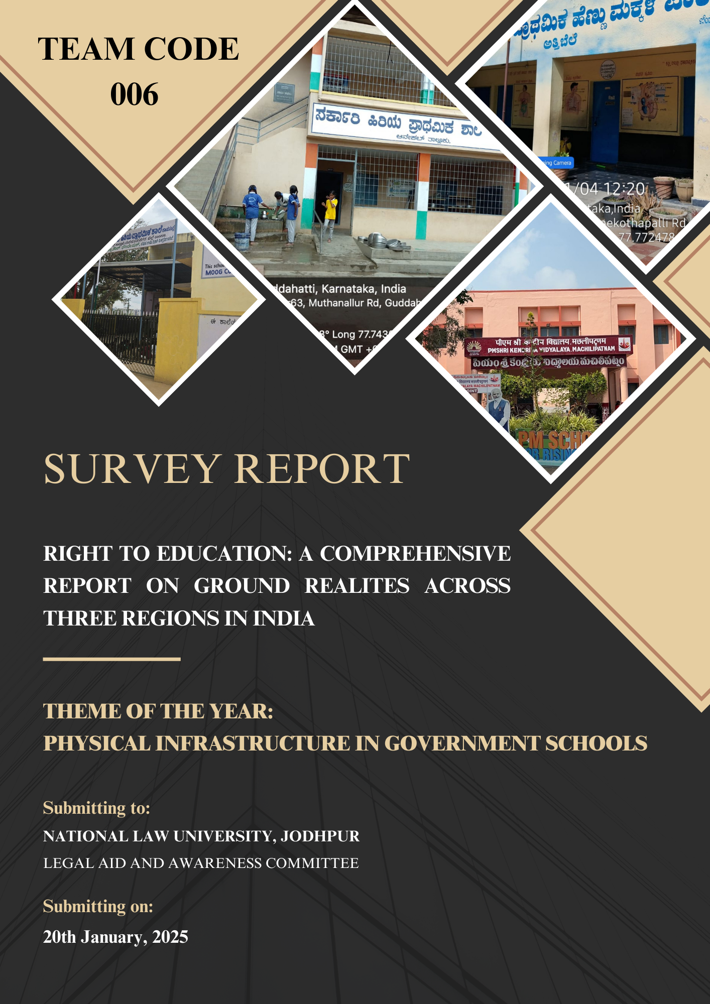

RIGHT TO EDUCATION: A COMPREHENSIVE REPORT ON GROUND REALITIES ACROSS THREE REGIONS IN INDIA
- ABSTRACT
This is a study on the implementation of the Right to Education (RTE) Act, 2009 with special reference to the physical infrastructure in government primary schools of Karnataka, Tamil Nadu and Andhra Pradesh. The central concern of the study is to determine the status on the implementation of the prescribed physical infrastructure requisites of the RTE in these states as well as the reasons, which still hinder their attainment.
The primary methodology was a combination of quantitative and qualitative approaches using structured questionnaires and direct field observations in a sample of 8 urban and rural primary schools in each state. The survey was based on some important infrastructure parameters which are covered in the RTE Act, 2009 such as number of classrooms, sanitation, supply of water for drinking, playgrounds, and essential teaching materials.
The results indicate that there are some reports of improved infrastructure development, there are still major gaps which exist. However, a shared challenge across all states was the under provision of sanitation, irregular maintenance of classrooms, overpopulation, and shortage of classroom materials. Notably, rural schools suffered comparatively more from these gaps. The study reveals that even though the RTE Act, 2009.
Keywords: Right to Education (RTE) Act, 2009, Government Schools, Primary Education, School Infrastructure, Karnataka, Tamil Nadu, Andhra Pradesh
- INTRODUCTION
Education has long been hailed as the cornerstone of societal progress, vital not only for individual empowerment but also for the collective advancement of nations. It is through education that individuals unlock their potential, pursue their aspirations, and contribute to the broader socio-economic development of their communities. The transmission of knowledge and values across generations ensures continuity, strengthens societal bonds, and fosters socio-economic mobility, reducing inequality and creating opportunities for growth. As such, education is not merely a tool for knowledge acquisition but also a critical instrument for societal transformation.
In recent times, however, the perception of education has shifted from being a means of personal and collective empowerment to a mechanism for cost recovery and financial sustainability. Despite this shift, education remains the most influential force in shaping the character and identity of both individuals and nations. The disparity between developed, developing, and underdeveloped countries often hinges on the accessibility, equity, and quality of their education systems. An educated population is indisputably a national asset, driving both economic growth and societal development.
The global importance of education is enshrined in the United Nations' recognition of the Right to Education as a fundamental human right. This global consensus was mirrored in India’s legislative framework, culminating in the enactment of the Right to Education (RTE) Act of 2009. India’s commitment to education as a fundamental right dates back to the National Policy on Education (NPE) of 1968, which emphasized the necessity of providing elementary education for all. The subsequent policies, notably the 1986 revision and the 1992 National Policy, further strengthened this commitment. In parallel, India ratified the United Nations Convention on the Rights of the Child in 1992, signalling its intention to uphold international standards in guaranteeing education for all children.
The Right to Education Act, 2009, stands as a significant milestone in India’s educational history, codifying the provision of free and compulsory education for children aged 6 to 14. It mandates the state to ensure that education is accessible, equitable, and of adequate quality. However, the implementation of this ambitious legislation, while progressive, faces several challenges at the ground level.
This report offers a detailed evaluation of the implementation of the Right to Education Act in eight government schools across Karnataka, Tamil Nadu, and Andhra Pradesh. The empirical data gathered from these schools’ highlights both successes, such as adherence to teacher-student ratios and provision of basic amenities, and challenges, including deteriorating infrastructure, lack of sufficient sports facilities, and sporadic student attendance. The effectiveness of the RTE Act’s implementation is often questioned, particularly in rural and underserved areas, where access to quality education remains a significant hurdle.
By presenting these findings, this report emphasizes the intersection between legal mandates and social realities, reflecting the need for legal reforms to align with the ground-level needs of education. The aim is to provide insights that will guide future policy discussions and foster a deeper understanding of how the law can be better utilized to ensure that every child in India receives their rightful education.
2.1. OBJECTIVES OF THE REPORT
The Report is intended to provide a deeper understanding of how well the Act is being implemented, its successes, and the challenges it faces on the ground level, in particular;
- To evaluate the current status of the Right to Education (RTE) Act’s implementation in 8 government schools across different regions, particularly in Karnataka, Tamil Nadu, and Andhra Pradesh.
- To assess the implementation of RTE Act, by highlighting the hidden challenges that appear adequate externally, but face internal issues.
- To provide practical recommendations for bridging gaps in RTE compliance and enhancing the overall quality of education.
2.2. RESEARCH METHODOLOGY
The Methodology adopted for this report is empirical, focusing on the collection and analysis of the obtained primary data, to evaluate the implementation of the Right to Education Act, 2009. The empirical survey was conducted in 8 government schools, across 3 states of India, i.e. Tamil Nadu, Karnataka and Andhra Pradesh. The schools were surveyed to assess the RTE implementation comprehensively across different grades and geographic regions. The data was obtained using questionnaires and interviews. Field visits were conducted to directly observe the facilities, working and nature of the selected schools, and gather insights through structured interviews with Headmasters, teachers and students. The data were analysed in accordance with the RTE guidelines, incorporating quantitative and qualitative aspects such as student enrollment and attendance, teaching and learning resources, hygiene practices and security measures. While the study provides in-depth analysis and insights, it is limited to eight schools across 3 states of India.

- FINDINGS OF THE SURVEY
We have chosen government schools in Tamil Nadu, Karnataka, and Andhra Pradesh in order to perform an extensive survey on the application and effects of the Right to Education Act. With the use of their UDISE codes for data validation, these schools represent a range of urban and rural environments to guarantee a fair evaluation of accessibility, quality, and inclusion in education policy under the Act.

3.1. REGION-WISE SUMMARY REPORT
S.No | STATE | DISTRICT | AREA TYPE | NAME OF THE SCHOOL
1 | TAMIL NADU | RAJAPALAYAM | URBAN | 8 Ward Municipal Middle School, Rajapalayam Municipality  UDISE Code- 33260612765
1 | TAMIL NADU | SIVAGANGAI | RURAL | Panchayat Union Primary School (PUPS) Paiyur  UDISE Code- 33230900901
1 | TAMIL NADU | ERODE | RURAL | Panchayat Union Primary School, Chinnathambipalayam.  UDISE Code- 33100200502
2 | KARNATAKA | BENGALURU | URBAN | Government Higher Primary (Girls) School, Attibele.  UDISE Code- 29200417902
2 | KARNATAKA | BENGALURU | RURAL | Government Higher Primary School, Guddahatti  UDISE Code- 29200411101
2 | KARNATAKA | BENGALURU | RURAL | Government Higher Primary School, Rayasandra  UDISE Code- 29200413001
3 | ANDHRA PRADESH | MACHILIPATNAM | URBAN | Kendriya Vidyalaya, Machilipatnam  UDISE Code-28163791114
3 | ANDHRA PRADESH | NTR District | RURAL | Zilla Parishat School, Vijayawada  UDISE Code-28161800109

3.2. MAJOR FINDINGS & HIGHLIGHTS OF THE SURVEY
S. No | Components | 8 Ward Municipal Middle School | PUPS Paiyur | PUPS, Chinnathambipalayam. | GHPS Girls, Attibele | GHPS, Guddahatti | GHPS, Rayasandra | KV,  Machilipatnam | ZPS  Vijayawada
1 | Classes | GRADE 1-8 | GRADE 1-5 | GRADE  1 - 5 | GRADE 1-7 | GRADE 1-7 | GRADE 1-7 | GRADE  1-12 | GRADE  1-5
2 | Clientele | CO-ED | CO-ED | CO -ED | CO-ED | CO-ED | CO-ED | CO-ED | CO-ED
3 | Separate Washrooms for Girls and Boys | YES | YES | YES | YES | YES | YES | YES | YES
4 | Water Facility | YES | YES | YES | YES | YES | YES | YES | YES
5 | Playground | YES | YES | YES | NO | NO | NO | YES | YES
6 | Availability of Sports Equipment | YES | NO | YES | NO | NO | YES | YES | YES
7 | Mid-Day Meals | YES | Yes | YES | YES | YES | YES | NO | YES
8 | Library Facility | Yes | YES | NO | YES | NO | YES | YES | NO
9 | Computer Labs | YES | NO | NO | YES | NO | NO | YES | NO
10 | Teacher-Student Ratio | 01:30 | 01:11 | 01: 20 | 01:18 | 01:33 | 01: 43 | 01:39 | 01:20
11 | Total Number of Rooms | 8 | 8 | 3 | 10 | 07 | 07 | 48 | 12

3.3. GROUND REALITY ON RTE IMPLEMENTATION IN KARNATAKA
The Right to Education (RTE) Act of 2009 along with Article 21A of the constitution guarantees free and compulsory education for children aged between 6 to 14 in India. This portion of the study provides an assessment of this right and RTE implementation in government schools in the state of Karnataka. Additionally, this section points out the important facets such as the School's infrastructure, student and teacher attendance, in compliance with RTE guidelines.
According to the Unified District Information System for Education Plus 2023–2024 Report, with respect to school and management category, the state of Karnataka has 49,306 government schools, of which 20,679 are Foundational & Preparatory (Class 1–5) and 21,728 are middle schools (Class 1–8) .
3.3.1. ATTIBELE
The survey was conducted in the Government Higher Primary (Girls) School, which is situated in the Attibele area (Ward No. 7) in Anekal, Karnataka. This co-educational school, that provides studies from Grades 1 to 7, presently has 111 students enrolled in Grades 1-5.
Infrastructure facilities:
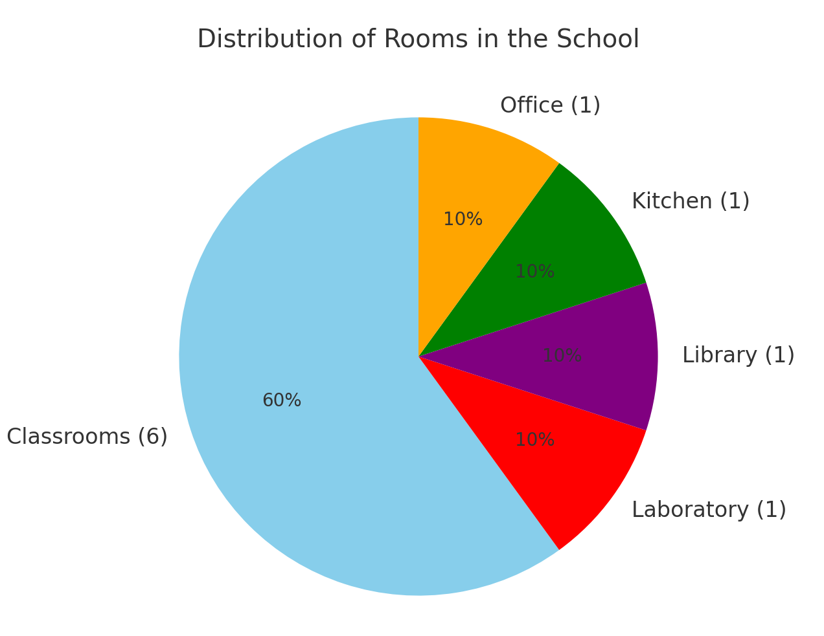
- The school building's pucca classification, i.e., School building with baked brick walls/stone walls and roof top with slab or wooden/iron girders or tiles, reveals how closely it adheres to basic construction criteria.
- Further, it is pertinent to note that this school has 10 rooms, out of which one needs major repairs, showcasing a lack of infrastructure upkeep.
Sanitation Facilities:
- Restroom facilities: Boys, girls, and teachers have separate toilets that are functional and clean.
- Handwash: Functional and sufficient to meet the demands of students.
- Drinking Water: The school uses RO water cans for drinking water thereby ensuring safety, health and hygiene of the students.
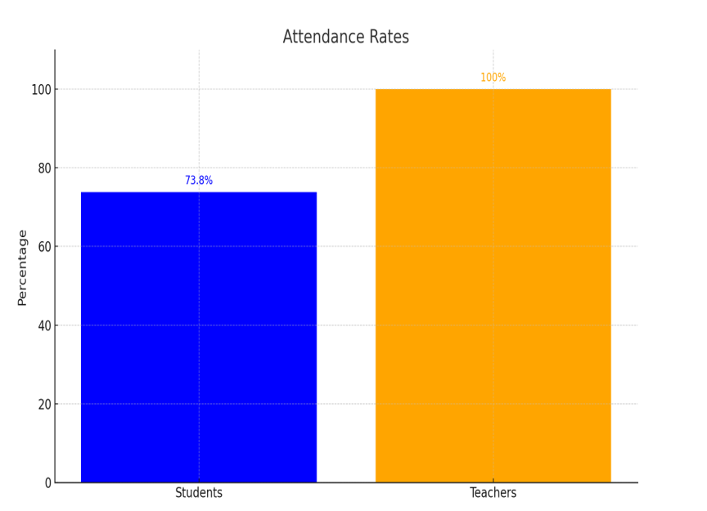
Student and Teacher Attendance:
- Student Attendance: On the day of the survey, 82 out of 111 students (73.8%) were present.
- Teacher Attendance: All 6 posted teachers (100%) were present.
- Additionally, the teacher-to-student ratio of 1:18 (18 children per teacher) complies with RTE guidelines, thereby guaranteeing that all children's learning requirements are met.
The findings from the surveyed school in Attibele, Karnataka, show that foundational compliance with RTE rules is robust, notably in areas such as teacher-student ratio (one teacher for one classroom), cleanliness, and availability to safe drinking water. Nonetheless, problems like absence of a playground, deteriorating infrastructure, and erratic student attendance signals how crucial consistent funding and community involvement are.
3.3.2 GUDDAHATTI, ANEKAL
In the Government Higher Primary School, located in the Guddahatti village in Anekal, Karnataka 562107 There are now 133 students enrolled in Grades 1–5 at this coeducational institution, which offers instruction from Grades 1–7.
The school has 7 rooms, one of which need extensive repairs, and that every room has broken windows and a water leak issue in the classrooms with cement sheets for the roof, demonstrating a lack of infrastructure maintenance. There is one office space, four classrooms, a library that doubles as a classroom because of space constraints, and a lab that appears to be underutilized and dusty, as seen in the attached photos.
Sanitation Facilities:
- Restroom facilities: Girls, and boys each have their own restrooms, which are functional but unclean.
i) Boys have 4 toilet rooms out of which 2 are functional but not clean and the urinals are not clean where using such toilet may lead to unhygienic and infectious diseases.
ii) Girls have two toilets which are clean to an extent, but the size of the toilet are very small and creates inconvenience in using them.
iii) Teachers use the same restroom as that of students and don’t have separate toilets.
- Handwash: The handwash is functional, but it is insufficient to satisfy the needs of students since it is dirty and frequently clogged, resulting in stagnant, unclean water and an unsanitary atmosphere.
- Drinking Water: The school utilizes RO water cans for drinking water.
Student and Teacher Attendance
- Student Attendance: 132 out of 133 students, or 99.2%, were present on the day of the survey.
- Teacher Attendance: All four of the Grades 1–5 posted teachers (100%) were present.
- In addition, the teacher-to-student ratio is not in line with RTE criteria, which makes it difficult for the kids to study and may result in requirements not being satisfied.
Challenges faced: There were travel difficulties since the school was located in the interior rural area. Even the students and teachers face the same issue every day as told by the teachers.
The results from the Anekal, Karnataka, school survey indicate that basic RTE compliance is not fully met. The teachers have tried their best to address these issues to the Panchayaths and the authorities but there were no changes. The opinion sought by the school's students was also expressed in the form of a video regarding the difficulties faced. CLICK VIDEO
3.3.3. RAYASANDRA
GHPS RAYASANDRA was established in 1961 and the Department of Education manages it. It is located in Rural area. It is located in ANEKAL block of BENGALURU SOUTH district of Karnataka. The school consists of Grades from 1 to 7. The school is Co-educational and has 6 classrooms for instructional purposes. All the classrooms are in good condition. The school has a Pucca boundary wall.
Sanitation Facilities:
- Restroom facilities: There are 20 separate washrooms for Girls and Boys, all hygienic and functional. The washroom facilities are generally in good condition, though regular cleaning and maintenance schedules need to be ensured for sustained hygiene.
- Handwash: Yes, a functional hand wash station is available for students and staff.
- Drinking Water: Yes, safe drinking water is available through water coolers and taps. Teachers use the same water supply as students.
Student and Teacher Attendance
- Student Attendance: On the day of the survey, 86% of the students were present.
- Teacher Attendance: All 5+7 (Non-teaching staff) posted teachers (100%) were present.
- Additionally, the teacher-to-student ratio is 1:43 and it complies with the RTE guidelines, guaranteeing that all children's learning requirements are met.
GHPS Rayasandra has made commendable progress in meeting the requirements of the RTE Act. Some features like improving the condition of classrooms and washrooms, enhancing library usage, and ensuring a more robust maintenance system, the school can improve their compliance with the provisions of the RTE Act.

3.4. GROUND REALITY ON RTE IMPLEMENTATION IN TAMIL NADU
This portion of the study assesses the implementation of RTE in government schools in Tamil Nadu. It focuses on Teacher-student ratio, availability of hygienic sanitation facilities, well maintained classrooms and infrastructure and other provisions and mandates under The Right to Education Act, 2009. According to the Unified District Information System for Education Plus Report, Tamil Nadu boasts 37,215 government schools, of which 15,842 are foundational and preparatory (Classes 1–5) and 16,205 are middle schools (Classes 1–8). This portion of the report provides the insights obtained from the surveys conducted in 3 schools in the State of Tamil Nadu.

3.4.1. SIVAGANGAI
Panchayat Union Public School (PUPS), PAIYUR was established in 1971 and the Local body manages it. It is situated in the SIVAGANGAI block of the SIVAGANGA district of Tamil Nadu. The school is Co-educational and consists of Grades from 1 to 5. Tamil is the medium of instruction in this school and academic session starts in April.
The school building's pucca classification. Further, it has 8 rooms, all in good condition and well-maintained. The school has 450 books in its library. Mid-day meals are prepared and provided within the premises of the School.
Sanitation Facilities:
- Restroom facilities: Total 3 washrooms, separate for Girls, Boys and teachers.
- Handwash: Functional and sufficient to meet the demands of students.
- Drinking Water: The source of Drinking Water in the school is Tap Water and it is functional, ensuring the health and hygiene of the students.
Student and Teacher Attendance
- Student Attendance: On the day of the survey, 100% of the students were present.
- Teacher Attendance: All 3 posted teachers (100%) were present.
- Additionally, the teacher-to-student ratio is 1:11 and it complies with the RTE guidelines.
The survey of Panchayat Union Public School (PUPS), Paiyur, shows that the institution upholds several provisions of the RTE Act. However, there are opportunities to strengthen the school’s overall impact.
- Increasing library resources and introducing digital learning tools or activity-based learning methods could enhance educational outcomes.
- Regular capacity-building programs for teachers can ensure they remain equipped with modern pedagogical techniques.
- Sports equipment can be provided to the students thereby, making sports and Physical Education a part of the regular school activities.
3.4.2. RAJAPALAYAM
The 8 Ward Municipal Middle School, located in Rajapalayam Municipality, Tamil Nadu, offers education for Grades 1 to 8 and is Co-educational in functioning. The school building's pucca classification, and has 8 rooms, all in good condition and well-maintained.
The school has a library with subject-related books, newspapers, and diverse reading materials. Mid-day meals are prepared and provided within the premises. Mid-day meals are prepared and provided within the premises of the School. The school has a boundary wall for security but informal feedback from teachers and students suggests that the wall might not be sufficient in preventing unauthorised access or providing complete security.
Sanitation Facilities:
- Restroom facilities: There are separate washrooms for Girls, Boys and the Teachers.
- Handwash: Functional and sufficient to meet the demands of students.
- Drinking Water: Drinking water is provided, though many students bring water from home, perhaps due to concerns over the availability or quality of water at the school.
Student and Teacher Attendance
- Student Attendance: Total number of students from Grades 1-5 are 247 and on the day of the survey, 92.31% of the students were present.
- Teacher Attendance: All 11 posted teachers (100%) were present.
- Additionally, the teacher-to-student ratio is 1:30 and it complies with the RTE guidelines, guaranteeing that all children's learning requirements are met.
The survey of Rajapalayam Municipal Middle School shows that it has made significant strides in meeting the infrastructure standards set by the RTE Act. However, there is a need for designating a space for the Head Teacher. While the boundary wall is in place, it can be improvised.
3.4.3. CHINNATHAMBIPALAYAM
This part of the report evaluates the implementation of the RTE Act in Panchayat Union Primary School, Chinnathambipalayam, Erode district, Tamil Nadu. This co-educational school was established in 1954 and is managed by the local body. It is situated in a rural area in Anthiyur block of Erode district and is accessible by an all-weather road. The school offers education from Grades 1 to 5, with Tamil as the medium of instruction.
Infrastructure:
- The school has a pucca boundary wall, but the wall is inadequate to ensure complete safety.
- The school building comprises a total of 3 rooms, including two classrooms designated for instructional purposes and one room for non-teaching activities but it is non – functional.
- All the classrooms are in good condition, with no major repairs needed. However, the absence of proper dividers between grades within the classrooms presents a challenge to teaching and managing multiple grades effectively in the same space.
- While the school does not have a headmaster’s room, it is in compliance with RTE guidelines as a separate room is required when there are > 150 students.
Pupils and Teachers:
- The student enrolment currently stands at 59 students (previously 61). On survey date (13/01/2025), 95% of the students were present, i.e., 56 (34 Boys + 22 Girls)
- The school has 3 teachers, including the headmaster, and complied with RTE teacher-student ratio i.e. for 61 students, there are three teachers. On the day of the visit, all teachers were present, 100% attendance rate.
Sanitation:
- The school has one toilet each for boys and girls, both of which are clean and usable. They also have separate toilets for IED students. However, there are no separate toilets for teachers.
Drinking Water & Hand wash facility:
- The school provides safe and hygienic drinking water through an RO tap water system and is fully functional and easily accessible to both students and teachers. Further, a separate hand wash facility is provided that is functional & sufficient.
Library:
- It houses a total of 676 books, including storybooks, but for the library there is no separate dedicated room and book issuance records are kept up to date.
Playground:
- The school has a small playground, which is shared with a nearby temple. This shared usage limits the playground's utility, creating a “colliding nature”.
The Panchayat Union Primary School in Chinnathambipalayam, Erode, presents a mixed picture of RTE Act implementation. The absence of a dedicated library, and the lack of proper dividers between grades, slightly hinders the efficiency of teaching.

3.5 GROUND REALITY ON RTE IMPLEMENTATION IN ANDHRA PRADESH
This section provides an assessment of the implementation of the RTE Act in government schools in the state of Andhra Pradesh. The Andhra Pradesh government has undertaken significant measures to enhance school infrastructure and integrate digital education. Under the "Mana Badi Nadu-Nedu" programme, 44,671 state-run schools have received infrastructural improvements. According to the Andhra Pradesh Socio-Economic Survey 2023–2024, the state has a total of 58,606 schools, comprising 45,350 government and aided schools and 13,256 private schools. The total student enrollment across all school types is 70.82 lakh, with 20.16 lakh (28.47%) in primary schools, 9.67 lakh (13.65%) in upper primary schools, and 40.99 lakh (57.88%) in high schools. The dropout rates are notably low, with no dropouts at the primary level (Classes I–V), 0.01% at the upper primary level (Classes VI–VIII), and 2.39% at the secondary level (Classes IX–X).
3.5.1 . MACHILIPATNAM
The Kendriya Vidyalaya in Machilipatnam, Andhra Pradesh (Pin Code: 521001), was surveyed to assess its compliance with the RTE Act, 2009. This co-educational institution caters to students from Class 1 to Class 12 and is situated in an urban locality, accessible via an all-weather road. The school building is classified as pucca, featuring baked brick walls and a concrete roof. The campus comprises 48 rooms, including 30 classrooms, 4 of which require minor repairs. There is also a designated room for the Headmistress and a separate library. The playground is spacious,equipped with facilities for both indoor and outdoor games.
Sanitation Facilities:
The school has a total of 48 toilets, with 24 for boys and 24 for girls, all of which are functional and separate facilities for teachers. However, the cleanliness of these facilities could be fully assessed during the visit.
- Restroom facilities : Boys,girls, and teachers have separate toilets that are functional and clean
- Handwash: Functional and sufficient to meet the demands of students.
- Drinking Water : The school ensures access to clean and safe drinking water for its students, a valuable facility that was generously donated by an alumni.

Student and Teacher Attendance:
- Student Attendance :The school reported 437 students enrolled in Grades 1 to 5, with a 91.0755% attendance of 398 students out of 437 students on the day of the survey.
- Teacher Attendance : The teacher strength was recorded at 11, with 9 teachers present that day, resulting in an attendance rate of 81.81%.
- The teacher-to-student ratio 1: 39 was found to be in compliance with the RTE guidelines.
Additional Features: The school organizes regular morning assemblies, and teachers actively engage in both teaching and mentoring activities. The non-teaching staff, paid by the Kendriya Vidyalaya Sangathan office, assist with administrative duties.
The findings highlight that while the school meets several RTE compliance criteria, ongoing infrastructure maintenance and consistent funding support are necessary to address minor repairs and ensure uninterrupted functioning of all facilities.
3.5.2 VIJAYAWADA
The survey was conducted in the Zilla Parishat School, NTR District, Vijayawada Andhra Pradesh. This co-educational school, that provides studies from Grades 1 to , presently has 56 students enrolled in Grades 1-5.
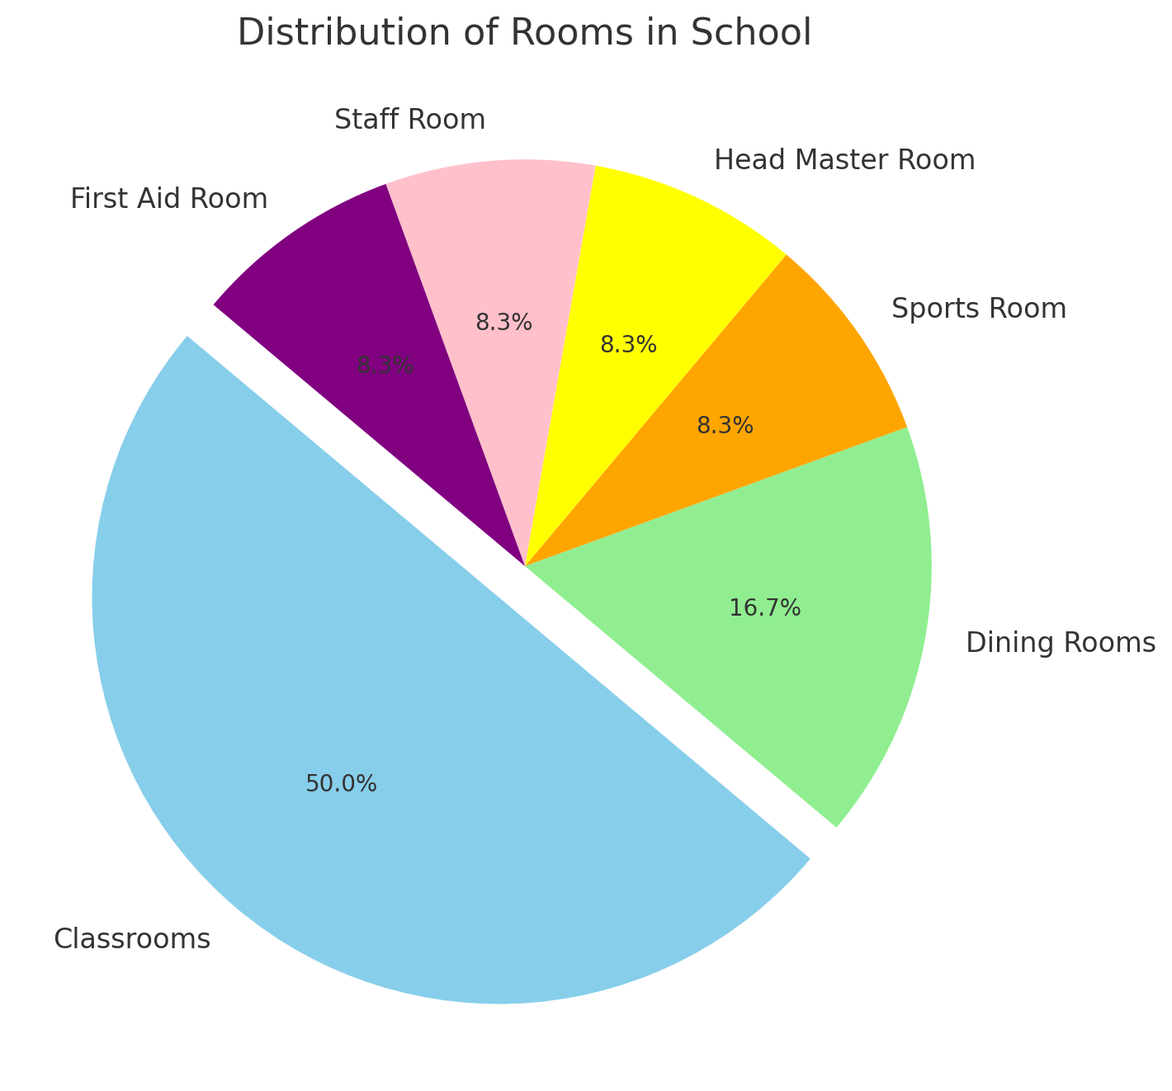
Infrastructure facilities:
The school building's pucca classification, i.e., School building with baked brick walls/stone walls and roof top with slab or wooden/iron girders or tiles, reveals how closely it adheres to basic construction criteria. Further, it is pertinent to note that this school has 12 rooms, out of which five rooms need major repairs, showcasing a lack of infrastructure upkeep.
Sanitation Facilities:
- Restroom facilities: Boys, girls, and teachers have separate toilets that are functional and clean. There are 4 toilets available for girls and 4 toilets available to boys separately and There are separate toilets available to the teachers as well
- Handwash: Functional and sufficient to meet the demands of students.
- Drinking Water: The school uses RO water cans for drinking water thereby ensuring safety, health and hygiene of the students.
Student and Teacher Attendance:
- Student Attendance: On the day of the survey, 42 out of 56 (75%) students were present.
- Teacher Attendance: All 12 posted teachers (100%) were present.
The findings from the surveyed school in NTR District, Vijayawada show that foundational compliance with RTE rules is robust, notably in areas such as teacher-student ratio (one teacher for one classroom), cleanliness, and availability to safe drinking water. Nonetheless, problems like absence of libraries, deteriorating infrastructure, and erratic student attendance signals how crucial consistent funding and community involvement are.

- ISSUES WITH IMPLEMENTATION
Major Issues In Implementing The Rte Act In Government Schools:
1. Infrastructure Deficiency
- The infrastructure in most surveyed government schools is compiled but outdated and inadequate. Classrooms lack modern amenities such as proper seating arrangements, digital learning tools, and well-equipped laboratories.
- Many schools also do not have computer labs or access to computer-aided learning.
2. Insufficient Quality in Resources
- The resources provided, such as textbooks, equipment, and learning materials, are “ just sufficient” to meet basic needs. SOMETIMES, just sufficient cannot induce efficacy. However, they do not align with the demands of a dynamic and evolving world.
- The lack of advanced resources like STEM kits, digital aids, and modern teaching tools limits students’ ability to compete with their peers in private schools.
3. Academic and Curriculum Gaps
- The curriculum taught in government schools is outdated and does not incorporate contemporary events, advanced subjects, or practical activities. Need for dynamic methodology of teaching .
- Practical learning sessions, which are vital for building critical thinking and problem-solving skills, are either absent or minimal.
4. Accountability and Governance Challenges
- The RTE Act, being central legislation, faces challenges due to taking care of responsibility as it comes under Concurrent list .
- Local Body Governance: Most schools are managed by local bodies, which “ cannot bear the accountability of central Act”. This creates a significant gap in accountability.
5. Teacher Qualifications and Training
- While some teachers in government schools are well-qualified and experienced, others lack the necessary qualifications or need additional training to stay updated with modern teaching techniques.
6. Language Barriers in Primary Education
- The RTE Act allows for flexibility in school transfers across states, but language barriers often create challenges for migrant children. These students struggle to adapt to regional languages, which leads to a high dropout rate.
- For instance, in Panchayat Union Primary School, Chinnathambipalayam, migrant students faced difficulties in continuing their education due to the lack of support for non-native language learners.
7. Misrepresentation of Compliance
- Some schools falsely claim to meet RTE guidelines, reporting fully equipped facilities when, in reality, they lack basic amenities like libraries, functional labs, and playgrounds, negatively impacting students' learning experiences.
- Lack of awareness is another impediment in achieving the goals of rte.
8. No Compliance of School Management Committees (SMCs)
- The Right to Education (RTE) Act requires schools to establish School Management Committees (SMCs), comprising parents, social workers, and local representatives. However, SMCs often fail to deliver due to three key challenges:
- Lack of awareness among parents and community members about their roles.
- Economic constraints, making it difficult for disadvantaged parents to contribute.
- Ineffective bridging of the gap between schools, the state, and society.
9. Lack of Parent-Teacher Engagement
- Limited Parent-Teacher Interaction: Most schools surveyed showed minimal cooperation between parents and teachers, leaving parents uninformed about their child's academic performance and the school's challenges.
- parents being engaged in informal employment, find it hard to help their kids in Education

- SUGGESTIONS AND RECOMMENDATIONS
The Right to Education (RTE) Act, 2009, is a legislation aimed at ensuring free and compulsory education for children aged 6 to 14 years across India. The Right of Children to Free and Compulsory Education (RTE) Act, 2009, which represents the consequential legislation envisaged under Article 21-A, means that every child has a right to full time elementary education of satisfactory and equitable quality in a formal school which satisfies certain essential norms and standards. In Ashok Kumar Thakur v. Union of India, the Hon’ble SC held that all the children within the age limit specified under Article 21A, must receive schooling, and such education must meet minimum quality standards, such as, infrastructure adequacy, teacher-student ratios and hygienic and safe environment. In the case of Avinash Mehrotra v. Union of India , the Supreme Court expanded the ambit of this right by declaring that the right to education includes the right to a safe and secure learning environment. This Act is historic in nature and a significant accomplishment by the Indian government. However, the Act will be effective, and the intended objective of the Act can only be achieved, if the barriers that prevent disadvantaged children from attending school are addressed.
· Concentrate on teacher training programs: The quality of teachers is the foundation of any instructional program. Untrained or unmotivated teachers can derail any program, no matter how ambitious. Developing a uniform training program to develop and produce excellent teachers is critical for the RTE Act to yield real outcomes.
· Utilize computer and satellite technologies to raise awareness and interest: Create mobile units that tour various educational centers, particularly in distant places, and display relevant films to teachers and students. This will help maintain interest and encourage curiosity. Even a visit every fortnight or month would suffice.
5.1. REGION-SPECIFIC RECOMMENDATIONS
- Infrastructure Development
Some schools, notably PUPS Chinnathambipalayam, GHPS Rayasandra, and GHPS Guddahatti, do not have enough classrooms or playgrounds.
Suggestions:
- Playgrounds: To meet the RTE requirement for physical development, schools lacking playgrounds, such as GHPS Attibele, GHPS Rayasandra and GHPS Guddahatti, should be given dedicated play spaces.
- Classrooms: To guarantee a positive learning environment, more classrooms must be built at schools with limited space, such as PUPS Chinnathambipalayam.
- Sports and Extracurricular Activities
Several schools, including GHPS Attibele, GHPS Guddahatti and PUPS Paiyur, lack sports equipment.
Suggestions:
- Supply of sports equipment to all schools is a necessity, to support physical education and extracurricular activities. Inter-school sports activities must be conducted, to promote student engagement and teamwork.
- Library Facilities
Schools such as PUPS Chinnathambipalayam, 8 Ward Municipal school, Rajapalayam, GHPS Guddahatti and ZPS Vijayawada do not have functional libraries.
Suggestions:
- The schools can establish and maintain a separate room and designate it as a Library, within the premises of the school. These libraries must be equipped with diverse books of different genres, magazines, newspapers and educational materials.
- The schools have to introduce regular library periods to cultivate reading habits among the students and improve literacy.
- Computer-Aided Labs
Schools such as PUPS Paiyur, GHPS Rayasandra and ZPS Vijayawada, lack access to computer-aided labs.
Suggestions:
- The schools need to set up computer labs via implication of Governmental schemes or funds, or by NGO assistance, to foster digital literacy.
- The teachers need to be given efficient training to integrate these digital tools into classroom teaching.
- Teacher-Student Ratio
Schools such as GHPS Rayasandra (1:43), GHPS Guddahatti (1:33), and KV Machilipatnam (1:39) exceed the recommended teacher-student ratio of 1:30.
Suggestions:
- There is an immediate requirement of recruiting additional teachers in these schools to align with the RTE norms, ensuring effective teaching and learning outcomes.
- The teachers need to be provided with regular Development Programs to enhance the instructional quality and thereby, enhance the overall educational experience. · Regular capacity-building programs for teachers can ensure they remain equipped with modern pedagogical techniques.
- Safety and Security
Schools such as the 8 Ward Municipal School, Rajapalayam, improvements can be made, especially in the areas of security and administrative space.
- Boundary walls and secure gates must be constructed in all the schools to ensure a safe environment for the school students.
- The schools can invest in reinforcing or raising the boundary wall, and consider adding CCTV cameras for better surveillance.
- Sanitation and Hygiene
While most of the schools report functional washrooms, GHPS Guddahatti lacks well maintained washrooms for the students.

Suggestions:
- The schools have to implement periodic cleaning schedules and regular maintenance of washrooms
- Well maintained handwashing stations can promote hygiene practices and decency among the students.
- Monitoring and Evaluation
- A robust monitoring framework needs to be developed to assess the compliance with RTE provisions, including student enrollment, attendance, and learning outcomes.
- Regular audits of infrastructure, teaching quality, and facilities need to be conducted to ensure continuous improvement.
Thus, the successful implementation of these recommendations will address the critical gaps identified in the survey, ensuring compliance with RTE Act and providing a robust framework for quality education. This collaborative effort will contribute to achieving the inherent objectives of providing accessible and quality education as per the RTE Act, 2009.

- CONCLUSION
With the noble objective of giving every child the access to high-quality basic education, the government had passed this Right to Education (RTE) Act. However, a survey conducted in three different states exposes a discrepancy between the Act's actual execution and its intended objectives. The findings emphasize how essential it is to have adequate infrastructure, and the fact that, in addition to regular teachers’ attendance reflecting a strong commitment to fulfilling RTE objectives, constant students’ participation is required and the student teacher ratio has to be maintained to further achieve it.
Moreover, a favorable learning environment has to be created by filling up the gaps in infrastructure maintenance, playground facilities, library resources, and cleanliness. Student growth, academic achievement, and well-being are all directly impacted when these objectives are met. In turn, dealing with these issues and implementing the suggested recommendations into practice could potentially enhance the effectiveness of the RTE Act. Nevertheless, the RTE Act is a significant piece of legislation that created a fair, just, and easily accessible educational system in India, guaranteeing that every child aged between 6 to 14 years have an equal opportunity to study and prosper.
It is imperative that government bodies, local communities, and stakeholders collaborate together to ensure consistent funding, regular monitoring, and active involvement in school improvement initiatives. Together, these efforts will make sure that strong foundations in education are built not just with bricks and mortar, but with care, commitment, and the resolve to leave no child behind.

ANNEXURE 1
RTE SURVEY FORMS
1.1 RTE SURVEY, GOOGLE FORMS
Kindly click the below links to find the Survey Forms filled through Google Forms for the empirical survey which was conducted in 8 government schools, across 3 states of India, i.e. Tamil Nadu, Karnataka, and Andhra Pradesh.
- TAMIL NADU:
RAJAPALAYAM- 8 Ward Municipal Middle School, Rajapalayam Municipality
SIVAGANGAI- Panchayat Union Primary School (PUPS) Paiyur
ERODE- Panchayat Union Primary School, Chinnathambipalayam.
- KARNATAKA:
BENGALURU, URBAN- Government Higher Primary (Girls) School, Attibele.
BENGALURU, RURAL- Government Higher Primary School, Guddahatti
BENGALURU, RURAL- Government Higher Primary School, Rayasandra
- ANDHRA PRADESH:
MACHILIPATNAM- Kendriya Vidyalaya, Machilipatnam
NTR District- Zilla Parishat School, Vijayawada

1.2 RTE SURVEY FORMS
Team Code: 006
SCHOOL SURVEY FORM- 1

Empirical Inquiry by Law Colleges on Implementation of the RTE Act, 2009
(For Paper Presentation and Discussion at National Law University Jodhpur)
Theme of the Year: Physical Infrastructure in State-provided Primary Schools
BASIC INFORMATION



The fundamental right to education of every child is enunciated in international law in Article 28 of the Convention on the Rights of the Child, to which India acceded in 1992; and in the Indian Constitution in Article 21A, and its consequential legislation, ‘The Right of Children to Free and Compulsory Education, 2009’.
The right to education was earlier in Article 45 of the Directive Principles of State Policy. The 86th Amendment of the Constitution in 2002 moved it to the list of fundamental rights thus making this right ‘justiciable’. However, justiciability of the right to education depends on the extent to which lawyers and the courts are aware of and sensitive to the manner in which education is delivered.
Our objective, as members of the Legal Aid Committee/ Society or Law School Community, is to enquire through this empirical exercise, into how the right to education is being made available to the child. Thus, not only do we ourselves learn, but through our reports, the legal fraternity at large can potentially be sensitized towards claiming this right for all children.

1. Name of School: 8th Ward Municipal Middle
2. Name of Village/ Town with Municipal Corporation (in case of Municipal Corporation give ward Number also) : Rajapalayam Municipality
3. Pin Code (6 digits) 626117
4. Block Name Rajapalayam Municipality
5. Lowest Class in the School- 1st Standard (after pre-primary)
6. Highest Class in the School- 8th Standard
7. Is school in urban, rural, semi urban area?: (Urban ___; Rural √; Semi Urban ______)
8. Clientele (Tick one): Girls only__ Boys only___ Co Ed √
9. Is this school approachable by all-weather Road? Yes√No
10. Does this school run-in shifts (see note) Yes
No √
11. Name of HM- Vijaya Selvi
12. Mobile Number of HM: +919150642632

PUPILS AND TEACHERS IN THE PRIMARY SCHOOL
(For grades 1 to 5 only)
13. No. of Students in grades 1 to 5 (On School Register)- 247
14. No. of students (grades 1 to 5) present today (as per School statement)-228
15. Percentage of students present today (calculate yourself)- 92.31
16. No. of Teachers for grades 1 to 5 (posted to the school)-11
17. No. of Teachers (for grade 1 to 5) present today (as per School statement) -11
18. Percentage of teachers present today (calculate yourself) 100%
19. Primary (only) school Teacher to pupil Ratio
(Only one of the columns will apply) (Calculate yourself)
If the number of pupils in the school in classes 1 to 5 is….
a) Less than  60 are there 2  teachers or more in the school? | b) Between 61-90, Are  there 3 or  more  teachers? | c) Between 91- 120, Are  there 4 or  more  teachers? | d) Between  120-200,  Are there 5  or more  teachers? | e) Above  150, is there  a Head  Teacher in  addition to 5  teachers? | f) Above 200, is the pupil to teacher  ratio; is there a  teacher- pupil  ratio at primary  being 40 children  per teacher
Yes - | Yes - | Yes - | Yes - | Yes - | Yes -√
No - | No - | No - | No - | No - | No -

20. Total number of non-teaching staff: 0
21. Who pays the salary of non- teaching staff? -
22. For what work the non-teaching staff has been employed? -
INFRASTRUCTURE
Building
23. How would you describe the building? Pucca
Pucca:School building with baked brick walls/stone walls and roof top with slab or  wooden/iron girders or tiles | Partially Pucca:School building with baked brick walls or stone walls with corrugated sheet or asbestos sheet or thatched roof top | Kachha:School building with unbaked brick or mud walls with corrugated asbestos sheet or thatched roof top.

24. Total Number of Rooms - 8
25. Total Number of Classrooms-8
26. Is there one classroom per teacher? (Calculate yourself: Number of classrooms/number of teachers) Yes√No___
27. Where pupils >150, is there a Head Teacher? NA___; Yes√; No____
28. If yes above, Is there a room for the head teacher? Yes√; No___

Condition of Rooms/ Classrooms
29. Number of Classrooms in need of Minor Repair - 0
30. Number of Classrooms in need of Major Repair- 0
31. Number of other rooms needing repair- 0
Library
32. Is there any library? Yes, a separate room -Yes; Yes, ‘a space’ √; No________
33.Does the library contain Newspapers? Yes √; No__________ 34. Does the library contain Magazines? Yes √; No__________
35. Does the library contain Books? (subject related) Yes √; No__________
36. Does the library contain Story Books? Yes √; No__________
37. Is there a record of books issued? Yes√; No________
38. If Yes, above, then Date when last Book was issued 27/11/2024
Playground:
39 Is there any playground in the school? Yes√; No________
40. How would you describe the playground? A big playground that is enough for the number of students there and they also provide sports equipments to play.
41. Do students get any play materials, sport equipments, etc.? Yes√; No______
Washroom Facility:
42. Total Number of toilets available: Girls: 5 Boys 2
43. Total number of toilets functional and Usable: Girls: 5 Boys: 2
44. Are there any separate toilets for teachers? Yes√; No________
45. Are any of the toilets locked? Yes ________ ; No √
Drinking Water:
46. Is there any facility for safe drinking water for children? Yes√; No________
47. Are children allowed to use Teachers’ water supply? Yes_______; No√
48. Mode of drinking water: Water cooler:√Other ( Pl specify) RO Water(Reverse Osmosis)
49. What is the condition of surrounding area near this facility? User Friendly, surrounded by a number of houses.
50. Is there any hand wash facility? Yes√ No___
51. If Yes, is it functional and sufficient? Yes√ No___
Security of the School:
52. For the security of the school, is there a boundary wall or fencing? Yes√No__
53. Is this boundary wall or fencing sufficient for security of school? Yes√ No__
Teaching in the School:
54. When you visited the school, what were teachers doing? Involved in teaching and engaging with students.
55. Apart from teaching, what else are they doing? Engaging with students, maintaining records.
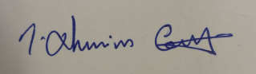
56. Does school-assembly happen in the school? Yes√ No__
Details of the Team Member who conducted the Survey

Name:Rhenius Caleb J
Signature:

(I hereby acknowledge that the information provided is true to the best of my knowledge)

SCHOOL SURVEY FORM- 2
Team Code: 006

Empirical Inquiry by Law Colleges on Implementation of the RTE Act, 2009
(For Paper Presentation and Discussion at National Law University Jodhpur)
Theme of the Year: Physical Infrastructure in State-provided Primary Schools
BASIC INFORMATION

The fundamental right to education of every child is enunciated in international law in Article 28 of the Convention on the Rights of the Child, to which India acceded in 1992; and in the Indian Constitution in Article 21A, and its consequential legislation, ‘The Right of Children to Free and Compulsory Education, 2009’.
The right to education was earlier in Article 45 of the Directive Principles of State Policy. The 86th Amendment of the Constitution in 2002 moved it to the list of fundamental rights thus making this right ‘justiciable’. However, justiciability of the right to education depends on the extent to which lawyers and the courts are aware of and sensitive to the manner in which education is delivered.
Our objective, as members of the Legal Aid Committee/ Society or Law School Community, is to enquire through this empirical exercise, into how the right to education is being made available to the child. Thus, not only do we ourselves learn, but through our reports, the legal fraternity at large can potentially be sensitized towards claiming this right for all children.

1. Name of School:
Panchayat Union Primary School (PUPS) Paiyur
2. Name of Village/ Town with Municipal Corporation
THIRUPPATUR, SIVAGANGAI DISTRICT
3. Pin Code (6 digits) 630203
4. Block Name Thiruppatur
5. Lowest Class in the School GRADE-1
6. Highest Class in the School GRADE-5
7. Is school in urban, rural, semi urban area?: (RURAL)
8. Clientele- Co Ed
9. Is this school approachable by all-weather Road? Yes
10. Does this school run-in shifts No
11. Name of HM MAHALINGAM H
12. Mobile Number of HM: +91_9750765848_
PUPILS AND TEACHERS IN THE PRIMARY SCHOOL
(For grades 1 to 5 only)
13. No. of Students in grades 1 to 5 (On School Register) ___21__________
14. No. of students (grades 1 to 5) present today (as per School statement)______21____
15. Percentage of students present today (calculate yourself) __________100%________
16. No. of Teachers for grades 1 to 5 (posted to the school) ____2______________
17. No. of Teachers (for grade 1 to 5) present today (as per School statement) _____2_____
18. Percentage of teachers present today (calculate yourself) ___100%________________
19. Primary (only) school Teacher to pupil Ratio 1:11

(Only one of the columns will apply) (Calculate yourself)
If the number of pupils in the school in classes 1 to 5 is….
a) Less than  60 are there 2  teachers or more in the school? | b) Between 61-90, Are  there 3 or  more  teachers? | c) Between 91- 120, Are  there 4 or  more  teachers? | d) Between  120-200,  Are there 5  or more  teachers? | e) Above  150, is there  a Head  Teacher in  addition to 5  teachers? | f) Above 200, is the pupil to teacher  ratio; is there a  teacher- pupil  ratio at primary  being 40 children  per teacher
YES- ✓ | Yes - | Yes - | Yes - | Yes - | Yes -
No - | No - | No - | No - | No - | No -

20. Total number of non-teaching staff: _____________-___________________ 21. Who pays salary of non- teaching staff? ________-__________________
22. For what work the non-teaching staff has been employed?______-______
INFRASTRUCTURE
Building
23. How would you describe the building? _____PUCCA BUILDING____________
Pucca:School building with baked brick walls/stone walls and roof top with slab or  wooden/iron girders or tiles | Partially Pucca:School building with baked brick walls or stone walls with corrugated sheet or asbestos sheet or thatched roof top | Kachha:School building with unbaked brick or mud walls with corrugated asbestos sheet or thatched roof top.

24. Total Number of Rooms _____05____________________
25. Total Number of Classrooms___02___________________
26. Is there one classroom per teacher? (Calculate yourself: Number of classrooms/number of teachers) YES
27. Where pupils >150, is there a Head Teacher? NA___; Yes____; No____
28. If yes above, Is there a room for the head teacher? Yes__;

Condition of Rooms/ Classrooms
29. Number of Classrooms in need of Minor Repair ____-_______
30. Number of Classrooms in need of Major Repair ____-_______
31. Number of other rooms needing repair ___________-______
Library:
32. Is there any library? Yes, a separate room Yes, ‘a space’
33.Does the library contain Newspapers? Yes
34. Does the library contain Magazines? Yes;
35. Does the library contain Books? (subject related) Yes;
36. Does the library contain Story Books? Yes
37. Is there a record of books issued? No
38. If Yes, above, then Date when last Book was issued - NIL
Playground:
39 Is there any playground in the school? Yes
40. How would you describe the playground? ____It is small but we ll maintained________________
41. Do students get any play materials, sport equipments, etc.? No
Washroom Facility:
42. Total Number of toilets available: Girls: ___1______ Boys_________1________
43. Total number of toilets functional and Usable: Girls: ___1_____ Boys:_____1_____
44. Are there any separate toilets for teachers? Yes
45. Are any of the toilets locked? No
Drinking Water:
46. Is there any facility for safe drinking water for children? Yes
47. Are children allowed to use Teachers’ water supply? Yes
48. Mode of drinking water: Other ( Pl specify) TAP WATER
49. What is the condition of surrounding area near this facility?
The surrounding area is safe
50. Is there any hand wash facility? Yes
51. If Yes, is it functional and sufficient? Yes
Security of the School:
52. For the security of the school, is there a boundary wall or fencing? Yes
53. Is this boundary wall or fencing sufficient for security of school? Yes
Teaching in the School:
54. When you visited the school, what were teachers doing?
They were teaching the students.
55. Apart from teaching, what else are they doing?
Nothing specific
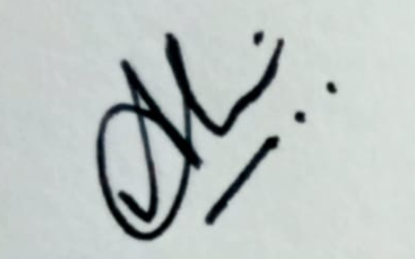
56. Does school-assembly happen in the school? Yes
Details of the Team Member who conducted the Survey

Name: Alakammai G
Signature:

(I hereby acknowledge that the information provided is true to the best of my knowledge)

SCHOOL SURVEY FORM- 3
Team Code: 006

Empirical Inquiry by Law Colleges on Implementation of the RTE Act, 2009
(For Paper Presentation and Discussion at National Law University Jodhpur)
Theme of the Year: Physical Infrastructure in State-provided Primary Schools
BASIC INFORMATION

The fundamental right to education of every child is enunciated in international law in Article 28 of the Convention on the Rights of the Child, to which India acceded in 1992; and in the Indian Constitution in Article 21A, and its consequential legislation, ‘The Right of Children to Free and Compulsory Education, 2009’.
The right to education was earlier in Article 45 of the Directive Principles of State Policy. The 86th Amendment of the Constitution in 2002 moved it to the list of fundamental rights thus making this right ‘justiciable’. However, justiciability of the right to education depends on the extent to which lawyers and the courts are aware of and sensitive to the manner in which education is delivered.
Our objective, as members of the Legal Aid Committee/ Society or Law School Community, is to enquire through this empirical exercise, into how the right to education is being made available to the child. Thus, not only do we ourselves learn, but through our reports, the legal fraternity at large can potentially be sensitized towards claiming this right for all children.

1. Name of School:
__PUPS__Chinnathambipalayam_______________
2. Name of Village/ Town with Municipal Corporation (in case of Municipal Corporation give ward Number also)
___Chinnathambipalayam_________________
3. Pin Code (6 digits) 638502 _ _ _ _
4. Block Name _____Anthiyur______________
5. Lowest Class in the School _____1_____ (after pre-primary)
6. Highest Class in the School _____5____
7. Is school in urban, rural, semi urban area?: (Urban ___; Rural _Yes___; Semi Urban ______)
8. Clientele (Tick one): Girls only__ Boys only___ Co Ed__Yes_
9. Is this school approachable by all-weather Road? Yes____
10. Does this school run-in shifts (see note) No
11. Name of HM: S.Umarani
12. Mobile Number of HM: +91_9865197050

PUPILS AND TEACHERS IN THE PRIMARY SCHOOL
(For grades 1 to 5 only)
13. No. of Students in grades 1 to 5 (On School Register) ____59______________
14. No. of students (grades 1 to 5) present today (as per School statement)____56_________
15. Percentage of students present today (calculate yourself) _____95%_________________
16. No. of Teachers for grades 1 to 5 (posted to the school) ______3____________
17. No. of Teachers (for grade 1 to 5) present today (as per School statement) _3__
18. Percentage of teachers present today (calculate yourself) ______100%________________
19. Primary (only) school Teacher to pupil Ratio
(Only one of the columns will apply) (Calculate yourself)
If the number of pupils in the school in classes 1 to 5 is….
a) Less than  60 are there 2  teachers or more in the school? | b) Between 61-90, Are  there 3 or  more  teachers? | c) Between 91- 120, Are  there 4 or  more  teachers? | d) Between  120-200,  Are there 5  or more  teachers? | e) Above  150, is there  a Head  Teacher in  addition to 5  teachers? | f) Above 200, is the pupil to teacher  ratio; is there a  teacher- pupil  ratio at primary  being 40 children  per teacher
Yes - | Yes - | Yes - | Yes - | Yes - | Yes -
No - | No - | No - | No - | No - | No -

20. Total number of non-teaching staff: ____0____________________________ 21. Who pays salary of non- teaching staff? __NA________________________
22. For what work the non-teaching staff has been employed?_______________________NA______________________
INFRASTRUCTURE
Building
23. How would you describe the building? ______________________
Pucca:School building with baked brick walls/stone walls and roof top with slab or  wooden/iron girders or tiles | Partially Pucca:School building with baked brick walls or stone walls with corrugated sheet or asbestos sheet or thatched roof top | Kachha:School building with unbaked brick or mud walls with corrugated asbestos sheet or thatched roof top.

24. Total Number of Rooms _____3____________________
25. Total Number of Classrooms_____2_________________
26. Is there one classroom per teacher? (Calculate yourself: Number of classrooms/number of teachers) Yes___No___
27. Where pupils >150, is there a Head Teacher? Yes
28. If yes above, Is there a room for the head teacher? No

Condition of Rooms/ Classrooms
29. Number of Classrooms in need of Minor Repair ____No but as there are only two classrooms , it is difficult to manage the multiple grades, if there are class dividers , it would be easy for them
30. Number of Classrooms in need of Major Repair _____No___
31. Number of other rooms needing repair _______________The third room which is not used and non functional, it need repairment__
Library:
32. Is there any library? Yes, ‘a space’
33.Does the library contain Newspapers? Yes
34. Does the library contain Magazines? No__________
35. Does the library contain Books? (subject related) Yes
36. Does the library contain Story Books? Yes
37. Is there a record of books issued? Yes
38. If Yes, above, then Date when last Book was issued_______10/01/2025_____________
Playground:
39 Is there any playground in the school? Yes_____
40. How would you describe the playground? It is small in areabut it cannot be completely utilised by the schools as it is also property of the temple located within school premises__________
41. Do students get any play materials, sport equipments, etc.?_ Yes
Washroom Facility:
42. Total Number of toilets available: Girls: _____1____ Boys_______1__________
43. Total number of toilets functional and Usable: Girls: ____1____ Boys:____1______
44. Are there any separate toilets for teachers? No________
45. Are any of the toilets locked? No ____________
Drinking Water:
46. Is there any facility for safe drinking water for children? Yes_______
47. Are children allowed to use Teachers’ water supply? Yes_______
48. Mode of drinking water: Water cooler:____ Other ( Pl specify) ___RO water__
49. What is the condition of surrounding area near this facility? ____It is clean and hygiene
50. Is there any hand wash facility? Yes
51. If Yes, is it functional and sufficient? Yes

Security of the School:
52. For the security of the school, is there a boundary wall or fencing? Yes
53. Is this boundary wall or fencing sufficient for security of school? No
Teaching in the School:
54. When you visited the school, what were teachers doing? Teaching - Tamil subject in 4th grade
55. Apart from teaching, what else are they doing? They were preparing lessons plans and attendance calculation
56. Does school-assembly happen in the school? Yes
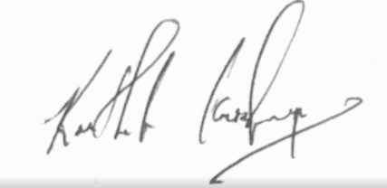
Details of the Team Member who conducted the Survey

Name: Karthik Krishnan N
Signature:

(I hereby acknowledge that the information provided is true to the best of my knowledge)

Team Code: 006
SCHOOL SURVEY FORM- 4

Empirical Inquiry by Law Colleges on Implementation of the RTE Act, 2009
(For Paper Presentation and Discussion at National Law University Jodhpur)
Theme of the Year: Physical Infrastructure in State-provided Primary Schools
BASIC INFORMATION

The fundamental right to education of every child is enunciated in international law in Article 28 of the Convention on the Rights of the Child, to which India acceded in 1992; and in the Indian Constitution in Article 21A, and its consequential legislation, ‘The Right of Children to Free and Compulsory Education, 2009’.
The right to education was earlier in Article 45 of the Directive Principles of State Policy. The 86th Amendment of the Constitution in 2002 moved it to the list of fundamental rights thus making this right ‘justiciable’. However, justiciability of the right to education depends on the extent to which lawyers and the courts are aware of and sensitive to the manner in which education is delivered.
Our objective, as members of the Legal Aid Committee/ Society or Law School Community, is to enquire through this empirical exercise, into how the right to education is being made available to the child. Thus, not only do we ourselves learn, but through our reports, the legal fraternity at large can potentially be sensitized towards claiming this right for all children.

1. Name of School: Government Higher primary (Girls) School.
2. Name of Village/ Town with Municipal Corporation (in case of Municipal Corporation give ward Number also): Attibele, Anekal, Ward No. 7.
3. Pin Code (6 digits): 562107
4. Block Name: Anekal
5. Lowest Class in the School (after pre-primary): Class 1.
6. Highest Class in the School: Class 7.
7. Is school in urban, rural, semi urban area? Urban.
8. Clientele: Co Ed.
9. Is this school approachable by all-weather Road? Yes.
10. Does this school run-in shifts? No.
11. Name of HM: Hymavathi. A
12. Mobile Number of HM: +91 97406 97732

PUPILS AND TEACHERS IN THE PRIMARY SCHOOL
(For grades 1 to 5 only)
13. No. of Students in grades 1 to 5 (On School Register): 111.
14. No. of students (grades 1 to 5) present today (as per School statement): 82.
15. Percentage of students present today (calculate yourself): 73.8%
16. No. of Teachers for grades 1 to 5 (posted to the school): 6 (2 visiting faculty).
17. No. of Teachers (for grade 1 to 5) present today (as per School statement): 6.
18. Percentage of teachers present today (calculate yourself): 100% (Excluding the visiting faculty)
19. Primary (only) school Teacher to pupil Ratio: 1: 18.

If the number of pupils in the school in classes 1 to 5 is….
a) Less than  60 are there 2  teachers or more in the school? | b) Between 61-90, Are  there 3 or  more  teachers? | c) Between 91- 120, Are  there 4 or  more  teachers? | d) Between  120-200,  Are there 5  or more  teachers? | e) Above  150, is there  a Head  Teacher in  addition to 5  teachers? | f) Above 200, is the pupil to teacher  ratio; is there a  teacher- pupil  ratio at primary  being 40 children  per teacher
Yes - | Yes - | Yes - | Yes - | Yes - | Yes -
No - | No - | No - | No - | No - | No -

20. Total number of non-teaching staff: NIL
21. Who pays the salary of non- teaching staff? NA
22. For what work the non-teaching staff has been employed? NA

INFRASTRUCTURE
BUILDING
23. How would you describe the building? Pucca

Pucca:School building with baked brick walls/stone walls and roof top with slab or  wooden/iron girders or tiles | Partially Pucca:School building with baked brick walls or stone walls with corrugated sheet or asbestos sheet or thatched roof top | Kachha:School building with unbaked brick or mud walls with corrugated asbestos sheet or thatched roof top.

24. Total Number of Rooms: 10
25. Total Number of Classrooms: 6
26. Is there one classroom per teacher? Yes
27. Where pupils >150, is there a Head Teacher? NA
28. If yes above, Is there a room for the head teacher? Yes
CONDITION OF ROOMS/ CLASSROOMS
29. Number of Classrooms in need of Minor Repair: NIL
30. Number of Classrooms in need of Major Repair: 1.
31. Number of other rooms needing repair: NIL
LIBRARY:
32. Is there any library? Yes, a separate room
33.Does the library contain Newspapers? Yes
34. Does the library contain Magazines? Yes
35. Does the library contain Books? (subject related) Yes
36. Does the library contain Story Books? Yes
37. Is there a record of books issued? Yes
38. If Yes, above, then Date when last Book was issued: 03/01/2025.
PLAYGROUND:
39 Is there any playground in the school? No
40. How would you describe the playground? NA
41. Do students get any play materials, sport equipments, etc.? No
WASHROOM FACILITY:
42. Total Number of toilets available: Girls: There are two washrooms available: one for urination and another for toileting purposes., Boys: There are two washrooms available: one for urination and another for toileting purposes.
43. Total number of toilets functional and Usable: Girls: Both, Boys: Both.
44. Are there any separate toilets for teachers? Yes
45. Are any of the toilets locked? No
DRINKING WATER:
46. Is there any facility for safe drinking water for children? Yes
47. Are children allowed to use Teachers’ water supply? Yes
48. Mode of drinking water: Water can RO
49. What is the condition of the surrounding area near this facility? The school is situated in a prime location, surrounded by well-maintained areas, & it's near the marketplace.
50. Is there any hand wash facility? Yes
51. If Yes, is it functional and sufficient? Yes
SECURITY OF THE SCHOOL:
52. For the security of the school, is there a boundary wall or fencing? Yes
53. Is this boundary wall or fencing sufficient for school security? Yes
TEACHING IN THE SCHOOL:
54. When you visited the school, what were teachers doing? When I visited the school, the Headmaster was in the middle of explaining something to the students.
55. Apart from teaching, what else are they doing? NIL
56. Does school-assembly happen in the school? Yes
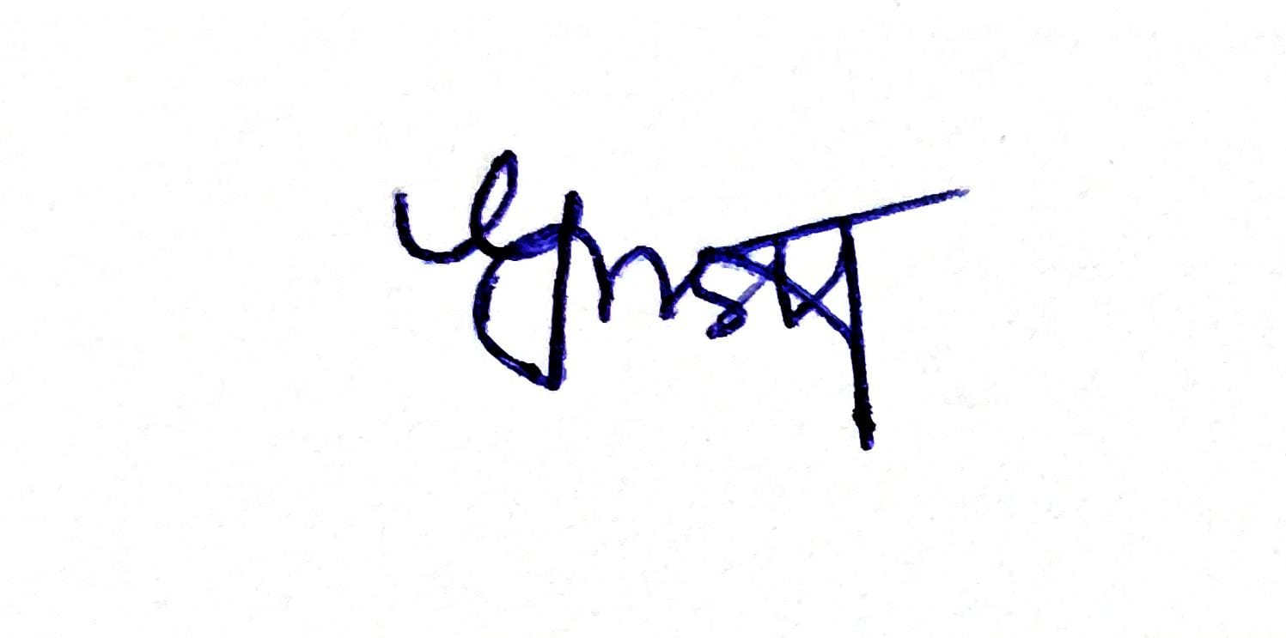
Details of the Team Member who conducted the Survey

Name: Usha G
Signature:

(I hereby acknowledge that the information provided is true to the best of my knowledge)

Team Code: 006

SCHOOL SURVEY FORM- 5

Empirical Inquiry by Law Colleges on Implementation of the RTE Act, 2009
(For Paper Presentation and Discussion at National Law University Jodhpur)
Theme of the Year: Physical Infrastructure in State-provided Primary Schools
BASIC INFORMATION

The fundamental right to education of every child is enunciated in international law in Article 28 of the Convention on the Rights of the Child, to which India acceded in 1992; and in the Indian Constitution in Article 21A, and its consequential legislation, ‘The Right of Children to Free and Compulsory Education, 2009’.
The right to education was earlier in Article 45 of the Directive Principles of State Policy. The 86th Amendment of the Constitution in 2002 moved it to the list of fundamental rights thus making this right ‘justiciable’. However, justiciability of the right to education depends on the extent to which lawyers and the courts are aware of and sensitive to the manner in which education is delivered.
Our objective, as members of the Legal Aid Committee/ Society or Law School Community, is to enquire through this empirical exercise, into how the right to education is being made available to the child. Thus, not only do we ourselves learn, but through our reports, the legal fraternity at large can potentially be sensitized towards claiming this right for all children.

1. Name of School:
Government Higher Primary School, Gudda Hatti
2. Name of Village/ Town with Municipal Corporation (in case of Municipal Corporation give ward Number also) Gudda Hatti
3. Pin Code (6 digits) 562107
4. Block Name Anekal
5. Lowest Class in the School Class 1 (after pre-primary)
6. Highest Class in the School Class 7
7. Is school in urban, rural, semi urban area?: (Urban ___; Rural _✔_; Semi Urban ______)
8. Clientele (Tick one): Girls only__ Boys only___ Co Ed_✔_
9. Is this school approachable by all-weather Road? Yes_✔___ No________
10. Does this school run-in shifts (see note) Yes___ No_✔_
11. Name of HM Asha
12. Mobile Number of HM: +91 8105867310

PUPILS AND TEACHERS IN THE PRIMARY SCHOOL
(For grades 1 to 5 only)
13. No. of Students in grades 1 to 5 (On School Register) 133
14. No. of students (grades 1 to 5) present today (as per School statement) 132
15. Percentage of students present today (calculate yourself) 99.2%
16. No. of Teachers for grades 1 to 5 (posted to the school) 4
17. No. of Teachers (for grade 1 to 5) present today (as per School statement) 4
18. Percentage of teachers present today (calculate yourself) 100%
19. Primary (only) school Teacher to pupil Ratio
(Only one of the columns will apply) (Calculate yourself)
If the number of pupils in the school in classes 1 to 5 is….
a) Less than  60 are there 2  teachers or more in the school? | b) Between 61-90, Are  there 3 or  more  teachers? | c) Between 91- 120, Are  there 4 or  more  teachers? | d) Between  120-200,  Are there 5  or more  teachers? | e) Above  150, is there  a Head  Teacher in  addition to 5  teachers? | f) Above 200, is the pupil to teacher  ratio; is there a  teacher- pupil  ratio at primary  being 40 children  per teacher
Yes - | Yes - | Yes - | Yes - | Yes - | Yes -
No - | No - | No - | No -There are 4 Teachers only | No - | No -

20. Total number of non-teaching staff: 2
21. Who pays salary of non- teaching staff? Government
22. For what work the non-teaching staff has been employed? Cleaning the campus, vessels and serving food.

INFRASTRUCTURE
Building
23. How would you describe the building? PUCCA
Pucca:School building with baked brick walls/stone walls and roof top with slab or  wooden/iron girders or tiles | Partially Pucca:School building with baked brick walls or stone walls with corrugated sheet or asbestos sheet or thatched roof top | Kachha:School building with unbaked brick or mud walls with corrugated asbestos sheet or thatched roof top.

24. Total Number of Rooms 7
25. Total Number of Classrooms 4
26. Is there one classroom per teacher? (Calculate yourself: Number of classrooms/number of teachers) Yes___No_✔__
27. Where pupils >150, is there a Head Teacher? NA_✔__; Yes____; No____
28. If yes above, Is there a room for the head teacher? Yes__; No_✔__

Condition of Rooms/ Classrooms
29. Number of Classrooms in need of Minor Repair ____2_______
30. Number of Classrooms in need of Major Repair ____2_______
31. Number of other rooms needing repair ______4___________
Library:
32. Is there any library? Yes, a separate room ______; Yes, ‘a space’ _✔_____; No________ 33.Does the library contain Newspapers? Yes _✔____; No__________ 34. Does the library contain Magazines? Yes _____; No____✔______
35. Does the library contain Books? (subject related) Yes _____; No____✔______
36. Does the library contain Story Books? Yes __✔___; No__________
37. Is there a record of books issued? Yes__✔_____; No________
38. If Yes, above, then Date when last Book was issued____1/10/2025____________
Playground:
39 Is there any playground in the school? Yes_______; No___✔_____
40. How would you describe the playground?
There is no play area for the students. The teachers requested if any play area can be provided
41. Do students get any play materials, sport equipments, etc.?_ Yes____; No__✔____
Washroom Facility:
42. Total Number of toilets available: Girls: ___2______ Boys______4___________
43. Total number of toilets functional and Usable: Girls: __2______ Boys:____3______
44. Are there any separate toilets for teachers? Yes_____; No___✔____ 45. Are any of the toilets locked? Yes ___✔_____ ; No ____________
Drinking Water:
46. Is there any facility for safe drinking water for children? Yes__✔____; No________ 47. Are children allowed to use Teachers’ water supply? Yes___✔___; No________
48. Mode of drinking water: Water cooler:____ Other ( Pl specify) _Can Water___
49. What is the condition of surrounding area near this facility? __Satisfactory_
50. Is there any hand wash facility? Yes__✔_ No___
51. If Yes, is it functional and sufficient? Yes____ No_✔__
Security of the School:
52. For the security of the school, is there a boundary wall or fencing? Yes_✔_ No__ 53. Is this boundary wall or fencing sufficient for security of school? Yes_✔__ No__
Teaching in the School:
54. When you visited the school, what were teachers doing? __Teaching__
55. Apart from teaching, what else are they doing? Engaging activity with the students
56. Does school-assembly happen in the school? Yes__✔__ No__
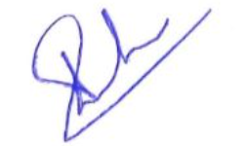
Details of the Team Member who conducted the Survey

Name: SNEHA K, 9th sem B.A. L.L.B
Signature:

(I hereby acknowledge that the information provided is true to the best of my knowledge)
Team Code: 006
SCHOOL SURVEY FORM- 6

Empirical Inquiry by Law Colleges on Implementation of the RTE Act, 2009
(For Paper Presentation and Discussion at National Law University Jodhpur)
Theme of the Year: Physical Infrastructure in State-provided Primary Schools
BASIC INFORMATION

The fundamental right to education of every child is enunciated in international law in Article 28 of the Convention on the Rights of the Child, to which India acceded in 1992; and in the Indian Constitution in Article 21A, and its consequential legislation, ‘The Right of Children to Free and Compulsory Education, 2009’.
The right to education was earlier in Article 45 of the Directive Principles of State Policy. The 86th Amendment of the Constitution in 2002 moved it to the list of fundamental rights thus making this right ‘justiciable’. However, justiciability of the right to education depends on the extent to which lawyers and the courts are aware of and sensitive to the manner in which education is delivered.
Our objective, as members of the Legal Aid Committee/ Society or Law School Community, is to enquire through this empirical exercise, into how the right to education is being made available to the child. Thus, not only do we ourselves learn, but through our reports, the legal fraternity at large can potentially be sensitized towards claiming this right for all children.

1. Name of School: GHPS, RAYASANDRA
2. Name of Village/ Town with Municipal Corporation (in case of Municipal Corporation give ward Number also)
Rayasandra Ward No 19
3. Pin Code (6 digits) 560099
4. Block Name Anekal
5. Lowest Class in the School ___1ST STD_______ (after pre-primary)
6. Highest Class in the School __7TH STD_______
7. Is school in urban, rural, semi urban area?: (RURAL)
8. Clientele (Tick one): Co Ed
9. Is this school approachable by all-weather Road? Yes
10. Does this school run-in shifts (see note) No
11. Name of HM: K.Venkateshamma
12. Mobile Number of HM: +916366238795

PUPILS AND TEACHERS IN THE PRIMARY SCHOOL
(For grades 1 to 5 only)
13. No. of Students in grades 1 to 5 (On School Register) ____218______________
14. No. of students (grades 1 to 5) present today (as per School statement)___88__________
15. Percentage of students present today (calculate yourself) ______90%________________
16. No. of Teachers for grades 1 to 5 (posted to the school) ___5_______________
17. No. of Teachers (for grade 1 to 5) present today (as per School statement) ___5________
18. Percentage of teachers present today (calculate yourself) __100%____________________
19. Primary (only) school Teacher to pupil Ratio
(Only one of the columns will apply) (Calculate yourself)
If the number of pupils in the school in classes 1 to 5 is…. 200 ABOVE
a) Less than  60 are there 2  teachers or more in the school? | b) Between 61-90, Are  there 3 or  more  teachers? | c) Between 91- 120, Are  there 4 or  more  teachers? | d) Between  120-200,  Are there 5  or more  teachers? | e) Above  150, is there  a Head  Teacher in  addition to 5  teachers? | f) Above 200, is the pupil to teacher  ratio; is there a  teacher- pupil  ratio at primary  being 40 children  per teacher
Yes - | Yes - | Yes - | Yes - | Yes - | Yes -
No - | No - | No - | No - | No - | No -

20. Total number of non-teaching staff: ___7_______________
21. Who pays salary of non- teaching staff? ______GOVT AIDED__
22. For what work the non-teaching staff has been employed?
Cooking, Serving Food, Vessel Washing, Cleaning etc

INFRASTRUCTURE
Building
23. How would you describe the building? ________PUCCA______________
Pucca:School building with baked brick walls/stone walls and roof top with slab or  wooden/iron girders or tiles | Partially Pucca:School building with baked brick walls or stone walls with corrugated sheet or asbestos sheet or thatched roof top | Kachha:School building with unbaked brick or mud walls with corrugated asbestos sheet or thatched roof top.

24. Total Number of Rooms _____11____________________
25. Total Number of Classrooms_____7_________________
26. Is there one classroom per teacher? (Calculate yourself: Number of classrooms/number of teachers) Yes__
27. Where pupils >150, is there a Head Teacher? YES_
28. If yes above, Is there a room for the head teacher? Yes
Condition of Rooms/ Classrooms
29. Number of Classrooms in need of Minor Repair ___________
30. Number of Classrooms in need of Major Repair ___________
31. Number of other rooms needing repair _________________
Library:
32. Is there any library? Yes, a separate room YES
33.Does the library contain Newspapers? YES
34. Does the library contain Magazines? YES
35. Does the library contain Books? (subject related) YES
36. Does the library contain Story Books? YES
37. Is there a record of books issued? YES_
38. If Yes, above, then Date when last Book was issued_______1.10.24_____________
Playground:
39 Is there any playground in the school? NO
40. How would you describe the playground? ____________________
41. Do students get any play materials, sport equipments, etc.?_NO
Washroom Facility:
42. Total Number of toilets available: Girls: ____10_____ Boys_______10__________ 43. Total number of toilets functional and Usable: Girls: _____10___ Boys:____10______
44. Are there any separate toilets for teachers? YES
45. Are any of the toilets locked? NO
Drinking Water:
46. Is there any facility for safe drinking water for children? YES
47. Are children allowed to use Teachers’ water supply? YES
Mode of drinking water: Water cooler:__

49. What is the condition of surrounding area near this facility? Satisfactory
50. Is there any hand wash facility? Yes_
51. If Yes, is it functional and sufficient? Yes_

Security of the School:
52. For the security of the school, is there a boundary wall or fencing? Yes
53. Is this boundary wall or fencing sufficient for security of school? Yes__
Teaching in the School:
54. When you visited the school, what were teachers doing?
55. Apart from teaching, what else are they doing?
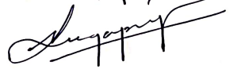
56. Does school-assembly happen in the school? Yes
Details of the Team Member who conducted the Survey

Name: Sugapriya S
Signature:

(I hereby acknowledge that the information provided is true to the best of my knowledge)

Team Code: 006
SCHOOL SURVEY FORM- 7

Empirical Inquiry by Law Colleges on Implementation of the RTE Act, 2009
(For Paper Presentation and Discussion at National Law University Jodhpur)
Theme of the Year: Physical Infrastructure in State-provided Primary Schools
BASIC INFORMATION

The fundamental right to education of every child is enunciated in international law in Article 28 of the Convention on the Rights of the Child, to which India acceded in 1992; and in the Indian Constitution in Article 21A, and its consequential legislation, ‘The Right of Children to Free and Compulsory Education, 2009’.
The right to education was earlier in Article 45 of the Directive Principles of State Policy. The 86th Amendment of the Constitution in 2002 moved it to the list of fundamental rights thus making this right ‘justiciable’. However, justiciability of the right to education depends on the extent to which lawyers and the courts are aware of and sensitive to the manner in which education is delivered.
Our objective, as members of the Legal Aid Committee/ Society or Law School Community, is to enquire through this empirical exercise, into how the right to education is being made available to the child. Thus, not only do we ourselves learn, but through our reports, the legal fraternity at large can potentially be sensitized towards claiming this right for all children.

1. Name of School: KENDRIYA VIDYALAYA_
2. Name of Village/ Town with Municipal Corporation (in case of Municipal Corporation give ward Number also) : MACHILIPATNAM
3. Pin Code (6 digits) : 521001
4. Block Name : BY PASS ROAD
5. Lowest Class in the Schoo :l 5TH CLASS (after pre-primary)
6. Highest Class in the School :12TH CLASS
7. Is school in urban, rural, semi urban area?: (Urban ✓; Rural ____; Semi Urban ______)
8. Clientele (Tick one): Girls only__ Boys only___ Co Ed :✓___
9. Is this school approachable by all-weather Road? Yes__ No :✓
10. Does this school run-in shifts (see note) Yes___ No:✓
11. Name of HM : MS.GLORY SWAROOPA RANI
12. Mobile Number of HM: +91 85007405851

PUPILS AND TEACHERS IN THE PRIMARY SCHOOL
(For grades 1 to 5 only)
13. No. of Students in grades 1 to 5 (On School Register) :437
14. No. of students (grades 1 to 5) present today (as per School statement): 398
15. Percentage of students present today (calculate yourself ) : 91.0755 %
16. No. of Teachers for grades 1 to 5 (posted to the school) :11
17. No. of Teachers (for grade 1 to 5) present today (as per School statement) :09
18. Percentage of teachers present today (calculate yourself) 81.81%
19. Primary (only) school Teacher to pupil Ratio
(Only one of the columns will apply) (Calculate yourself)
If the number of pupils in the school in classes 1 to 5 is….
a) Less than  60 are there 2  teachers or more in the school? | b) Between 61-90, Are  there 3 or  more  teachers? | c) Between 91- 120, Are  there 4 or  more  teachers? | d) Between  120-200,  Are there 5  or more  teachers? | e) Above  150, is there  a Head  Teacher in  addition to 5  teachers? | f) Above 200, is the pupil to teacher  ratio; is there a  teacher- pupil  ratio at primary  being 40 children  per teacher
Yes - | Yes - | Yes - | Yes - ✓ | Yes - | Yes -
No - | No - | No - | No - | No - | No -

20. Total number of non-teaching staff: :02
21. Who pays salary of non- teaching staff? Kendriya vidyalaya sangathan office
22. For what work the non-teaching staff has been employed? Office and administration work.
INFRASTRUCTURE
Building
23. How would you describe the building? Pucca
Pucca:School building with baked brick walls/stone walls and roof top with slab or  wooden/iron girders or tiles | Partially Pucca:School building with baked brick walls or stone walls with corrugated sheet or asbestos sheet or thatched roof top | Kachha:School building with unbaked brick or mud walls with corrugated asbestos sheet or thatched roof top.

24. Total Number of Rooms : 48
25. Total Number of Classrooms : 30
26. Is there one classroom per teacher? (Calculate yourself: Number of classrooms/number of teachers) Yes__✓_No___
27. Where pupils >150, is there a Head Teacher? NA___; Yes___✓_; No____
28. If yes above, Is there a room for the head teacher? Yes_✓_; No___

Condition of Rooms/ Classrooms
29. Number of Classrooms in need of Minor Repair :04
30. Number of Classrooms in need of Major Repair : 0
31. Number of other rooms needing repair :0
Library:
32. Is there any library? Yes, a separate room : YES
33.Does the library contain Newspapers? Yes _✓____; No__________ 34. Does the library contain Magazines? Yes ____✓_; No__________
35. Does the library contain Books? (subject related) Yes __✓___; No__________
36. Does the library contain Story Books? Yes ___✓__; No__________
37. Is there a record of books issued? Yes____✓___; No________
38. If Yes, above, then Date when last Book was issued______06-01-2025________
Playground:
39 Is there any playground in the school? Yes____✓___; No________
40. How would you describe the playground? _______Spacious_____________
41. Do students get any play materials, sport equipments, etc.?_ Yes_✓___; No______
Washroom Facility:
42. Total Number of toilets available: Girls: ____24_____ Boys_______24__________
43. Total number of toilets functional and Usable: Girls: ____24____ Boys:____24______
44. Are there any separate toilets for teachers? Yes___✓__; No________
45. Are any of the toilets locked? Yes ________ ; No ____✓________ Drinking Water:
46. Is there any facility for safe drinking water for children? Yes__✓_____; No________
47. Are children allowed to use Teachers’ water supply? Yes_______; No___✓_____ 48. Mode of drinking water: Water cooler:__✓__ Other ( Pl specify) _____

49. What is the condition of surrounding area near this facility? Normal conditions ( local) no fundings
50. Is there any hand wash facility? Yes__✓_ No___
51. If Yes, is it functional and sufficient? Yes_✓___ No___

Security of the School:
52. For the security of the school, is there a boundary wall or fencing? Yes✓____ No__
53. Is this boundary wall or fencing sufficient for security of school? Yes__✓_ No__
Teaching in the School:
54. When you visited the school, what were teachers doing? Teaching
55. Apart from teaching, what else are they doing? Mentoring
56. Does school-assembly happen in the school? Yes__✓__ No_
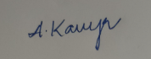
Details of the Team Member who conducted the Survey

Name: Adapa Kavya Amulyashree
Signature:

(I hereby acknowledge that the information provided is true to the best of my knowledge)

Team Code: 006
SCHOOL SURVEY FORM- 8

Empirical Inquiry by Law Colleges on Implementation of the RTE Act, 2009
(For Paper Presentation and Discussion at National Law University Jodhpur)
Theme of the Year: Physical Infrastructure in State-provided Primary Schools
BASIC INFORMATION

The fundamental right to education of every child is enunciated in international law in Article 28 of the Convention on the Rights of the Child, to which India acceded in 1992; and in the Indian Constitution in Article 21A, and its consequential legislation, ‘The Right of Children to Free and Compulsory Education, 2009’.
The right to education was earlier in Article 45 of the Directive Principles of State Policy. The 86th Amendment of the Constitution in 2002 moved it to the list of fundamental rights thus making this right ‘justiciable’. However, justiciability of the right to education depends on the extent to which lawyers and the courts are aware of and sensitive to the manner in which education is delivered.
Our objective, as members of the Legal Aid Committee/ Society or Law School Community, is to enquire through this empirical exercise, into how the right to education is being made available to the child. Thus, not only do we ourselves learn, but through our reports, the legal fraternity at large can potentially be sensitized towards claiming this right for all children.

1. Name of School: Zilla Parishat School
2. Name of Village/ Town with Municipal Corporation (in case of Municipal Corporation give ward Number also) NTR District, Vijayawada
3. Pin Code (6 digits) 520007
4. Block Name Vijayawada (NIL)
5. Lowest Class in the School Class 1(after pre-primary)
6. Highest Class in the School Class 5
7. Is school in urban, rural, semi urban area?: Rural
8. Clientele (Tick one): Co Ed
9. Is this school approachable by all-weather Road? Yes
10. Does this school run-in shifts (see note) No
11. Name of HM Naga Lakshmi
12. Mobile Number of HM: NIL

PUPILS AND TEACHERS IN THE PRIMARY SCHOOL
(For grades 1 to 5 only)
13. No. of Students in grades 1 to 5 (On School Register) __56
14. No. of students (grades 1 to 5) present today (as per School statement)______42
15. Percentage of students present today (calculate yourself) _________75
16. No. of Teachers for grades 1 to 5 (posted to the school) _____12
17. No. of Teachers (for grade 1 to 5) present today (as per School statement) 12
18. Percentage of teachers present today (calculate yourself) _________100_____________
19. Primary (only) school Teacher to pupil Ratio
(Only one of the columns will apply) (Calculate yourself)
If the number of pupils in the school in classes 1 to 5 is…. Option:A
a) Less than  60 are there 2  teachers or more in the school? | b) Between 61-90, Are  there 3 or  more  teachers? | c) Between 91- 120, Are  there 4 or  more  teachers? | d) Between  120-200,  Are there 5  or more  teachers? | e) Above  150, is there  a Head  Teacher in  addition to 5  teachers? | f) Above 200, is the pupil to teacher  ratio; is there a  teacher- pupil  ratio at primary  being 40 children  per teacher
Yes - | Yes - | Yes - | Yes - | Yes - | Yes -
No - | No - | No - | No - | No - | No -

20. Total number of non-teaching staff: ____3___
21. Who pays salary of non- teaching staff? NIL
22. For what work the non-teaching staff has been employed?Management and cleanliness of the school and the mid day meal and first aid
INFRASTRUCTURE
Building
23. How would you describe the building? ____Pucca______
Pucca:School building with baked brick walls/stone walls and roof top with slab or  wooden/iron girders or tiles | Partially Pucca:School building with baked brick walls or stone walls with corrugated sheet or asbestos sheet or thatched roof top | Kachha:School building with unbaked brick or mud walls with corrugated asbestos sheet or thatched roof top.

24. Total Number of Rooms ________12_________________
25. Total Number of Classrooms______10________________
26. Is there one classroom per teacher? (Calculate yourself: Number of classrooms/number of teachers) Yes
27. Where pupils >150, is there a Head Teacher? No
28. If yes above, Is there a room for the head teacher? NA

Condition of Rooms/ Classrooms
29. Number of Classrooms in need of Minor Repair _____All______
30. Number of Classrooms in need of Major Repair ______5_____
31. Number of other rooms needing repair : NIL
Library:
32. Is there any library? No
33.Does the library contain Newspapers? No
34. Does the library contain Magazines? No
35. Does the library contain Books? (subject related) No
36. Does the library contain Story Books? No
37. Is there a record of books issued? No
38. If Yes, above, then Date when last Book was issued____NA
Playground:
39 Is there any playground in the school? Yes
40. How would you describe the playground? It's big enough for the kids and it also has a volleyball net
41. Do students get any play materials, sport equipments, etc.?_ Yes
Washroom Facility:
42. Total Number of toilets available: Girls: _4_ Boys_4_
43. Total number of toilets functional and Usable: Girls: ____4____ Boys:______4____
44. Are there any separate toilets for teachers? Yes
45. Are any of the toilets locked? No
Drinking Water:
46. Is there any facility for safe drinking water for children? Yes
47. Are children allowed to use Teachers’ water supply? Yes
48. Mode of drinking water: Water cooler
49. What is the condition of surrounding area near this facility? Its clean
50. Is there any hand wash facility? Yes
51. If Yes, is it functional and sufficient? Yes

Security of the School:
52. For the security of the school, is there a boundary wall or fencing? Yes
53. Is this boundary wall or fencing sufficient for security of school? Yes
Teaching in the School:
54. When you visited the school, what were teachers doing? NIL
55. Apart from teaching, what else are they doing? NIL
56. Does school-assembly happen in the school? Yes

Details of the Team Member who conducted the Survey

Name: Adapa Trisha
Signature:

(I hereby acknowledge that the information provided is true to the best of my knowledge)

ANNEXURE 2

ANNEXURE-2
PHOTOS TAKEN DURING THE SURVEY

- TAMIL NADU
Three schools in the state of Tamil Nadu have been surveyed, and the photos taken during the survey are herein attached below.

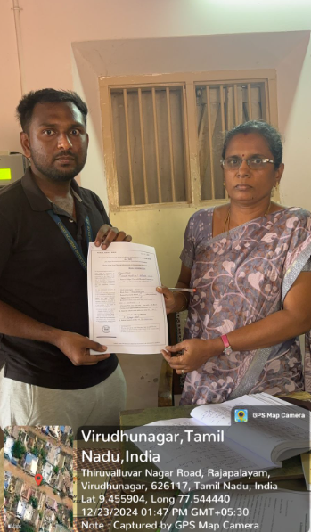
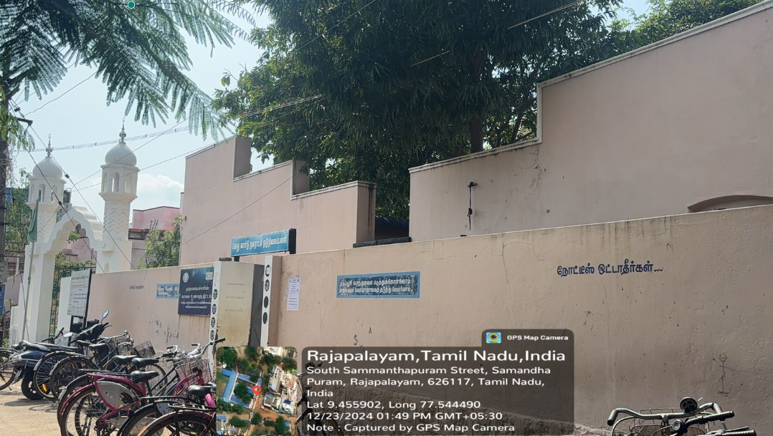
1.1 Rajapalyam[8 Ward Municipal Middle School, Rajapalayam Municipality]

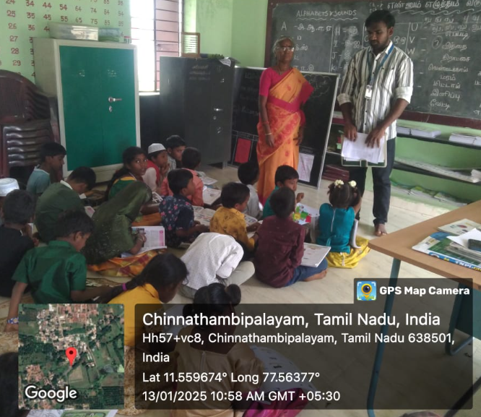
1.2 Erode [Panchayat Union Primary School, Chinnathambipalayam.]
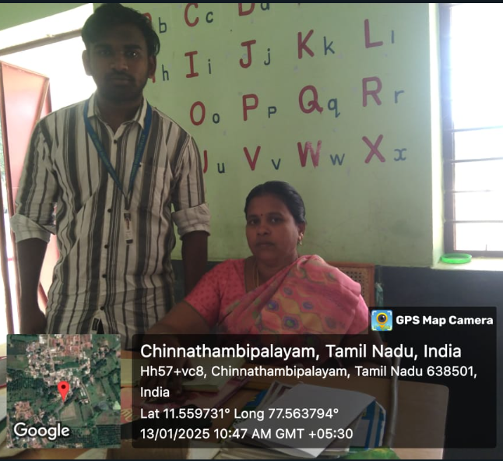

- KARNATAKA
Three schools in the state of Karnataka have been surveyed, and the photos taken during the survey are herein attached below.

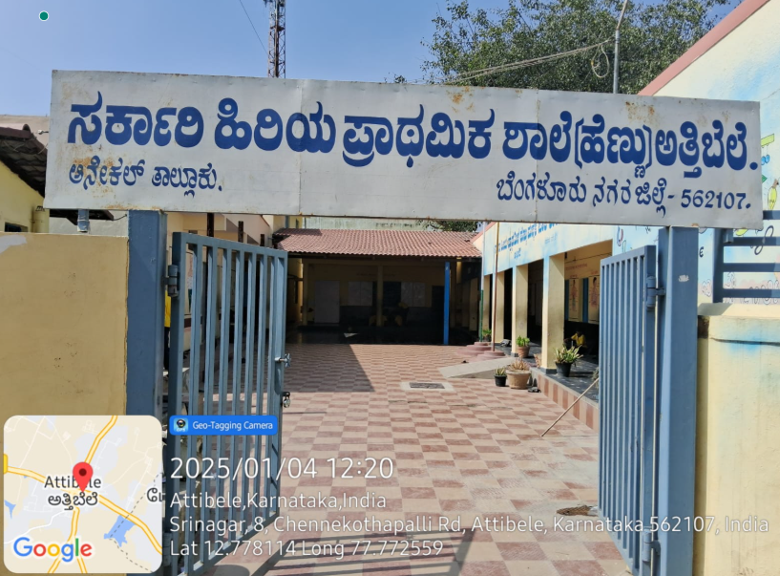
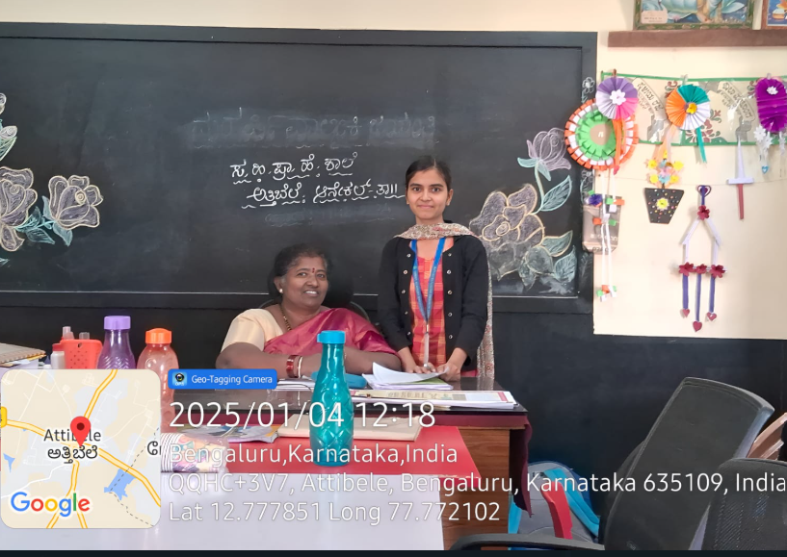
2.1. Attibele [Government Higher Primary (Girls) School, Attibele.]

2.2. Anekal [Government Higher Primary School, Gudhatti.] CLICK VIDEO
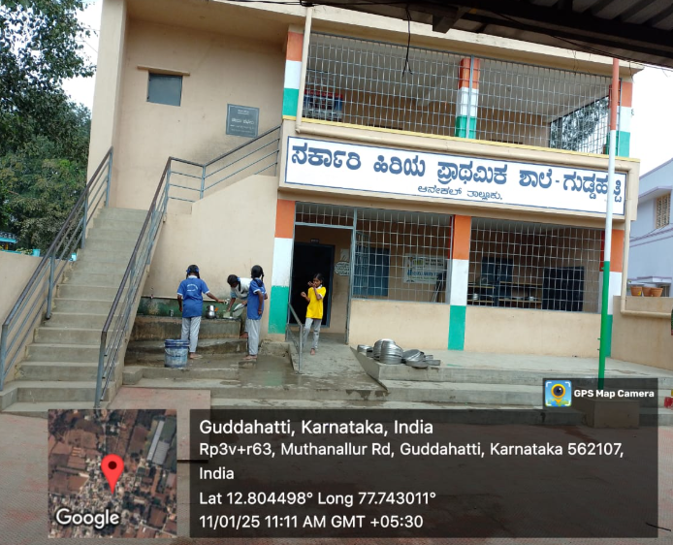
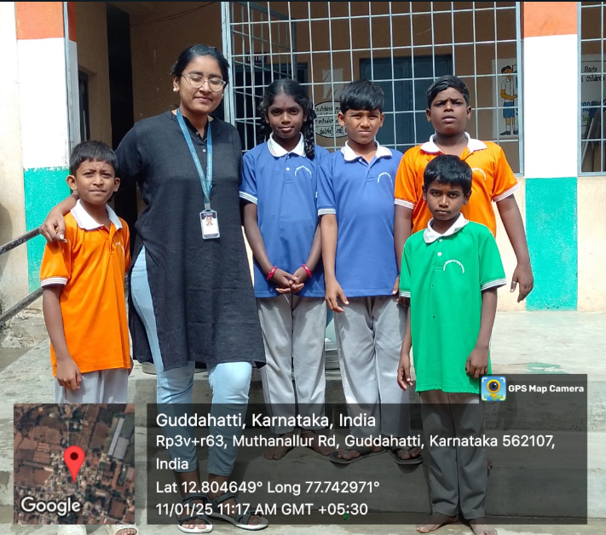

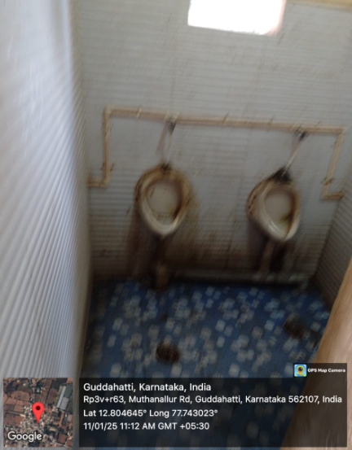
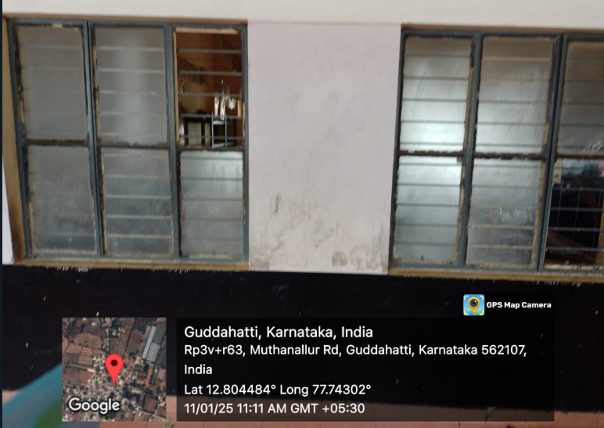

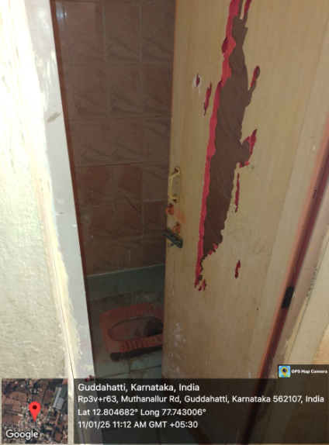
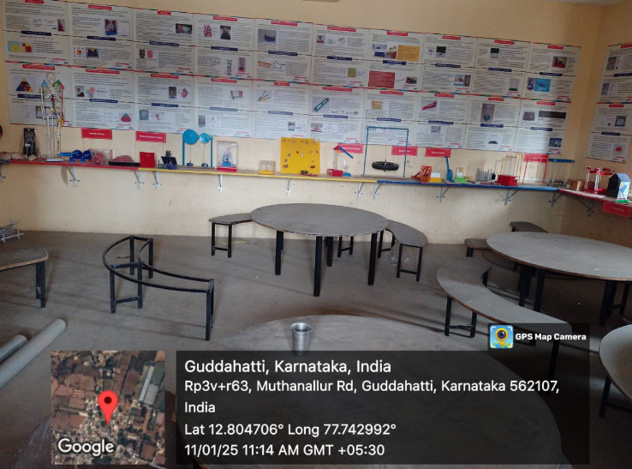

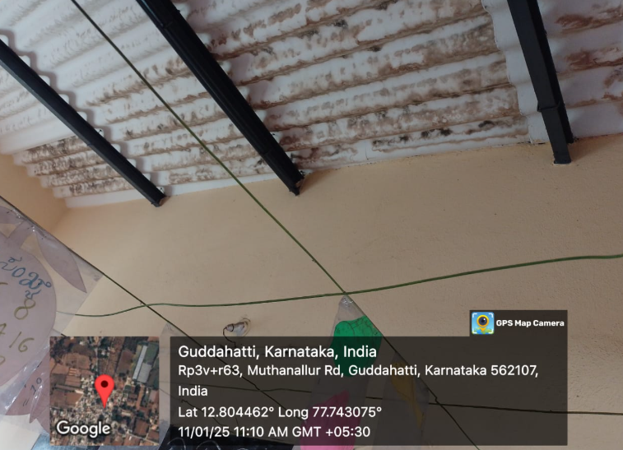
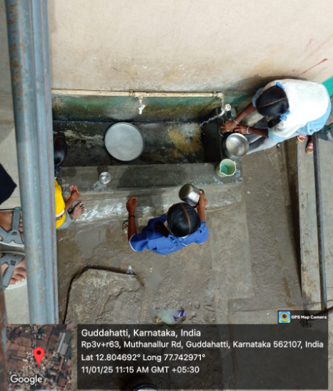
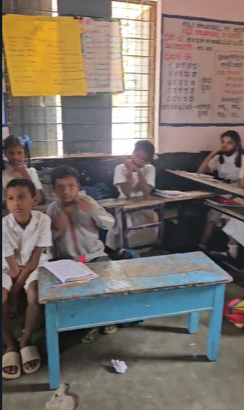
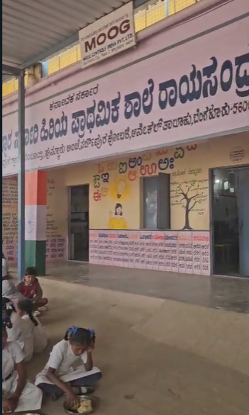
2.3 Rayasandra [Government Higher Primary School, Rayasandra] CLICK VIDEO

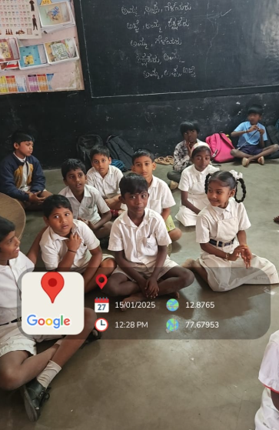
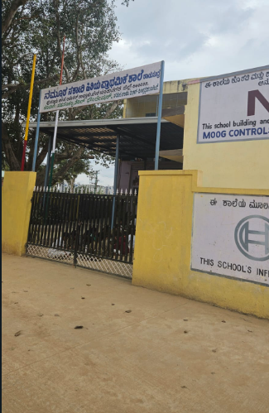

3. ANDHRA PRADESH
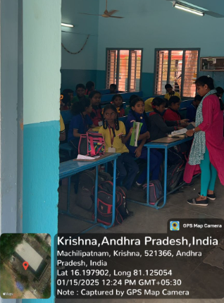
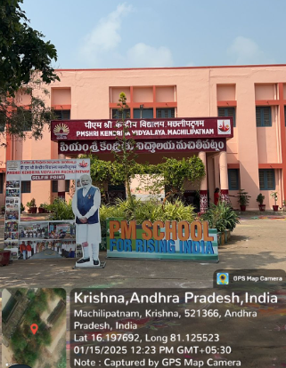
3.1 MachiliPatnam[Kendriya Vidyalaya, Machilipatnam]

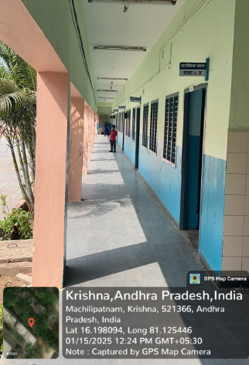
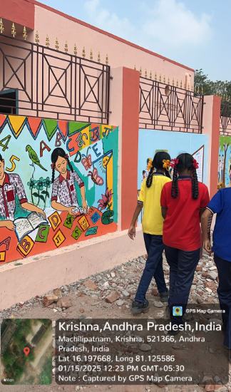

3.2 NTR Dictrict [ Zilla Parishat School, Vijayawada]
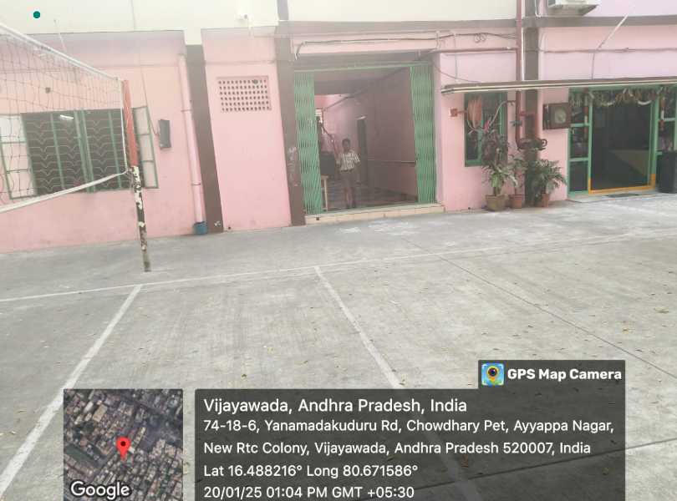
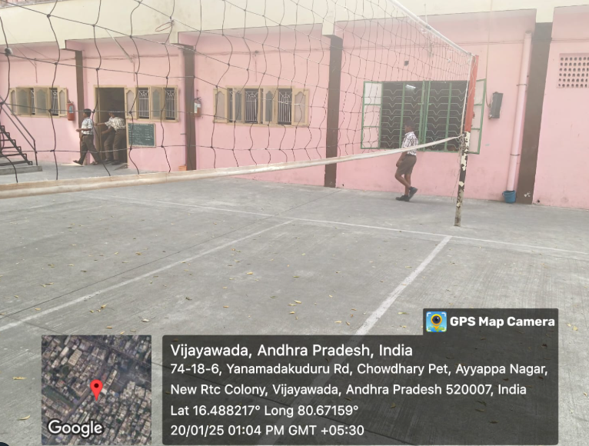

INDIA CONST. art. 21A, amended by The Constitution (Eighty-sixth Amendment) Act, 2002.
UDISE⁺, https://udiseplus.gov.in/#/en/page/publications (last visited Jan. 11, 2025).
Unified District Information System for Education Plus (UDISE+). Annual Report on School and Management Categories. Ministry of Education, Government of India, 2023–2024.
TABLE 5.1
ANNEXURE-2
ANNEXURE-2
TABLE 3.1
ANNEXURE 1.
Dr. Manveer Singh, Research of Implementation of Right to Education for Free and Compulsory Education, 5, IJRSML, 28, 33 (2017).
Article 21A. Right to education The State shall provide free and compulsory education to all children of the age of six to fourteen years in such manner as the State may, by law, determine.
Ministry of Education, Government of India. "Right to Education." https://www.education.gov.in/rte#:~:text=The%20Right%20of%20Children%20to,satisfies%20certain%20essential%20norms%20and.
Ashok Kumar Thakur v. Union of India, AIR 2008 6 SCC 1
Avinash Mehrotra v. Union of India, AIR 2009 6 SCC 398
Table 3.1
ANNEXURE 2, 2.2. Anekal [Government Higher Primary (Girls) School, Attibele.]
The Right to Education Act, 2009, Government of India, Act No. 35 of 2009, Section 3. This section mandates free and compulsory education for children aged 6 to 14 years.
National Policy on Education, 1986, Ministry of Education, Government of India.The NPE 1986 laid the foundation for universal education and addressed strategies for improving accessibility and quality.
Constitution of India, Article 21-A. The 86th Amendment to the Constitution of India in 2002 incorporated the Right to Education as a fundamental right, making it mandatory for the state to provide free and compulsory education to children.
Constitution of India, Article 21-A, 86th Amendment Act, 2002. Article 21-A guarantees free and compulsory education to children aged 6 to 14, making education a fundamental right.
Table 3.1
Table 3.1
Table 3.1
Table 3.1

