TEAM CODE 003
2ND NLUJ RIGHT TO EDUCATION PAPER PRESENTATION & DISCUSSION SERIES

RTE ACT: IS QUALITY EDUCATION A DISTANT DREAM?

ABSTRACT

The Right to Education (RTE) Act, 2009, was enacted to ensure free and compulsory education for all children aged 6 to 14 years in India, laying the foundation for an equitable access to elementary education. This study critically analyses the compliance of RTE norms by primary and upper primary government schools in urban, semi-urban and rural areas, focusing on key provisions such as infrastructure, pupil-teacher ratio, quality of education, student enrolment, and the comparison of educational standards in Tier-1, Tier-2, and Tier-3 cities. The research adopts a ground-level approach, conducting in-person surveys in government schools to evaluate their adherence to RTE guidelines.

The study highlights disparities in the implementation of RTE provisions, particularly in resource-constrained regions. While many schools exhibit compliance with fundamental aspects like enrolment and basic infrastructure, significant gaps remain in areas such as teacher-pupil ratios, availability of libraries, playgrounds, or even the basic environment to support the child’s education. The survey has noted several problems encompassing those related to low enrolment rates because of lack of formal documents like Aadhar Card, unavailability of safe drinking water, shortage of teaching and non-teaching staff in schools and many more.

This paper underscores the urgent need for targeted policy measures to address the identified disparities. Though the problems require a comprehensive and well executed approach, the team suggests a few inclusions like equipping the schools with sufficient resources to ensure regular maintenance of washrooms, libraries, playgrounds and other such facilities. By undertaking a thorough analysis of the schools’ compliance with RTE norms, this study contributes to reveal the ground realities of the government schools, the problems faced by them and provides actionable solutions for policymakers and analysts to bridge the existing gap.

- INTRODUCTION & SIGNIFICANCE OF THE SURVEY-REPORT

"Education is the most powerful weapon which you can use to change the world." Nelson Mandela
Education is a vital enrichment of a person’s mind, tailored through learned experiences. It is one of the most vital aspects of human lives that not just empowers the individual but also brings in societal development and economic progress. It is of no doubt that education is not a privilege, rather a fundamental right; an educated citizen is capable of making informed decisions, enjoying prosperity and educating others as well. One of the most fulfilling ways to escape poverty is through education; for a learned man can implement his knowledge and skills. Moreover, education fosters social equality by bridging gaps across economic and social classes, offering everyone an equal opportunity to learn, grow and succeed, regardless of their background. As a fundamental right, education is a binding commitment from the government to ensure access to quality education by all the people, regardless of their socio-economic status.
The evolution of education policies in India culminated in the enactment of the Right to Education Act of 2009, marked by several historical milestones, legislative changes and socio-political influences. Tracing its history from the colonial period, the first hands-on intervention of the State in education was via the Charter Act of 1813 which introduced Western education however simultaneously it also systematically marginalized indigenous systems. This was followed by the constitution of the Hunter Education Commission of 1882-83 which focused on primary education and local self-government for schools, thus opening education to a larger section yet not changing the prevalent social stratification. Post-independence, issues with literacy and accessibility plagued India and following the leadership of Maulana Abul Kalam Azad, the first Minister of Education, efforts were made to establish a unified national educational framework. The Kothari Commission (1964-66) called for equal educational opportunities and laid the groundwork for future policies. National education policies further shaped the system, with the First National Policy on Education (1968) advocating free and compulsory education up to age 14 and emphasizing regional languages and teacher training. The Second National Policy on Education (1986), formulated under the aegis of Prime Minister Rajiv Gandhi, aimed to address disparities in access and quality while promoting inclusivity which was enhanced by subsequent amendments such as in 1992. The constitutional framework also played an important role in this regard and with insertion of Article 21A through the 86th Amendment (2002) into the Constitution, education became a fundamental right for children aged 6 to 14 years. This amendment was pivotal in framing the RTE Act, which came into effect on April 1, 2010.

The main objective of the RTE Act, 2009 is to provide free and compulsory access to elementary education to all children aged 6 to 14 years. This implies, no child shall be liable to pay any kind of fee or charges which prohibit him from pursuing and completing their elementary education (this excludes a child who has been admitted by his parents to a school which is not supported by the appropriate government). The Act also creates a duty for the appropriate government to ensure admission, attendance, and completion of elementary education by all children from 6 to 14 years. The Act revolves around a student-centric approach where it clearly prohibits any physical punishment or mental harassment on the child, provides for a curriculum which ensures all-round development of the child, and brings the child out of any potential fears, trauma or anxiety; all of this can be achieved through a child friendly learning system.

2. RESEARCH METHODOLOGY AND LIMITATIONS OF STUDY

This study examines the implementation and challenges of the Right to Education (RTE) Act through a field survey conducted in schools. A qualitative and quantitative research approach was adopted to gather data, ensuring a comprehensive understanding of the issue. The primary data collection method was a structured survey administered directly in schools.
Data was collected through in-person visits to schools. The members sought answers to the questions in the questionnaire and other relevant information related to the school’s overall infrastructure, educational facilities, teaching resources and compliance with the RTE norms.
A stratified random sampling method was utilized, and data was collected from schools in urban, semi-urban, and rural areas. The data obtained through surveys was also supplemented through personal interviews and observational notes taken during field visits, ensuring a holistic understanding of ground realities. For personal interviews, ethical considerations were prioritized and informed consent was obtained from the participants, ensuring confidentiality.

The scope of this study has certain limitations which are being discussed here. Firstly, the survey was restricted to primary and primary with upper primary schools only, potentially narrowing the inclusivity and sample space for interpretation. Furthermore, the period for data collection was interrupted by the schools’ winter break, limiting our access to the schools. Additionally, the survey relied on certain predetermined questions, which, though set a specific theme for the study, also left scope for interpretation of other relevant themes. The reliance on field surveys posed logistical challenges for our members and this may have introduced biases due to respondent availability and willingness to participate over different areas. Lastly, the exclusive focus on the Right to Education (RTE) Act analysis limited the scope of the study, potentially overlooking broader educational dynamics and scope for further research in such government schools. These limitations highlight areas for further research and explore the themes and topics not discussed in this study.

3. FACTS & FINDINGS
The ‘Right of Children to Free and Compulsory Education Act, 2009’ (RTE Act) draws its power from Articles 29 and 30 of the Indian Constitution i.e., fundamental rights which talk about ‘Protection of Interests of Minorities’ and ‘Right of Minorities to Establish and Administer Educational Institutions’. As such the Act stipulates rules that schools have to adhere to, these cover diverse aspects including (but not limited to) right to free and compulsory education, 25% of the class population to be children from weaker section [Sec12 (1)(c)], infrastructure including school building and learning equipment (Sec 8 & 9), a playground, a kitchen for cooking mid-day meal, Teacher-student ratio and other essential amenities.
The survey reports attached help us in navigating the gap between the statutory rules and reality of various societies in regards to government-run educational institutions. Our surveyors have diligently collected diverse data and accounts from schools across states and regions of the country. This was done in order to substantiate our research by complying to empirical standards as accurately as possible and also that the quality of education and the comprehensive institutional environment differs substantially between villages, Tier 3, Tier 2, Tier 1 and Metropolitan cities despite being run by the government. This attribute is not in relation to the government running the state, rather the same phenomenon could be observed within the same state.’
The following table showcases the schools that were surveyed by the team, which shall be referred to in detail and critically analysed.
Code name | Primary School | State
S1 (i) | Gaya Survey (Katari) | Bihar
S1 (ii) | Gaya Survey (Gewalbigh) | Bihar
S2 | Sirsa Survey | Haryana
S3 | Khodna Khurd Survey | Ghaziabad (UttarPradesh)
S4 | North West Delhi | New Delhi
S5 | Ghaziabad Survey | UttarPradesh
S6 (i) | Unnao Survey | UttarPradesh
S6 (ii) | Lucknow Survey | UttarPradesh
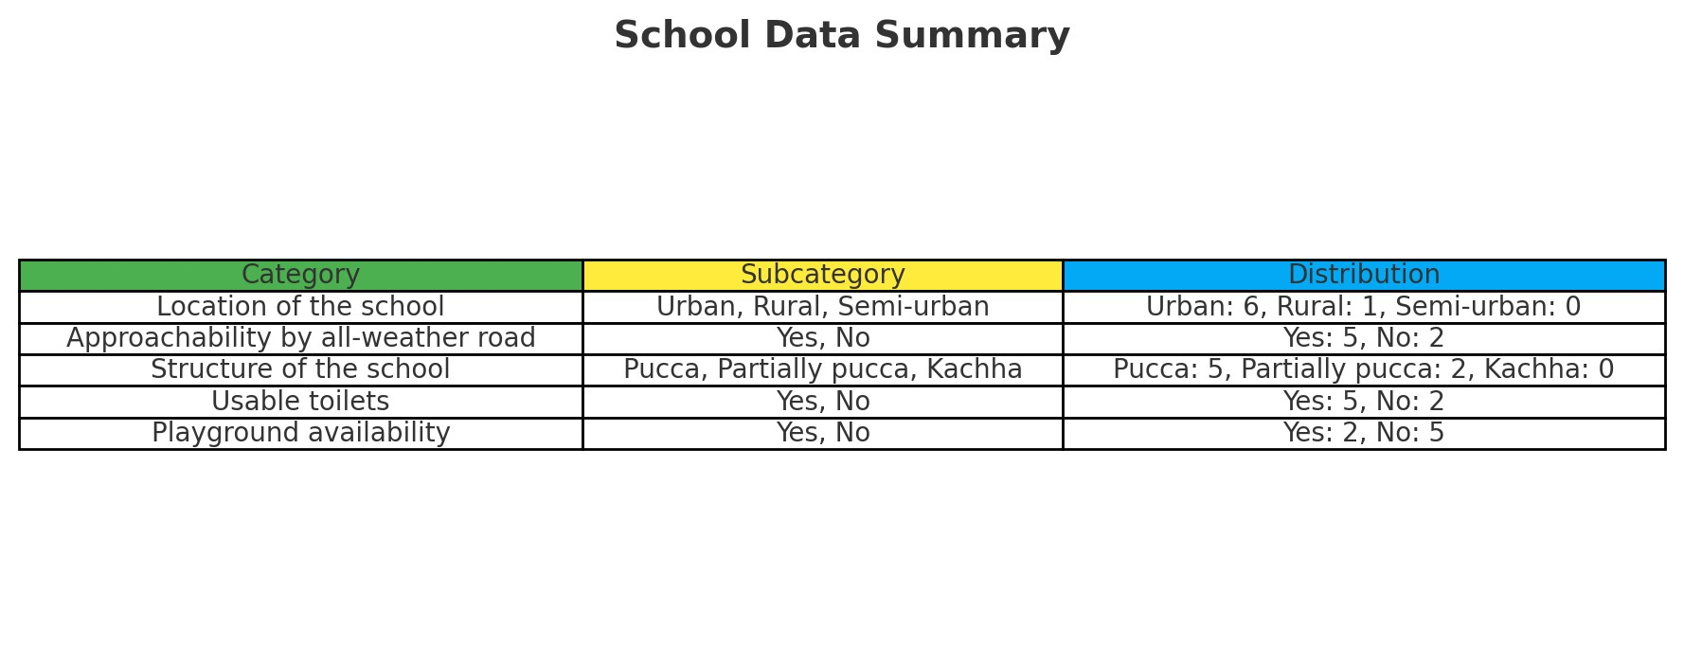
Central to the legislative framework of the Act are Sections 8(d) and 19, emphasizing on the importance of infrastructure and adherence to prescribed norms. Section 8(d) mandates the government to provide adequate infrastructure, including school buildings, sufficient teaching staff, and learning equipment, creating an environment curated to foster learning. Section 19 further requires all schools to comply with the standards detailed in the Schedule of the Act pertaining to durable, all-weather buildings, a sufficient number of classrooms, safe drinking water, separate toilets for boys and girls, libraries, playgrounds, and boundary walls. Schools failing to meet these norms risk losing recognition, underlining the Act’s commitment to maintaining quality standards. However, contrary to the ambitions etched into the Act, the implementation of these norms varied widely across schools in different regions.

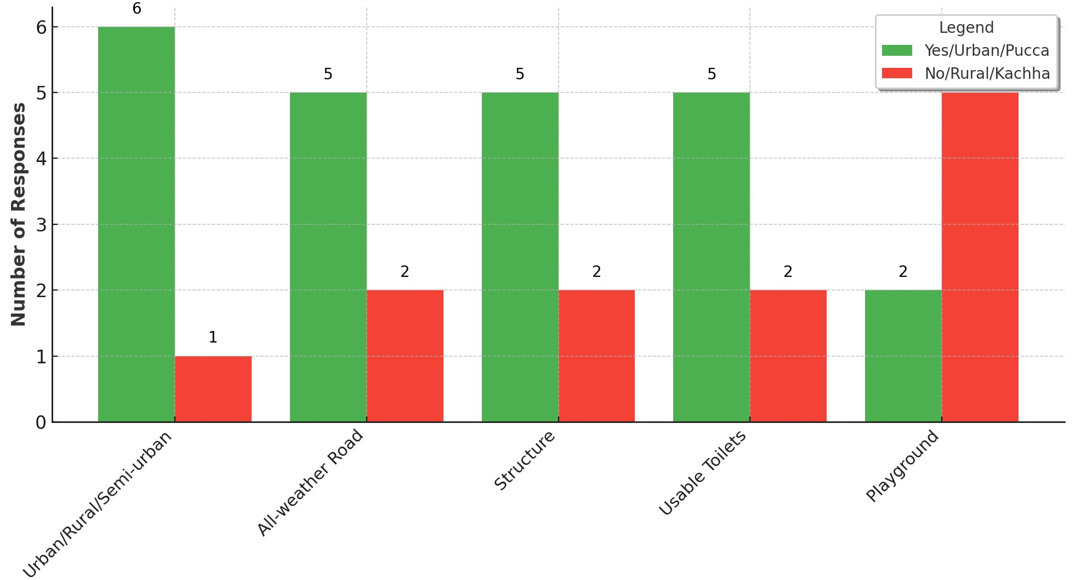

3.2 Pupil-Teacher Ratio

Section 25 of the RTE Act, 2009, concerns the Pupil-Teacher Ratio standards in schools. It says that for primary schools, the ratio is set to 1 teacher for every 30 students, and for upper primary schools, it gives the criteria of 1 teacher for every 35 students. The ratio ensures that every student gets adequate attention.
The survey findings of the primary schools done by the team members about the Pupil- Teacher Ratio are as follows:
STATE | SCHOOLS | PTR | REMARKS
Bihar | Gaya (Katari) S1 (i) | 49:1 | Severely Overcrowded
Bihar | Gaya (Gewalbigh) S1 (ii) | 23:1 | Satisfactory
Haryana | Sirsa S2 | 30:1 | Compliant
New Delhi | North West Delhi S4 | 38:1 | Overcrowded
Uttar Pradesh | KhodnaKhurd S3 | 26:1 | Satisfactory
Uttar Pradesh | Unnao S6 (i) | 21:1 | Adequate
Uttar Pradesh | Lucknow S6 (ii) | 62:1 | Critically Overcrowded
Uttar Pradesh | Ghaziabad (Vaishali Shetra) S5 | 96:1 | Extremely Overcrowded
From the survey data for the Pupil-Teacher Ratio in the primary schools of the states of Bihar, Haryana, and Uttar Pradesh, it is evident that a lot of variance exists on the very face. While the school in Katari, in Gaya district of Bihar has a 49:1 ratio, in the same state and district, another school in Gewalbigh has its PTR to a satisfactory limit of 23:1. This is in terms of student perspective that is juxtaposed to other sides of views when we see it in terms of the total number of teachers present in that particular school. It reveals latent facts about the severe shortage of teachers. As we observed from the data obtained during the survey, we find that the total number of students present in S1 (i) survey is 153 and the number of faculties count to only 4. It means that for one teacher school has the ratio of 38 students per teacher. That completely contrasts with the facts of PTR at primary and upper primary level. In Uttar Pradesh, the picture is mixed: KhodnaKhurd has a very satisfactory PTR of 26:1, Unnao had an adequate PTR of 21:1, while Lucknow and Ghaziabad are at very critical levels with the PTRs of 62:1 and 96:1, respectively, indicating severely to extremely overcrowded. This data underlines the need for some targeted interventions to have balanced pupil-teacher ratios and improve the quality of education.
The PTR criteria is very crucial for the growth of a satisfactory school climate and for both the teachers and students. When the PTR is lower, the teachers can provide more individualized and personalized attention to each student, meeting their specific learning needs and further helping and assisting them in better understanding ideas. Students' academic performance and overall personality development can be greatly improved by this individualized approach. This implies that teachers can better control their workload, lower their stress levels, and prevent burnout with a manageable PTR. It, thus, results in increased teaching efficacy and job satisfaction, which in turn also helps to create a more stable and driven teaching workforce.
The surveys of the upper primary schools done by the team and their findings about the Pupil-Teacher Ratio are:
SCHOOLS | PTR | REMARKS
Gaya (Katari) S1 (i) | 22:1 | Satisfactory
Gaya (Gewalbigh) S1 (ii) | 15:1 | Adequate
Ghaziabad (Vaishali Shetra) S5

4. MAJOR ISSUES IN IMPLEMENTATION
The reality of the implementation of this act in India is a far grimmer reality than the one painted by its declared ideals, which we hope to illustrate through our surveys and pre-existing research.
4.1 Infrastructure, Facilities & Staff
During the course of our research, our team found out that their surveyed government schools face significant challenges in providing quality education due to inadequate infrastructure and high pupil-teacher ratios. Many schools, particularly in economically-weaker areas, lack basic amenities like clean water, sanitation, and electricity, hindering conducive learning environments. The availability of resources like computers and libraries also varies significantly, creating disparities in access to quality education. Furthermore, high pupil-teacher ratios, often exceeding recommended norms, limit individual attention and hinder effective teaching-learning processes. This is exacerbated by teacher shortages, particularly in rural areas, and an uneven distribution of qualified educators. These issues not only impact learning outcomes but also contribute to increased dropout rates and exacerbate educational inequalities across different socioeconomic groups and regions. An example from our research shows that the student-Teacher Ratio in the Lucknow District survey was totalled to be 1:62, an abysmal violation of the required RTE ratio of 1:30 or 1:35. (Annexure S6 (ii))
The following findings have also been corroborated by other national studies, such as the recent data set released by the Unified District Information System for Education (UDISE+) which revealed that of the over 14.71 lakh schools in India, up to 1.52 lakh schools have no functional electricity. Further, the report says 67,000 schools operate without functional toilets, of which a majority (46,000) are government schools operating without functional toilets; While the latter may be a small number to some, the lack of such basic necessities not only deter potential students from enrolling, but also actively put in danger the health of the attending students.
The problem with Government School infrastructure simply doesn’t end with the supply, or lack thereof, of vital utilities but is further extended to the very campus that the students are kept within during their schooling hours. During the questionnaire period, our researchers were disheartened to find tin-roof, fungi-stained walls and abandoned school buildings with no substitute available in sight despite repeated promises of fundings. Further inside, the classrooms were filled with broken furniture, or simply torn mats, and inadequate educational technology. (Photographic Evidences taken from Government Schools in Gaya, Bihar and Unnao District, UP attached under annexures P1, P2, P3, P4, P5, P6, P7, P8)
‘There cannot be any school without a playground. Even the students who study in such a school are entitled to a good environment.’
On the extracurricular front, the honourable Supreme Court set aside a 2015 ruling by the High Court of Punjab and Haryana which allowed encroachment upon the land meant for a school playground in a Haryana Gram Panchayat; The above quote is by the SC bench of Justices M R Shah and B V Nagarathna, who utilised this judicial event beautifully by choosing to advocate for the rights of children. However, their efforts seem to be falling on deaf ears, with students having to make do with narrow lanes instead of the sprawling playgrounds in the privilege of many others. (Annexure P4)
These infrastructural issues can lead to an overall impact of the quality of education provided to the students, who are then ultimately being robbed by a larger machine from being given the same chance at academic and extra-academic opportunities due to their educational background.
Further research on the Indian schooling system in recent years, with a report on the condition of Government Schools of Dadra and Nagar Haveli, presented that over 50% of the school buildings the students were being taught in were either Kuccha Buildings or Buildings Under Construction. Even during the course of our results, one of the schools from UP were found to be conducted within under-constructed buildings, such as computer labs being held in abandoned rooms with no provisions of computers or assisting technology, with seemingly no utilization of the allocated budget in sight! (Annexure P9)
4.2 T1 vs. T2 vs. T3 and State Vs. Centre
The rural- urban divide is a concept that can be pointed out by a child, in relation to their observable environment and culture. However, one thing to acknowledge is that the state of government schools differs considerably across villages, Tier 3, Tier 2, Tier 3 and metropolitan cities across the country, i.e., the state of the school and its running is heavily influenced by the overall environment of the region or area it is situated in or is a part of.
Besides the available surveys, this report tried to delve deeper into the realm of equity through available online resources. The factors such as class size and population of the area play a significant role in the overall functioning but it has been observed that the overall idea of an institution that caters on the basis of equity often diminishes in this respect. Starting with accessibility to schools is one respect to be considered, Metropolitan and Tier 1 & 2 cities are well equipped with roads that remain operational through all weathers and even if a discrepancy arises, they are made functional within a few days at maximum in light of the continued movement of large populations. Whereas, roads in most villages and Tier- 3 cities that make up for 71.4% (2019) of road network are muddy, poor quality and riddled with potholes, which in a tropical country like India with heavy rainfall data disable transport or movement for the students, who often have to travel to other villages or Tier 3 cities.
Secondly, Major Metropolitan cities and Tier-1 cities in India often have operations by various NGOs which cater to the needs of the students from poorer sections. The best example would be ‘Teach for India’ which runs widespread operations in 8 cities of India including Delhi. The said NGO works directly with the government schools by sending fellows to equalise the Pupil-Teacher ratio and add on to the manpower of overcrowded schools. These fellows and volunteers are equipped with funds from the organisation to build on the learning material like charts and experiments that facilitate learning for students and also provide with stuff like stationery and counselling. The program also caters to the emotional needs of the students by bringing in more fellows and volunteers who can focus on a group of 4-5 children and understand their problems and facilitate their academic journey.
However, most of the NGOs despite starting work in villages do not cater to many of the needs as mentioned above, for the fellows and volunteers willing to work in these impoverished areas are very few, those volunteers who are from the same place often run out of funds and would have to return back to their other commitments such as family. Even programmes that are taken up are conducted to promote awareness through organisations like ‘Child Rights and You’ and ‘Kailash Satyarthi Foundation’.
Thirdly, young students from Tier 1 and Metropolitan cities have easier access to a variety of learning material be it through various newspapers, magazines, museums, internet and exposure through various events that take place in these hubs of activity to gain worldly knowledge. Villages and Tier 3 cities lack considerably in terms of access to worldly knowledge and opportunities like SUPW (Socially Useful Productive Work), learning material like books. It is not that the latter are completely devoid of resources rather that the availability and awareness is known to few.
4.3 Difficulties in Enrolment
The mandatory submission of Aadhaar cards for student enrolment in Indian government schools has created significant hurdles, impacting access to education.
One major challenge arises from discrepancies in data. Mismatches in names, dates of birth, and other personal details between school records and Aadhaar information can lead to delays and denials of admission. This is particularly problematic for children from marginalized communities who may have limited access to official documentation or face difficulties in rectifying errors in their Aadhaar details. Furthermore, lack of Aadhaar coverage among certain sections of the population, particularly in remote and rural areas, poses a significant barrier to enrolment. Obtaining an Aadhaar card can be a cumbersome process, requiring parents to travel long distances, stand in queues, and navigate complex procedures. This can be particularly challenging for parents from low-income households who may have limited time and resources.
Despite repeated clarifications by Government authorities that the Aadhar card need not be made a mandatory part of the admission process, The continued emphasis on Aadhaar for school enrolment can also lead to the exclusion of children from vulnerable groups, such as undocumented migrants, refugees, and children from nomadic communities. These children may not possess Aadhaar cards due to their marginalized status, denying them access to basic education. Moreover, the reliance on Aadhaar for school enrolment can raise concerns about data privacy and security. Linking sensitive personal information of children to a centralized database raises concerns about potential misuse and breaches of privacy.
These challenges highlight the need for a more nuanced approach to student enrolment. While Aadhaar can be a valuable tool for identifying and tracking students, it should not be the sole criterion for admission. Alternative forms of identification, such as birth certificates or ration cards, should be considered as valid proof of identity.
During personal interviews conducted with the staff of the surveyed government school in Gaya district of Bihar (Annexure S1(i)), our researchers found an interesting discovery: A significant barrier for poor families obtaining Aadhaar cards stems from the lack of essential documents like birth certificates. Many children, especially those born in rural areas or to marginalized communities, are not registered at birth, leaving them without official proof of their existence. This lack of a birth certificate creates a cascading effect, making it extremely difficult to obtain other crucial documents, including Aadhaar cards. Without these documents, accessing essential services like education, healthcare, and government benefits becomes a major challenge, further exacerbating the cycle of poverty. This highlights the urgent need for improved birth registration services, especially for vulnerable populations, to ensure that all children have access to their fundamental rights and can fully participate in society.
4.4 Analysis
Thus, one can analyse through the above frontiers that a critical lacuna in the implementation of the RTE Act, 2009 lies in inadequate monitoring and maintenance of these government schools and improper checks on the returns of the allocated funds, leading to disparities in infrastructure, teacher quality, and access to quality education across regions. Furthermore, implementation gaps are evident in areas like teacher training, ensuring inclusive education for children with disabilities, and addressing the needs of marginalized communities. The focus often remains on achieving enrolment targets, while quality of education, measured by learning outcomes, remains a major concern.
Weak monitoring and evaluation mechanisms hinder effective implementation and accountability. This, perhaps even coupled with political interference and bureaucratic hurdles, further hampers the realization of the RTE Act's objectives. These shortcomings necessitate a multi-pronged approach involving increased government funding, strengthened teacher training, improved infrastructure, and robust monitoring and evaluation systems to ensure equitable and quality education for all children.

5. Suggestions, Recommendations and Conclusion
The education system, like any other machinery, has its shortcomings, as evident through the findings of our study. Thus, in such circumstances, it is necessary to identify the means through which these shortcomings can be addressed.
A key issue is the admission process itself: In one of the personal interviews conducted with the headmaster of a primary school (Annexure S1(i)), our researchers discovered that several pupils faced issues in enrolment due to their Aadhaar cards. While the value of the Aadhaar as proof of identity cannot be undermined, it is necessary to realize that a majority portion of the demographic of pupils in government-run primary schools comprises children below the poverty line (BPL), who often face issues in producing valid Aadhaar cards.
Considering their precarious position, our team emphasizes the responsibility of the state in providing for such children. The state must take active steps to ensure that children who approach schools for admission and face issues with proof of identity are provided for by the state machinery, that their issues are resolved timely, and that they get a fair chance at education as anyone else.
Immediate actions should be taken to provide safe drinking water. This can include the installation of water purification systems or filters in schools to remove harmful contaminants like arsenic. The presence of arsenic in groundwater necessitates urgent and sustained efforts to ensure safe drinking water, including regular monitoring, water treatment solutions, and public health interventions to mitigate its adverse effects. Addressing this issue is critical to safeguarding the health and well-being of communities reliant on groundwater for their daily needs. Portable water filters or centralized purification systems can be effective solutions. In Bihar, the government initiative to provide every house with one tap water supply under the Har Ghar Nal Jal scheme provides effective running tap water supply to every house, including government schools, every day, for a particular hour of the day.
However, only one tap cannot ensure the availability of water throughout the day, so it is the responsibility of the state and the concerned department to ensure water storage provided under the scheme by providing sufficient funds for the same. Moreover, implementing rainwater harvesting systems can provide a sustainable source of clean water, provided states provide funds for the required system and regular water quality tests are conducted to monitor and ensure the safety of the water supply. For long-term solutions, investing in groundwater recharge projects can help replenish aquifers and improve the overall supply. These projects might involve creating recharge drought rivers or ponds to allow water to percolate into the ground.
To address the critical issue of teacher and non-teaching staff shortages in Tier 3 government primary and upper schools, it is essential to implement several strategic measures. Firstly, there should be a concerted effort to not only recruit and retain qualified teachers but also to periodically check up on the condition and needs of teachers. This can involve offering competitive salaries, benefits, and professional development opportunities to attract and motivate talented educators. In Uttar Pradesh and Bihar, our survey conductors discovered a unique problem that was personally shared by the teachers of government schools. They informed them that they faced significant difficulties in receiving salaries on time, as they had to circle the department for three months to receive their one-month salary, which compromises student education. Besides, they sometimes had to contribute money to install ceiling fans in summers. Additionally, it is crucial to reduce the administrative and non-teaching workload of teachers, allowing them to focus on delivering quality education according to the syllabus. Administrative tasks can be delegated to non-teaching staff, whose roles should be clearly defined.
By addressing these issues, we can create a more conducive learning environment that prioritizes the educational outcomes of students in Tier 3 government primary schools. Studies have shown that Delhi, Kerala, Tamil Nadu, and Nagaland operate at relatively efficient frontiers compared to states like Uttar Pradesh, Bihar, Madhya Pradesh, and Odisha. The same studies have indicated that efficient allocation of resources can help bridge this gap. In the surveys, one of our researchers (Annexure S1(i)) has revealed that while funds are allocated to the schools in a timely manner, the distribution of those funds is delayed to a large extent. This leads to stagnation in the development process, which in turn prejudices meaningful educational outcomes. Further, in comparison to Tier 1 states, which fare quite well in terms of infrastructural provisions, Tier 3 states face issues with water supply, electricity, benches, effective utilization of available space, maintenance of washrooms, playgrounds, libraries, etc. While in certain cases, it is a product of a faulty internal administrative machinery, at other times, it is plainly due to a lack of funds available to the state to implement reforms. In such cases, a recognition of the role of non-state actors in infrastructural development can help.
Involvement of non-state actors and private sector entities can expand opportunities for educational reforms. Private initiatives in India's school reform have improved access, equity, and equality for disadvantaged children. In a comparison between a private CSR initiative-aided and non-aided government schools, our researchers have revealed huge discrepancies in terms of facilities available to the students. CSR initiatives have been shown to significantly impact learning outcomes in primary education. For instance, ITC Limited's CSR activities have demonstrated a positive effect on the learning outcomes of primary school students in rural areas of India. CSR funding in education is also linked to broader sustainable development goals in India and the fulfilment of the vision of the RTE Act. Investments in education through CSR are seen as vital for economic growth and poverty reduction, supporting the achievement of Sustainable Development Goal 4, which aims for quality education for all. In light of these findings, promotion of state initiatives such as active preparation and release of lists of schools in need of help can also allay the infrastructural limitations. The state should take proactive measures to align its policies with current empirical research and ensure that its education model is developed in a holistic manner.
Finally, addressing the infrastructure issues in government primary and upper primary schools in Tier 3 states requires a strategic and multifaceted approach. Although significant efforts have been made since 2005, it is evident from the ground reality that the infrastructure remains insufficient, particularly when primary schools are converted to include upper primary students without adequate facilities. On-ground surveys observed that in Bihar, government primary schools are intentionally and deliberately affiliated with upper primary schools, which themselves are not sufficient to serve primary schools. To improve the situation, it is crucial to provide dedicated infrastructure that meets the needs of both primary and upper primary students. This includes constructing new buildings with sufficient classrooms, separate science and computer labs, a library, and well-maintained playgrounds, which are severely lacking in schools in Bihar. Focus should be on renovating existing structures, rather than demolishing them, to preserve resources and ensure safety, as observed by one of our surveyors in Uttar Pradesh (Annexure S6). Implementing regular maintenance programs and quality checks can prevent further deterioration.
In contrast to Bihar, where schools often have only 4-5 rooms, including unsafe kachha buildings (Annexure S1(i) and S(ii)), a model similar to Delhi Tier 1 government schools should be adopted. These schools were found to have a number of classrooms with dedicated classrooms per teacher, something which is very conducive to a productive learning environment (Annexure S4). Other than the composite grants the government provides to schools for one financial year for developmental work, funds should be allocated specifically for infrastructural development, ensuring that resources are used efficiently and transparently. Specific funds should also be provided to schools to ensure separate toilets for girls and boys, an aspect that was missing in one of the schools surveyed. Collaboration with local communities and non-governmental organizations can also help mobilize additional support and resources.
To conclude, the RTE Act represents a significant step towards ensuring quality education for all children in India. However, realizing its full potential requires a concerted effort from all stakeholders. By focusing on improving the quality of education, addressing the needs of marginalized children, and strengthening the implementation mechanisms, India can pave the way for a future where every child has the opportunity to reach their full potential.

ANNEXURES

PHOTOGRAPHS

P1
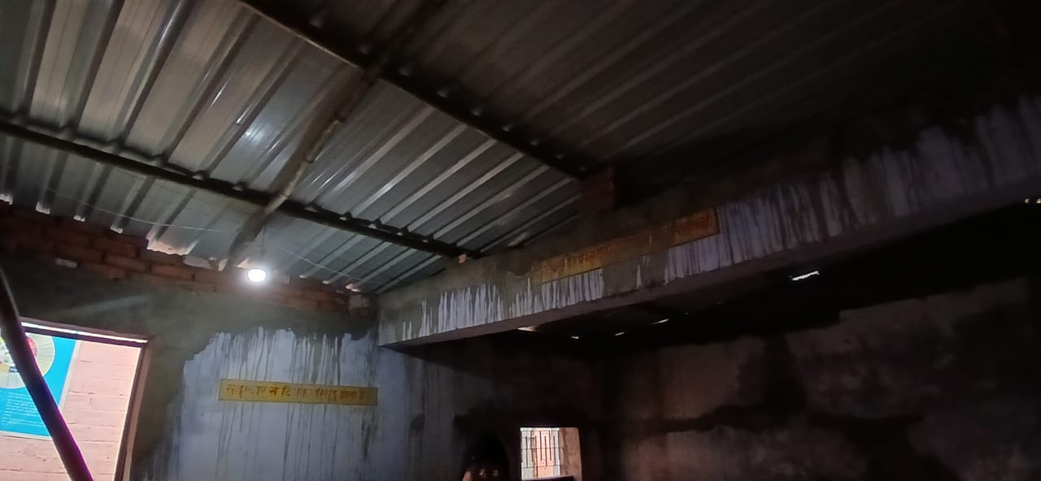
P2
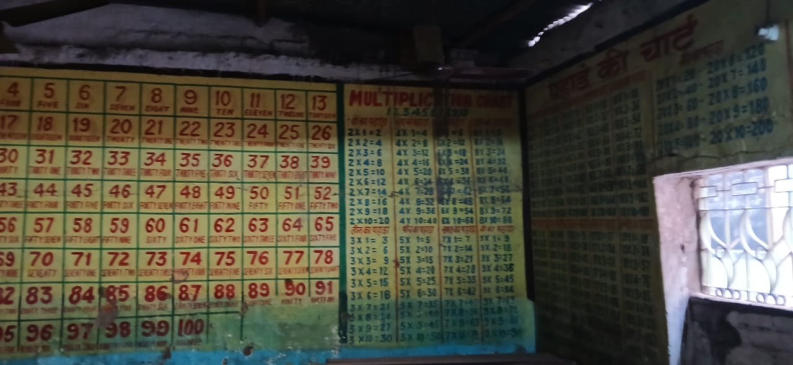
P3
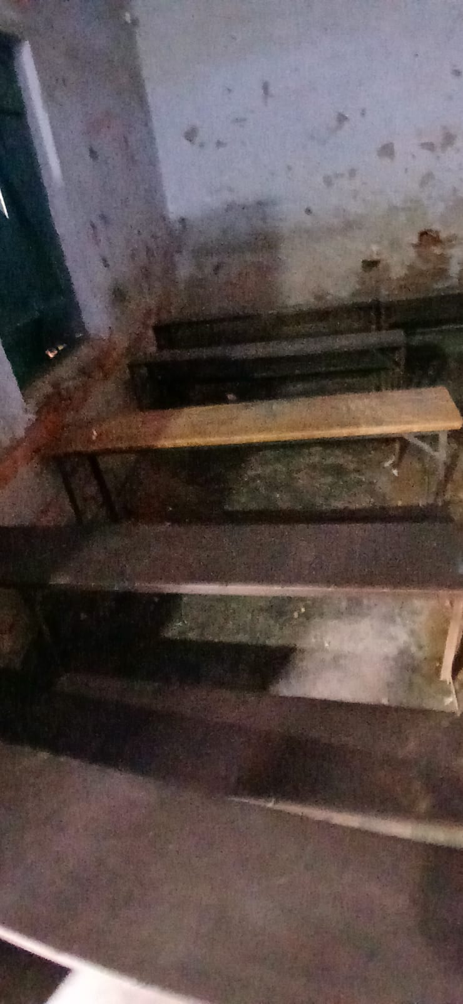
P4
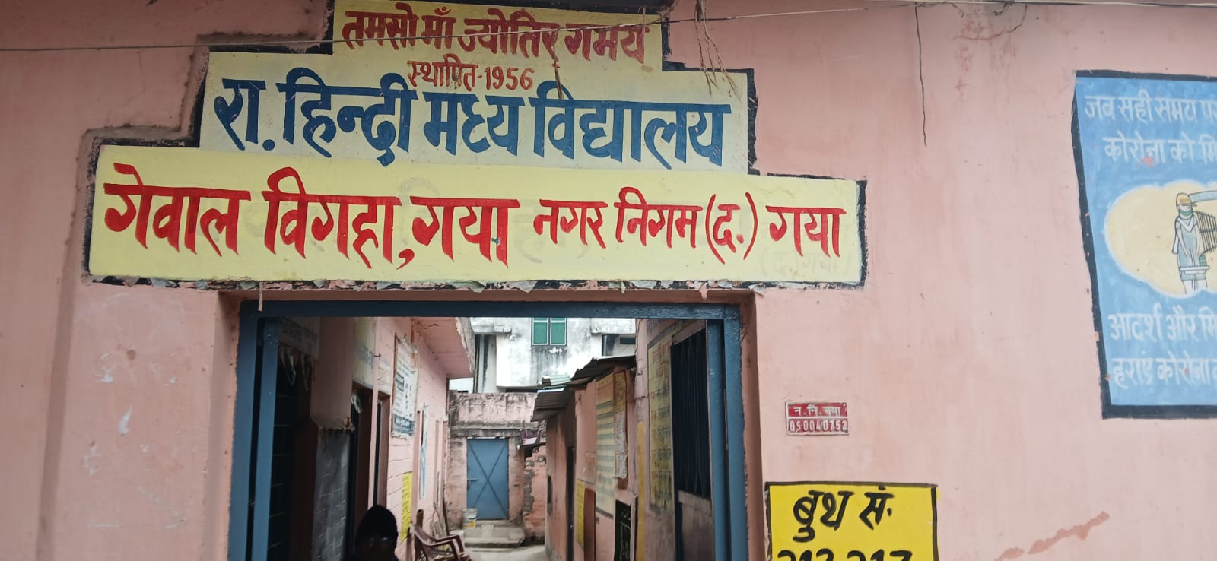
P5
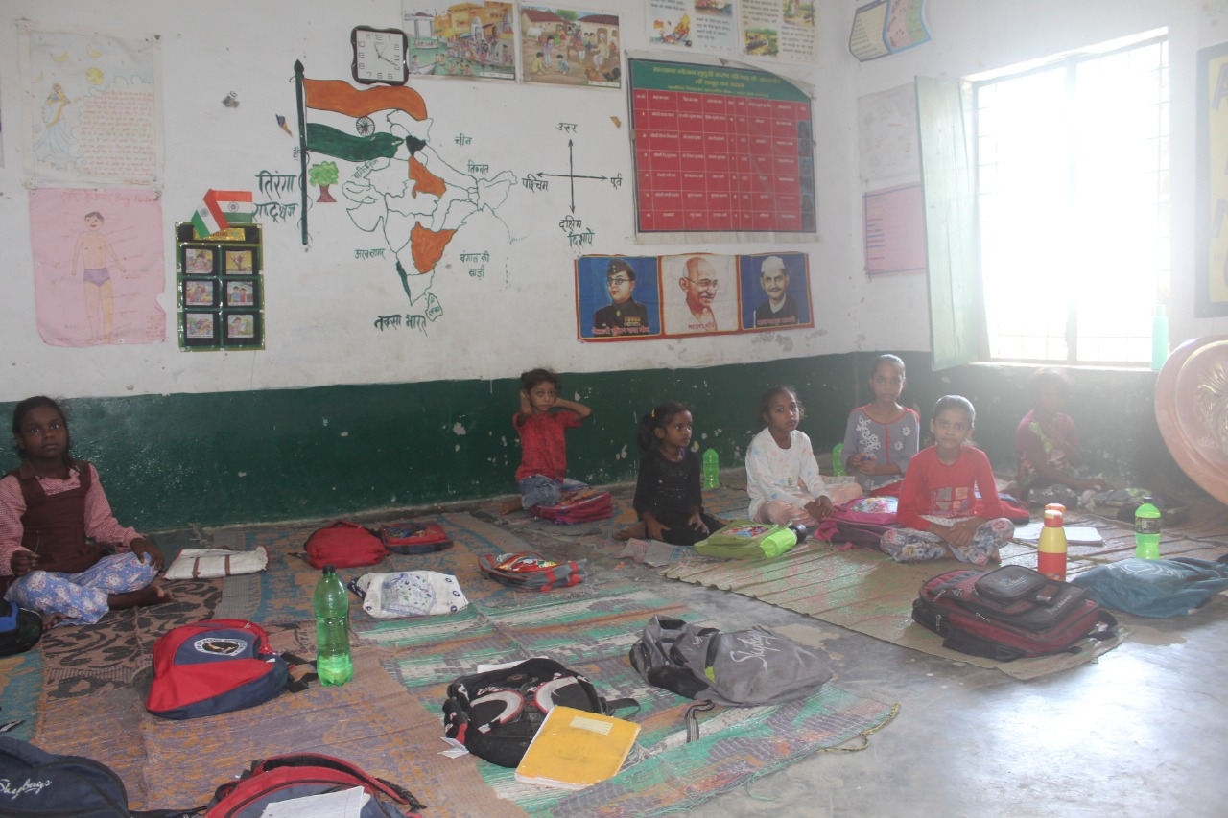
P6
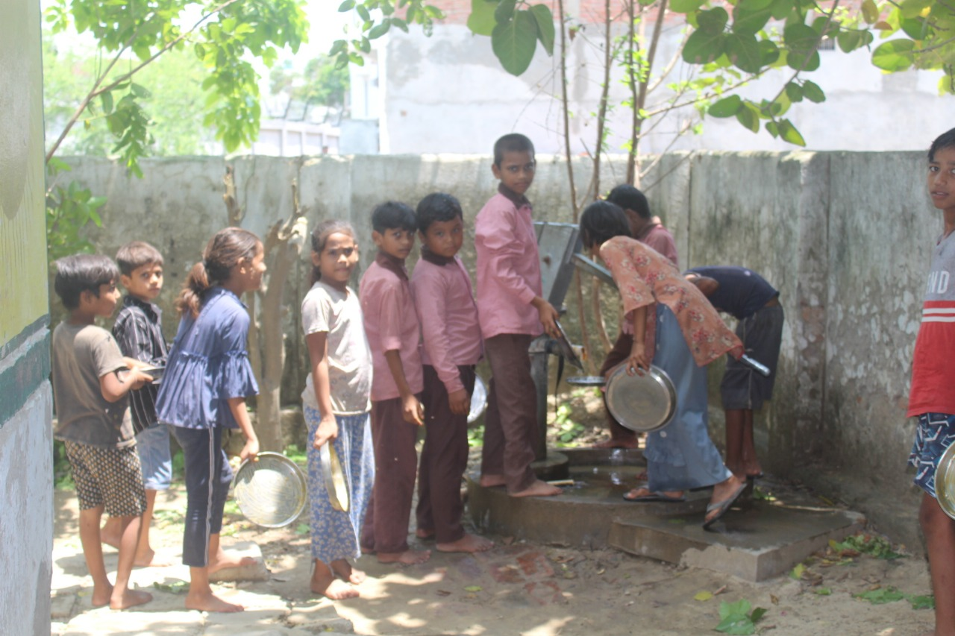
P7
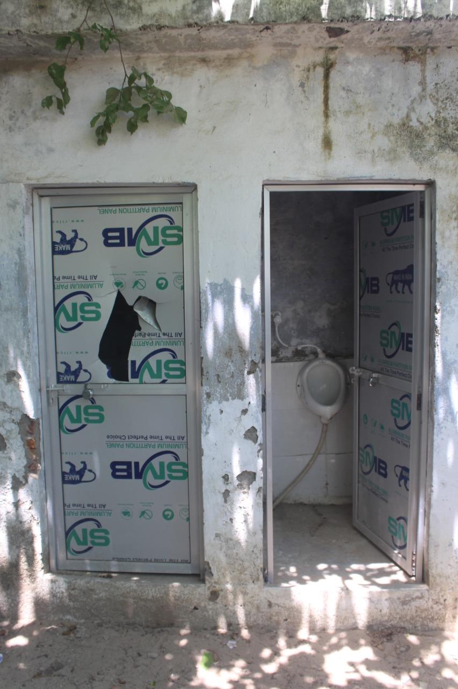
P8
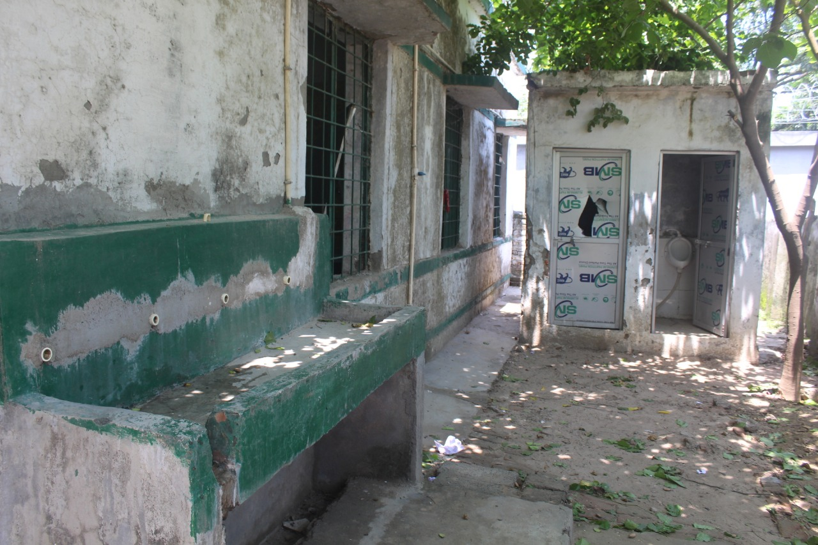
P9
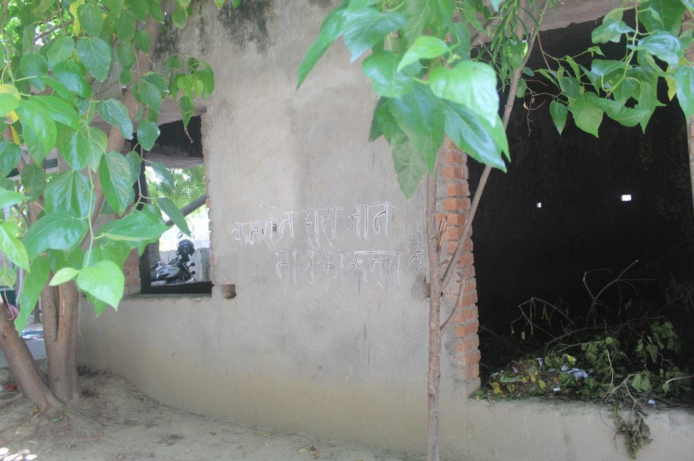

SURVEY QUESTIONNAIRES (Duly-Submitted as per given guidelines)

Gaya Survey (Katari) S1 (i)
Gaya Survey (Gewalbigh) S1 (ii)
Sirsa Survey S2
KhodnaKhurd Survey S3
Northwest Delhi S4
Ghaziabad S5
Lucknow (Unnao) Survey S6 (i)
Lucknow Survey S6 (ii)

SN | Districts | Links
S1(i) | Gaya Survey (Katari) | https://drive.google.com/file/d/1HgZ0YvkaT0nzoSbxpQr5yULdGuNwhK1n/view?usp=drivesdk
S1(ii) | Gaya Survey (Gewalbigh) | https://drive.google.com/file/d/1HurKCje_NSdpUVWcIzjVFBaf7T-fBLVB/view?usp=drivesdk
S2 | Sirsa Survey | https://drive.google.com/file/d/1HJooPUWE6V2NiS7RCXKWy5dQZHEP3byr/view?usp=drivesdk
S3 | Khodna Khurd Survey (Ghaziabad) | https://drive.google.com/file/d/1HgBTA6sQX5r5UubV6mQEiacgBPwrspRV/view?usp=drivesdk
S4 | Northwest Delhi Survey | https://drive.google.com/file/d/1HScvbYLJcvPe-XG3Cs4-CqiYkqNTnJYR/view?usp=drivesdk
S5 | Ghaziabad Survey | https://drive.google.com/file/d/1Hg0jjdKCYL6xtEvv--st0coKAmuKbGA4/view?usp=drivesdk
S6(i) | L Lucknow (Unnao) Survey | https://drive.google.com/file/d/1HTqNI7kQFwFh7sTLhc8BPF1DDVW_N7Pr/view?usp=drivesdk
S6(ii) | Lucknow Survey | https://drive.google.com/file/d/1HZdGSAtoyj75AEK0rzqLUZzfm-ICcmTL/view?usp=drivesdk

Right of Children to Free and Compulsory Education Act, 2009, No. 35, Acts of Parliament (India)
Parth Purohit, The History and Evolution Of The Indian Education System, C.R. Naidu and CO. http://www.crnaidu.in/u/white_paper/The%20History%20and%20Evolution%20Of%20The%20Indian%20Education%20System.pdf.
Sushil Manav, 'No power, toilets or water in Haryana schools': HC raps Khattar govt for its 'glaring insensitivity', (Nov. 28, 2023), https://theprint.in/india/no-power-toilets-or-water-in-haryana-schools-hc-raps-khattar-govt-for-its-glaring-insensitivity/1861776/.
Srinivas S, Understanding Student Teacher Ratio: Why It Matters, New Horizon Public School (July 24, 2024), https://nhps.in/everything-you-need-to-know-about-student-teacher-ratios/.
Government report reveals stark infrastructure gap in Indian schools, The Hindu (Jan. 2, 2025), https://www.thehindu.com/education/education-ministrys-udise-report-shows-nationwide-infrastructure-gaps-in-schools/article69054723.ece.
Vivek Mishra, No school can be without a playground: Supreme Court, (Mar. 9, 2023), https://www.downtoearth.org.in/governance/no-school-can-be-without-a-playground-supreme-court-88151.
Down To Earth, ‘Government schools imparting poor quality education’, (Jan. 17, 2014), https://www.downtoearth.org.in/environment/government-schools-imparting-poor-quality-education-43292.
Swatiprabha Munil Mandal, A Study on Poor Infrastructure in Government School in India with Reference to Dadra and Nagar Haveli, 6 International Journal for Multidisciplinary Research (IJFMR) (2024).
Ministry of Road Transport & Highways, Basic Road Statistics in India 2018- 19, Ministry of Road Transport & Highways ( July 20, 2022 4:06PM by PIB Delhi), Press Release: Press Information Bureau.
CRY Blog, Education in Rural India: Challenges, Opportunities, Initiatives, Child Rights and You (May 31, 2024), Education in Rural India: Challenges, Opportunities, Initiatives - CRY
Tribune News Service, Rohtak: Don’t deprive children of education for want of Aadhaar, PPP, says Edu Dept, The Tribune (Apr. 20, 2024), https://www.tribuneindia.com/news/haryana/dont-deprive-children-of-education-for-want-of-aadhaar-ppp-edu-dept-612655/.
Niraj Pandit, Government's insistence on Aadhaar card for portal registration plays havoc with students, Hindustan Times, (Aug. 16, 2024).
जन्म प्रमाण-पत्र के अभाव में बच्चों का नहीं बन पा रहा आधार कार्ड, (July 29, 2023), https://www-livehindustan-com.translate.goog/uttar-pradesh/balrampur/story-aadhaar-card-is-not-being-made-for-children-due-to-lack-of-birth-certificate-8504041.html?_x_tr_sl=hi&_x_tr_tl=en&_x_tr_hl=en&_x_tr_pto=sc&_x_tr_hist=true.
Benjamin Alcott & Pauline Rose, Schools and Learning in Rural India and Pakistan: Who Goes Where, and How Much Are They Learning?, 45 PROSPECTS 345-363 (2015).
S.K. Singh et al., Groundwater Arsenic Contamination and Associated Health Risks in Bihar, India, 8 INT'L J. ENV'TL RES. 49-60 (2014).
S. Mondal, M. Kumar & S. Jain, SITUATION PAPER ON ARSENIC CONTAMINATION IN WATER IN BIHAR
A. Dhingra & N. Batra, WATER AND LIVELIHOODS IN BIHAR (2023).
J.G. Ndiritu, S. McCarthy & N. Tshirangwana, Probabilistic Assessment of the Rainwater Harvesting Potential of Schools in South Africa, 364 PROC. INT'L ASS'N HYDROLOGICAL SCI. 435-440 (2014).
Swati Dutta, Evaluating the Technical Efficiency of Elementary Education in India: An Application of DEA, https://papers.ssrn.com/sol3/papers.cfm?abstract_id=2158518.
Sanyal & Nawani, S., Private Initiatives in School Reform in India, Oxford Res. Encyclopaedia of Educ. (2021).
CSR Watch Bureau, Indian Oil supports government school under its CSR, (Dec. 16, 2019), https://www.google.com/amp/s/psuwatch.com/amp/story/csrwatch/indian-oil-supports-government-school-under-its-csr.
S.N. Sinha & T. Chaudhari, Impact of CSR on Learning Outcomes, 29 MGMT. ENV'TL QUALITY: AN INT'L J. 1026-1041 (2018).
H. Upreti & R.K. Malhotra, Bridging the Urban-Rural Education Gap in India Through CSR Initiatives: A Conceptual Study with Special Reference to Sustainable Development Goal 4, 556 E3S WEB CONF. 01032 (2024).
Rukmini Banerji, Challenging Bihar on Primary Education, 46 ECON. & POL. WKLY. 33-39 (2011).
S. Shukla & S. Tiwari, Mapping the Inter-District Disparities in Primary Education Development in Bihar, 69 NAT'L GEOGRAPHICAL J. OF INDIA (3) (2023).
A. Kapur & A.N. Mukherjee, Fund Flows and Expenditure in Sarva Shiksha Abhiyan: A Case Study of Nalanda District, Bihar, in RIGHT TO EDUCATION IN INDIA 249-278 (Routledge India, 2015).

