2nd Edition
Of
National Law University, Jodhpur
On
Right to Education Paper Presentation & Discussion Series



SUBMITTED TO: SUBMITTED BY:
Legal Aid and Awareness Committee, Team Code: 034
National Law University, Jodhpur

TABLE OF CONTENTS

LIST OF FIGURES 4
ASSESSING INFRASTRUCTURE EQUITY: THE RIGHT TO EDUCATION 5
IMPLEMENATION IN DADRA AND NAGAR HAVELI AND DAMAN AND DIU 5
ABSTRACT 5
INTRODUCTION & SIGNIFICANCE OF THE SURVEY REPORT 6
KEY PROVISIONS OF THE ACT. 7
A. Fieldwork and Data Collection 8
B. Cross-Verification of Data 8
C. In-depth Interaction and Community Insights 8
D. Ethical Considerations and Governmental Permission 8
E. Data Analysis 9
F. LIMITATIONS OF STUDY 9
FACTS & FINDINGS 10
A. Pupil-Teacher Ratio 10
B. Shortages of Staff, Overcrowded Classrooms, & Other Challenges 10
C. Infrastructural Facilities: Assessment of School Buildings, Libraries, Playgrounds, Drinking Water, Washrooms, and Security Measures 11
C.1 Assessment of School Buildings 11
C.2 Library 12
C.3 Playground 13
C.5 Clean drinking facilities in Government Schools: Is there any facility for safe drinking water for children? 15
C.6 Teachers in Schools: Analysis 16
MAJOR ISSUES IN IMPLEMENTATION 18
1. Vacancies: 18
2. Lack of Support from Parents: 18
3. Contract-Based Appointments: 18
4. Inadequate Infrastructure: 18
5. Merger of the classes: The survey conducted by the research team has revealed a concerning tends in certain schools, where multiple classes are being merged for the institutional purposes (e.g., The merging of third and fourth grades for teaching). This practice results in the single teaching being responsible for instructing for more than one subject, raising significant concerns regarding the quality of education provided to the students. 19
Ultimately, 19
SUGGESTIONS 20
1. Teacher’s vacancy- 20
2. Washroom leakage 20
3. Lack of sports facilities 20
4. Accessible drinking water 21
5. Electricity facility- 22
6. Library resources- 22
7. No-Fail Policy 22
8. Expanding The Act for Secondary Education- 22
9. Facilities for the disabled students- 23
10. Non-functional School Management Committee 23
11. Decentralisation norms- 23
12. Promote wellbeing initiatives- 24
13. Transportation facilities- 24
14. Awareness programs- 24
CONCLUSION 25
ANNEXURES 26

LIST OF FIGURES

Number of Figures | Details
Figure 1 | Is there one classroom per teacher?
Figure 2 | Number of Classrooms in need of Minor Repair.
Figure 3 | Number of Classrooms in need of Major Repair.
Figure 4 | Is there a Library?
Figure 5 | If yes, is it functional and sufficient?
Figure 6 | Is there a playground in the schools?
Figure 7 | Do students get any play materials, sports equipment, etc.?
Figure 8 | Number of toilets for girls that are functional and usable?
Figure 9 | Number of toilets for boys that are functional and usable?
Figure 10 | Is there any facility for safe drinking water for children?
Figure 11 | When you visited the school, what were the teachers doing?
Figure 12 | Apart from teaching, what else were they doing?
Figure 13 | Is there a playground in the schools?
Figure 14 | Does the library contain newspapers?
Figure 15 | Does the library contain magazines?
ASSESSING INFRASTRUCTURE EQUITY: THE RIGHT TO EDUCATION
IMPLEMENATION IN DADRA AND NAGAR HAVELI AND DAMAN AND DIU

ABSTRACT
Education is the foundation upon which the society builds its future. The present research aims to explore the transformative impact of the Right to Education Act, (RTE) 2009( hereinafter referred to as “The Act”) on primary government schools in Dadra and Nagar Haveli and Daman and Diu. Enacted as a Fundamental Right in 2002, The Act aims to ensure free and compulsory education for all children aged 6 to 14. However, the implementation of this ambitious policy requires immense infrastructural investments and human resources. For the purpose of this research, data were collected from 14 schools in the Union Territory using a semi-structured survey. A questionnaire comprising 50 questions was prepared for studying challenges, and suggestions regarding The Act and especially on the infrastructure. The data collected was tabulated and analyzed qualitatively. The findings of the study showed that since its implementation, significant strides have been made in enrollment rates, particularly among marginalized communities, while addressing infrastructure and quality of education. However, these challenges remain in the effective implementation and resource allocation.
Keywords: DNHDD, Govt. Schools, Infrastructure, Right to Education, Schools, Teachers, Students.

INTRODUCTION & SIGNIFICANCE OF THE SURVEY REPORT
“माता शत्रुः पिता वैरी येन बालो न पाठितः ।
न शोभते सभामध्ये हंसमध्ये बको यथा ॥”
- चाणक्य नीति

A parent who does not facilitate and guide their child in studies is like the greatest enemy of the child. The presence of an uneducated person in the company of educated people is like a goose in the company of swans.

- Chanakyaniti
For many decades, the British Raj exploited the language barrier to prevent young Indians from gaining quality education. The constitution makers were aware of this injustice and in that spirit, including two specific provisions in our constitution i.e., “the State shall endeavor to provide, within a period of ten years from the commencement of this Constitution, for free and compulsory education for all children until they complete the age of fourteen years” (Article 45), and “ that children are given opportunities and facilities to develop in a healthy manner and in conditions of freedom and dignity and that childhood and youth are protected against exploitation and against moral and material abandonment” (Article 39(f)). As the above-mentioned articles were not enforceable back then, the Supreme Court time and again insisted on making the right justiciable. At the onset of the 21st century, when the country was economically stronger, the leaders of the nation introduced ‘free and compulsory education to all children of the age of six to fourteen years’ as a Fundamental Right. By the end of the decade, The Act was enacted.
The intention of The Act was to ensure that every child has a right to be provided full-time elementary education of satisfactory and equitable quality in a formal school that satisfies certain essential norms and standards. This objective is intricately woven with the principles of social justice, inclusivity, equality, and access enshrined in the Preamble of our Constitution.

KEY PROVISIONS OF THE ACT.

Section 8- “The term “compulsory education” means the obligation of the appropriate Government to—
(i) provide free elementary education to every child of the age of six to fourteen years; and
(ii) ensure compulsory admission, attendance, and completion of elementary education by every child of the age of six to fourteen years;”
Section 13- “No capitation fee or screening procedure for admission.”
Section 17- “Prohibition of physical punishment and mental harassment of children.”
Section 25- “Pupil-Teacher Ratio- (2) For the purpose of maintaining the Pupil-Teacher Ratio under sub-section (1), no teacher posted in a school shall be made to serve in any other school or office or deployed for any non-educational purpose, other than those specified in section 27”.

METHODOLOGY

The research methodology adopted for the present study was designed with precision to achieve a complete and accurate impact analysis of The Act. The key features of the methodology are enumerated below:

Fieldwork and Data Collection
The research team conducted extensive fieldwork in various locations to gather first-hand data on the implementation of The Act. This involved visits to schools, educational offices, and communities to study and document the ground realities of the process. A broad range of urban, semi-urban, and rural areas were selected to ensure that the findings reflected the varied experiences across different socio-economic and geographical contexts in the Union Territory. Key stakeholders, including school administrators, teachers, parents, and students, were interviewed through structured and semi-structured questionnaires to capture a wide spectrum of perspectives.

Cross-Verification of Data
To ensure that the data collected is reliable and accurate, a cross-checking mechanism was employed, wherein data was collected from multiple sources to validate the findings.

In-depth Interaction and Community Insights
In addition to formal interviews and observations, there was interaction with community members and stakeholders in informal settings. Informal discussions were useful in understanding socio-cultural factors affecting the effective implementation of The Act.

Ethical Considerations and Governmental Permission
The study was conducted with the highest standards of ethics. All participants were treated ethically, and they met the legal requirements. Formal permissions were secured to conduct this study from the respective government authorities. Participants were informed about the purpose of the research, and their consent was sought before collecting any data. Confidentiality was maintained to ensure that their identities were protected and privacy was maintained.

Data Analysis
The data collected was systematically organized and analyzed to identify trends, challenges, and successes in implementing The Act. Qualitative data from interviews and observations was coded thematically to highlight key findings. Official records and field surveys were statistically analyzed to generate quantitative data supporting qualitative insights.

LIMITATIONS OF STUDY
Firstly, due to time constraints, only 14 schools could be covered from Silvassa, Daman, and Diu. Secondly, due to financial constraints, the team was unable to travel long distances to schools that were geographically far from the University. Lastly, due to limited team members, more schools could not be covered in the survey and the team could not observe the schools for an extended period. Due to this, some of the findings of the survey had to be generalized (for example, the attendance data that was collected to check the attendance ratio of the students and teachers was based on the data collected on a single day and not via multiple visits. This may lead to a slight variation in the recorded and actual attendance ratio.) These limitations should be kept in mind while interpreting the data of the survey conducted.

FACTS & FINDINGS

A. Pupil-Teacher Ratio
Section 25(1) of The Act, states that, “Within six months from the date of commencement of this Act, the appropriate Government and the local authority shall ensure that the Pupil-Teacher Ratio, as specified in the Schedule, is maintained in each school.”
Figure 1. Is there one classroom per teacher?
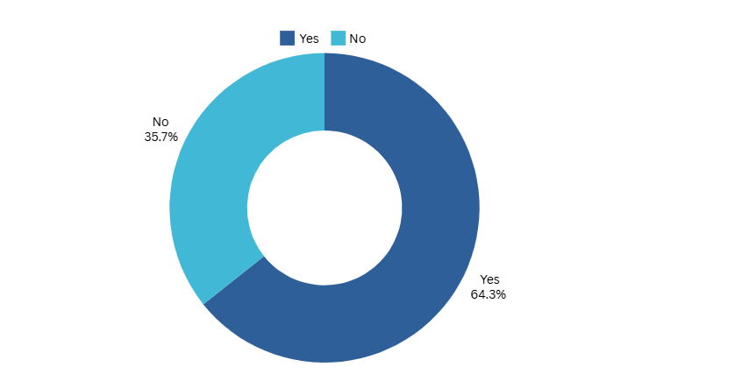
The ratio of teachers to students is a crucial metric for assessing the quality and effectiveness of teaching in a classroom. It has a major impact on many elements of the learning environment and refers to the number of students assigned to a single teacher.
Teachers are better equipped to meet each student's unique learning needs, strengths, and problems when the teacher-to-pupil ratio is balanced. Higher engagement, enhanced comprehension, and superior academic results are all fostered by this personalized approach. It supports the objectives of The Act which guarantees all children an equal chance to succeed in school, irrespective of their socioeconomic status. The teacher-to-pupil ratio is therefore more than just a number; it is the foundation of an educational system that strives for both effectiveness and fairness.
The survey was conducted across 14 schools. Out of the total schools, 8 (64.3%) schools had an appropriate teacher-to-pupil ratio whereas the remaining 6 (35.7%) schools did not have an appropriate teacher-to-pupil ratio as also shown in the above pie chart.

B. Shortages of Staff, Overcrowded Classrooms, & Other Challenges
The Non-Teaching Staff in the schools also play an important role in maintaining the management and functioning of the school, especially in government schools as they are responsible for mid-day meals, cleanliness, maintenance, security, etc. The non-availability of non-teaching staff affects the working of the school in day-to-day activities. During the survey conducted, it was found that there were 144 non-teaching staff employed in 14 schools averaging approximately 10 non-teaching staff per school. This shows that in almost all schools there are adequate non-teaching staff in school for fulfill their management work and maintain the functioning of the schools.
In some of the schools during the survey, it was observed that some of the classes like the third and fourth grades were merged and the students were sitting together in the same class due to the vacancy of teachers resulting in overcrowded classrooms in the school. This overcrowdedness of the students in classes overburdens the teacher with a lot of work and leads to a lack of individual attention in the classrooms which ultimately reduces the quality of education in the school.
One of the other challenges found during our survey was that some of the teachers of the school have to leave their classes and do the administrative work of the school which disturbs the class the school and it can even lead to gaps in learning and impact the consistency of education that students receive.

C. Infrastructural Facilities: Assessment of School Buildings, Libraries, Playgrounds, Drinking Water, Washrooms, and Security Measures

C.1 Assessment of School Buildings
Section 8 The Act lays down the duties of the appropriate Government to ensure inter alia that children belonging to weaker sections and disadvantaged groups are not discriminated against and prevented from pursuing and completing elementary education. In this regard, it becomes important for the government to achieve proper infrastructure of school buildings, utilization of human resources including both teaching staff and non-teaching staff, and provide learning equipment. Additionally, good quality elementary education conforming to norms and standards must be provided by structuring the curriculum in such a way that it not only helps to build knowledge but also the acumen to deal with practical aspects of life such as building leadership quality. Hence, there must be an extra curriculum as well. For this, the training of the teachers must be done regularly as prescribed. Moreover, the admission, attendance, and completion of elementary education by every child needs to be monitored by the government.
Good infrastructure in schools is crucial for fostering an effective learning environment that enhances student engagement and academic performance. Well-designed facilities, including spacious classrooms, adequate lighting, and modern amenities, contribute to students' comfort and concentration, minimizing distractions that can hinder learning. Access to essential resources such as libraries, laboratories, and recreational areas not only supports educational objectives but also aids in the holistic development of students. Ultimately, investing in robust school infrastructure is vital for nurturing a positive atmosphere that motivates students to excel academically and socially.
Figure 2. Number of Schools in Need Figure 3. Number of Schools in Need
for Minor Repair for Major Repair
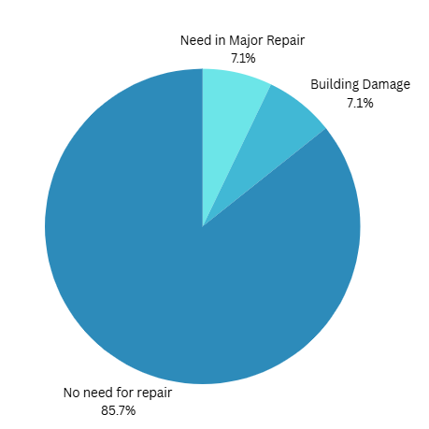
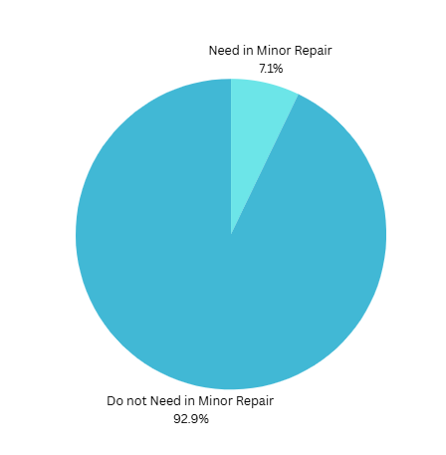

Figure 3. Number of Schools in Need for Major Repair
It can be observed from the data set of the survey, that the infrastructure of most of the schools were in good condition, needing only mild to medium repairs.

C.2 Library
Library, the vantage of knowledge, is one of the crucial aspects for students, and talking about government schools it is mentioned in The Act, that there shall be a library in each school providing newspapers, magazines, and books on all subjects, including story-books.

Figure 4. Is there a Library?
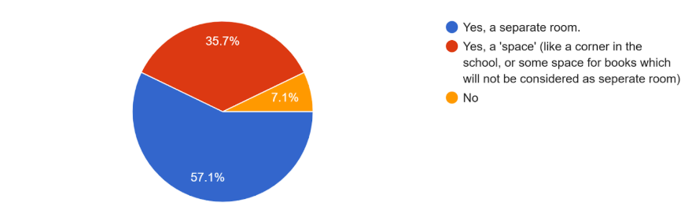
Subsequently, to conduct the survey, 14 schools were surveyed and amongst those, 57.1% had separate rooms assigned for the library, 35.7% had a space in a corner of a room that was considered as the library space, and 7.1% did not have a library at all. From the graph below, it can be inferred that 85.7% of the libraries are functional and the remaining 14.3% are not.
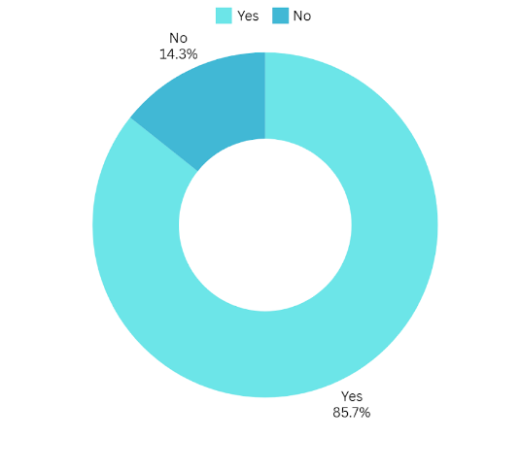
Figure 5. If yes, is it functional and sufficient?
Access to storybooks and non-fiction narratives exemplifies this impact. In the survey conducted, it was found that 71.4% of the institutions provide newspapers, while the remaining does not. A similar trend is observed regarding the availability of magazines, as indicated in the accompanying graph.
The analysis of this data suggests that the government of the Union territory is progressing towards educational growth, albeit at a gradual pace. Indeed, this trend reflects a commitment to improving resources that are crucial for nurturing young minds and fostering a culture of reading and learning within the school environment.

C.3 Playground
The Act ensures that children receive equal access to sports and other facilities, regardless of their background. Section 2 ensures that children admitted under section 12(1) are not discriminated against in terms of access to facilities and entitlements, including sports and extra-curricular activities.
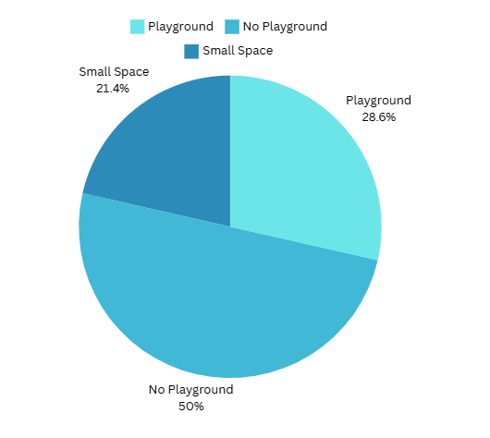
Figure 6. Is there a playground in the schools?
Playgrounds and sports facilities in schools are vital for the holistic development of students. They provide a structured environment for physical activity, promoting fitness, coordination, and overall health.

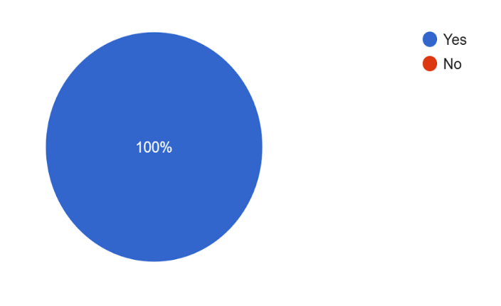
Figure 7. Do students get any play materials, sports equipment, etc.?
During the survey, it was observed that some schools lacked playgrounds despite having sports equipment. However, such resources are ineffective if they remain underutilized.

C.4 Functionality of Washrooms in Schools
Figure 8. Number of Toilets for Girls that are functional and usable?
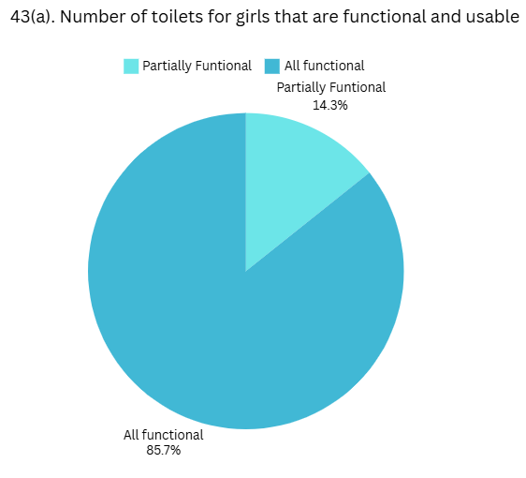
Under The Act, in the “NORMS AND STANDARDS FOR A SCHOOL” schedule, S.no. 2(iii), it is mentioned that there should be separate, clean, hygienic washrooms in the school for both boys and girls. Washrooms though available, should be in suitable condition, which when used by students should not be problematic.
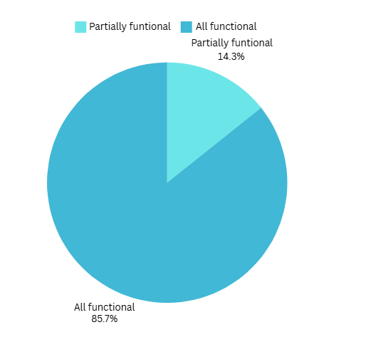
Figure 9. Number of Toilets for Boys that are functional and usable?
From the data collected via survey, it was observed that only 85.7% of the girls' washrooms are functional which covers the majoritarian aspect and the remaining are partially functional. The same is observed in the boys' washroom.

Sanitary Pads availability
One of the facilities that is lagging in all the girls' washrooms is the availability of a sanitary pads vending machine, which is one of the crucial needs for girls. And, now when focusing on cleanliness and hygiene, sanitary pads should be made available and incinerators should be installed for proper disposal of the pads.

Washrooms allotted specifically to physically challenged students
It was observed that only one school had a separate washroom for specially-abled students, a girl washroom despite there being no physically challenged girl in the school. This instance highlights the ignorance of the school towards the one physically challenged boy in the school.

C.5 Clean drinking facilities in Government Schools: Is there any facility for safe drinking water for children?
Water is a basic living amenity of the people and considering educational institution facilities regarding the same, The Act mandates the provision of basic infrastructural facilities in all schools, including clean drinking water. During the survey, it was observed that among all the schools, 92.9% of them had safe drinking water facilities but the remaining 7.1% did not have the same. Also, many schools tend to manage drinking water for students via taps and pipelines without treating them, which in the long run might result in water-infectious diseases. Therefore, this careless act depicts somewhere or the other, the lack of resources, concern for innocent lives, and lack of duties.

Figure 9. Is there any facility for clean drinking water for children?
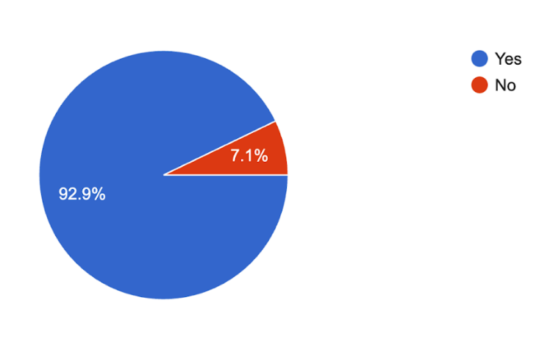

C.6 Teachers in Schools: Analysis
गुरुर्ब्रह्मा गुरुर्विष्णुः गुरुर्देवो महेश्वरः ।
गुरुः साक्षात् परब्रह्म तस्मै श्री गुरवे नमः ॥
The guru is Brahmā, the guru is Vişņu,
the guru is Maheśvara (Śiva),
the guru is the self-revealing limitless.
Salutations to that revered guru.
Teachers are considered the backbone of our society, and Indian culture deeply emphasizes their importance. A student develops his identity through the insights, values, and knowledge imparted by his teachers. The Act has included provisions from Sections 23 to 28 stating critical issues on the teacher-to-student ratio and teacher vacancies in government schools with implications of private tutoring. To properly evaluate the implementation of these provisions, our team's survey focused on essential elements related to teachers under The Act. This included evaluating the percentage of teacher allocation within schools, the number of subjects assigned to teachers for specific classes, and the range of activities teachers engage in beyond their teaching responsibilities.

Figure 11. When you visited the school, what were the teachers doing?
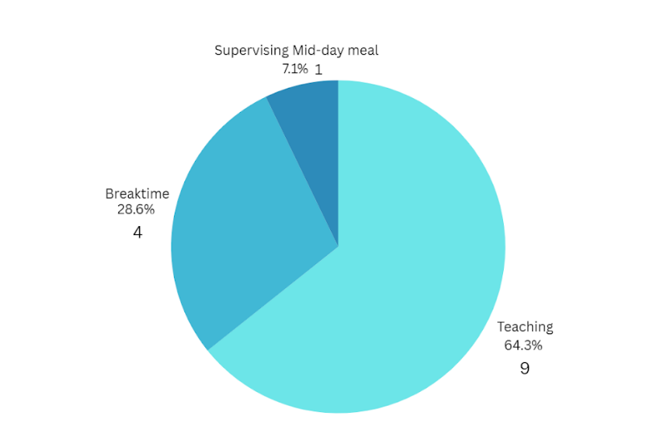
During the survey, it was observed that 64.3% of the teachers were busy with classes when the team reached the school, 7.1% of them were supervising the students during the mid-day meal and the remaining 28.6% were involved in other school work.

Figure 12. Apart from teaching, what else were they doing?
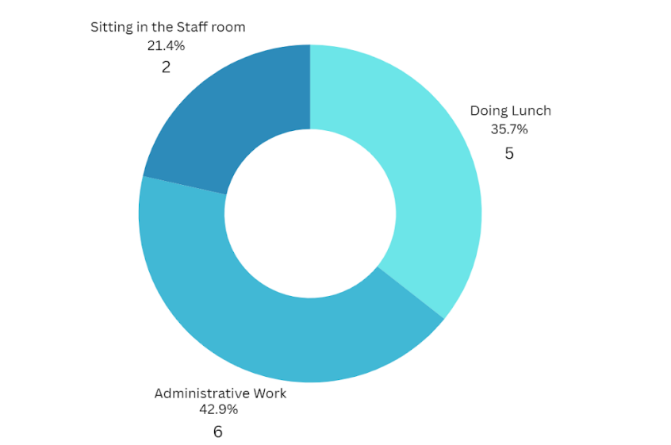
Apart from teaching, 42.9% were involved in administrative work, 35.7% were doing lunch and the remaining were in their staff rooms, doing their work.

MAJOR ISSUES IN IMPLEMENTATION

In the decade and a half since the implementation of The Act, there have been major strides taken in the domain of education by the government, especially focusing on access, infrastructure, and quality education. The Act, with its visionary mandates and comprehensive regulatory framework, has changed the shape of the education landscape in India. However, due to a lack of resources or lack of will, there continue to be facets of The Act that remain neglected.
Just like other States, the government schools in the Union Territory are a mixed bag of hits and misses. Overall, the Union Territory administration is working hard to ensure that the vision of our lawmakers through The Act is brought to life and that the tribal population of the Union Territory, especially girls, have access to quality education in their language. However, a few issues that were discovered during the course of the research have been briefly enumerated below:
- Vacancies: One of the problems is the higher vacancy rates of teachers in the Union Territory. In the schools surveyed, there were many vacancies for teachers in schools, leading to a single teacher having to teach multiple subjects. This not only leads to administrative difficulties of classes going free but also inefficiency in teaching and a lack of quality classes for the students.
- Lack of Support from Parents: Due to illiteracy, poor economic background, caste discrimination, or simple lack of information about student-welfare schemes, there appears to be a nonchalant attitude of parents in supporting their children with current curriculum and extracurricular activities.
- Contract-Based Appointments: Many teachers were appointed on a contractual basis. As contract-based teachers get fewer incentives and rewards (for example, dearness allowances, etc.) compared to permanent teachers, there is always insecurity in the mind of the faculty, leading them to look for other jobs and resign from the workplace.
- Inadequate Infrastructure: In a few schools, it was noted that they did not have separate playgrounds, proper libraries, or computer labs. This leads to the one-dimensional development of students, preventing a holistic approach toward education and skill development.
- Merger of the classes: The survey conducted by the research team has revealed a concerning tends in certain schools, where multiple classes are being merged for the institutional purposes (e.g., The merging of third and fourth grades for teaching). This practice results in the single teaching being responsible for instructing for more than one subject, raising significant concerns regarding the quality of education provided to the students.
Ultimately, the assignment of single teacher to cover all subjects places an undue burden on educators, further diminishing the effectiveness of teaching. A primary factor contributing to the merging of classes and the assignment of teachers to multiple subjects is the elevated vacancy rate among teaching staff. This situation underscores the need for strategic interventions to address staffing shortages and enhance the overall quality of education in these institutions.
As per our study, the overall implementation of The Act is going on the right path in the Union Territory. A few domains where there is scope for improvement, have been detailed in the next part of the Report.

SUGGESTIONS

1. Teacher’s vacancy- There are some regional problems because of which there is a lack in the implementation of The Act. One of the problems is the higher vacancy rates of teachers in the Union Territory. During a Lok Sabha question hour round, when a question was asked by Shrimati Poonam Mahajan, Member of Parliament, Lok Sabha, to the Ministry of Education, about the infrastructure and vacancy rate of teachers, a reply was released by the Ministry of Education according to which, the vacancy rate for elementary education is 19.46% in the Union Territory for the fiscal year 2023-24.
The higher vacancy rate in elementary education may indicate a need for increased support and resources for elementary teachers. The reason for higher vacancy rates in elementary schools is that the teachers are not provided with basic facilities that are easily found in other states and Union Territories. This causes them to reject job offers from Dadra and Nagar Haveli and Daman and Diu. Therefore, to address this problem, the government needs to ensure proper housing, pensions, and transportation facilities so that educators are drawn to remote areas.
2. Washroom leakage- In many schools, issues related to washrooms such as leakages remain a significant concern, as they create unhygienic conditions that may lead to the spread of diseases among students. Leaks can result in still water, which provides a breeding ground for bacteria and germs. Therefore, to prevent health risks, it is essential for schools to regularly inspect and maintain their washroom facilities, ensuring that all plumbing issues are addressed promptly. By improving the condition of washrooms, schools can create a cleaner and safer environment for students.
3. Lack of sports facilities- In many schools, students who want to participate in physical activities are limited by the absence of proper playgrounds and necessary sports equipment. According to the survey conducted, 50% of the government schools in the Union Territory do not have playgrounds, and 21.4% only have a small playground.
Figure 13. Is there a playground in the school?
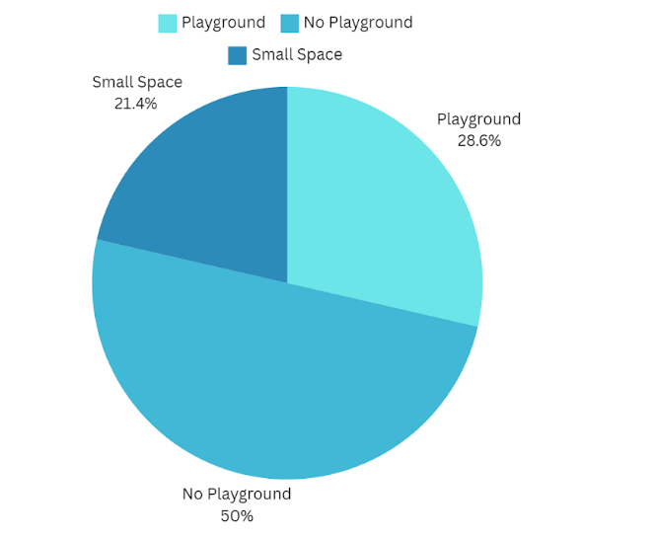
To address this problem, better playgrounds and necessary sports equipment need to be ensured. Moreover, at least two classes per week should be dedicated to physical education to encourage students to keep up their activity levels. Inter-school sports events would also give students the chance to develop teamwork and good sportsmanship. A healthier and more balanced environment would help students develop socially, mentally, and physically.
4. Accessible drinking water- Students' health and well-being are directly impacted by providing safe and easily accessible drinking water in schools. For drinking water, a sizable portion of schools currently use treated tap water, creating further challenges in maintaining systems for the same. To guarantee water purity, routine pipeline cleaning is necessary, but costly and time-consuming, which makes it less feasible for many schools. Consistent testing for water pollutants is impractical due to logistical and cost limitations, even with routine repair.
This raises the possibility of contamination and exposes students to dangerous materials that may cause severe health problems, like waterborne illnesses. To address these challenges, the installation of water coolers or pots offers a better solution. These alternatives are not only easier to maintain but also provide a safer source of drinking water.
However, the current adoption rate of water coolers in schools is alarmingly low, with only 31.8% of schools equipped with this essential facility. This highlights the urgent need for intervention by both school management and government authorities to prioritize the installation of water coolers. It is feasible to reduce the hazards connected with treated tap water while giving kids a dependable supply of clean drinking water by making investments in water coolers and making sure they are available in every school. Resolving this issue will help to create a more equal and healthy learning environment for everyone.
5. Electricity facility- According to the Ministry of Education’s UDISE+ Dashboard and the survey conducted, 100% of the schools in the Union Territory have proper electricity facilities. With some of them also having electricity generators.
6. Library resources- The libraries surveyed in the schools were adequate and had a sufficient number of books related to all subjects. In all the schools, books were regularly being issued according to the survey; however, there were no magazines in 35.7% of schools and no newspapers available in 35.7% of schools.
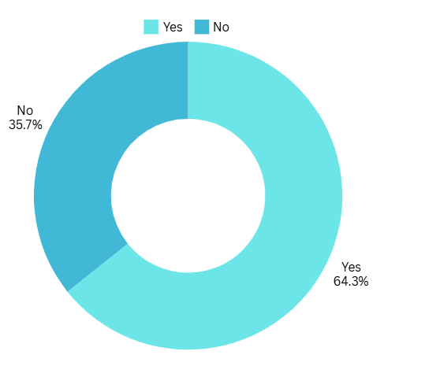
Figure 14. Does the Library contain Newspapers? Figure 15. Does the Library contain Magazines?
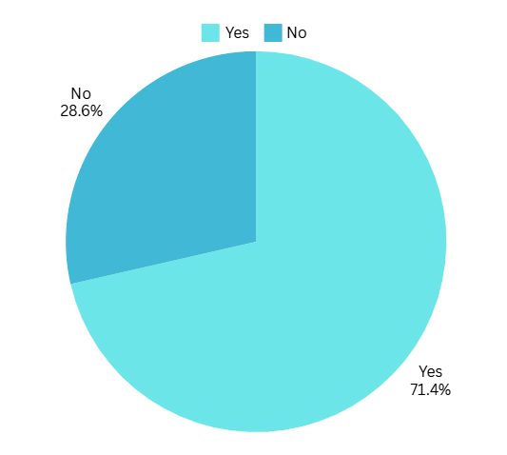
7. No-Fail Policy- The no-fail policy in The Act, ensures that students up to the 5th grade cannot fail, has resulted in a lack of motivation among both teachers and students. Teachers likely feel less inclined to put in their best effort as they have to pass the students compulsorily. Similarly, students lose motivation to study as they know that they will not fail. This policy, although well-meaning, has inadvertently reduced the overall quality of education.
8. Expanding The Act for Secondary Education- The Act ensures that children between the ages of 6 and 14 receive education, but it does not address the need for continued education after this age. By the time students reach 14, many are only able to complete their 8th grade. Education up to class 8 is not enough to equip students with the knowledge and qualifications. There is a need to extend the scope of The Act to include access to secondary and higher secondary education.
9. Facilities for the disabled students- According to the National Survey of Out of School Children Report 2014, about 28% of special needs children aged between 6 to 13, are out of school, and also up to 44% of kids with special needs who have multiple disabilities are not attending schools. To address this problem, schools should provide specialized teachers and educational resources to guarantee that kids with disabilities attend school regularly. Also, schools should ensure accessibility for physically disabled students by utilizing assistive technology, handrails, and ramps and the government should regularly check the accessibility of schools for disabled students and teachers.
10. Non-functional School Management Committee- According to section 21 of The Act of 2009, the schools should constitute a School Management Committee consisting of the elected representatives of the local authority, parents or guardians of children admitted in such schools, and teachers. However, while conducting the survey and interacting with the administration, the team found that some of the schools that were surveyed did not have any School Management Committee, and even if there was a School Management Committee, most of them were not functional or not represented as per section 21 of The Act.
It should be ensured by the government and school administration that there is a School Management Committee in each school and that it is constituted as per the provisions of section 21 of The Act. The School Management Committee could also be strengthened by educating them about their obligations under The Act. These committees can serve as efficient monitors to guarantee that the Act is properly applied at the grassroots level.
11. Decentralisation norms- There is a need for decentralized norms for every state and Union Territory as the education level is different for every state. For example, the education level of Uttar Pradesh is different from Kerala. So, the schemes and policies should be based on the problems each state is facing in implementing the provisions of The Act.
12. Promote wellbeing initiatives- It was observed during the survey that the core aim of the teachers is to imbibe knowledge and information in students. Many schools have student well-being initiatives such as Ramta-Ramta (means study while you play), and we learn English initiatives. However, when it comes to the well-being of not just education but also recreational activities, the schools are lagging as they just have one function in the entire year which is at the start of the admission known as Pravesh Utsav.
13. Transportation facilities- Also, the government schools should maintain regular bus/ van facilities to facilitate the students in transportation during all weathers.
14. Awareness programs- To ensure correct implementation of the provisions of The Act, the government should regularly conduct awareness programs to make sure that educators and school administrations are aware of their obligations and duties towards students and their education. Also, workshops, seminars, community engagement campaigns, and teacher training should be conducted regularly.

CONCLUSION
The detailed survey conducted across 14 schools in the Union Territory of Dadra and Nagar Haveli & Daman and Diu reveals an overall positive outlook on the implementation of The Act, indicating progress in educational access and quality. However, the findings also highlight several areas that require attention and improvement. Significant challenges persist, including staff shortages, overcrowded classrooms, and inadequate infrastructure impacting the overall educational experience. While most schools reported having functional libraries and playgrounds, a considerable number still lack essential resources, which affects students' holistic development by limiting opportunities for extracurricular engagement and learning. There is also a lack of importance given to access to clean and working toilets for girls because sanitation facilities are essential to their comfort and safety, which directly impacts attendance and school activities.
To conclude, the survey reflects a positive trajectory in educational reforms within Dadra and Nagar Haveli and Daman and Diu but simultaneously calls for targeted interventions to address existing challenges and enhance the overall educational framework.
The Act embodies the principles of social justice and equality, intending to provide every child with the right to free and quality education. Its attainment is crucial not only for individual development but also for the broader socio-economic advancement of society. Education is a fundamental right that empowers children and equips them with the skills needed to contribute positively to their communities.
In light of the facts and findings of the survey, the government and stakeholders (the education department, students, parents, teaching and non-teaching staff) must take decisive action. This includes ensuring adequate staffing in schools and addressing the disparities in resource availability. Collaborative efforts among government bodies, educational institutions, and community organizations are essential to create an environment where every child can thrive academically and socially. Stakeholders must prioritize the fulfillment of The Act’s objectives to pave the way for a more equitable educational landscape in India.

ANNEXURES
Image: 1. Developed infrastructure of the school building.
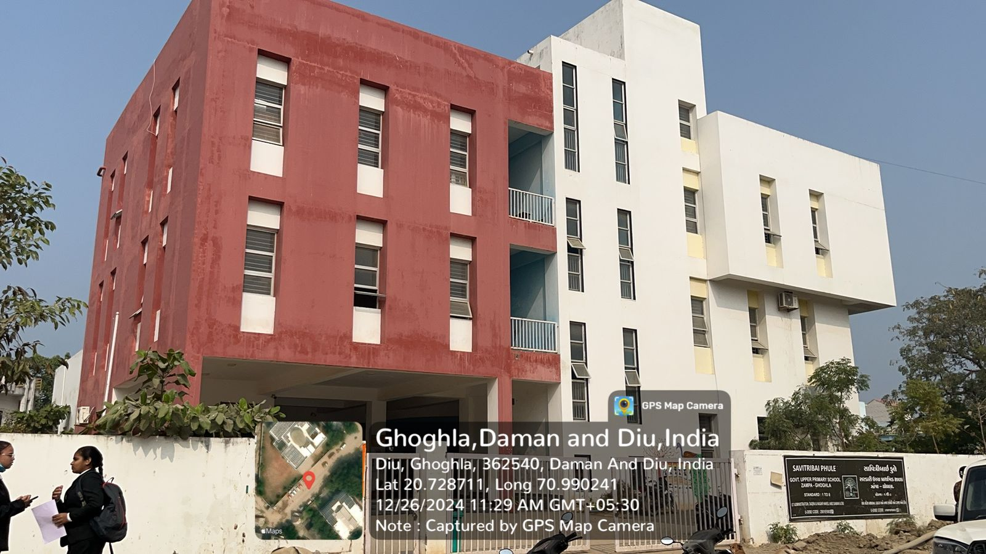
Image: 2. Playground image.
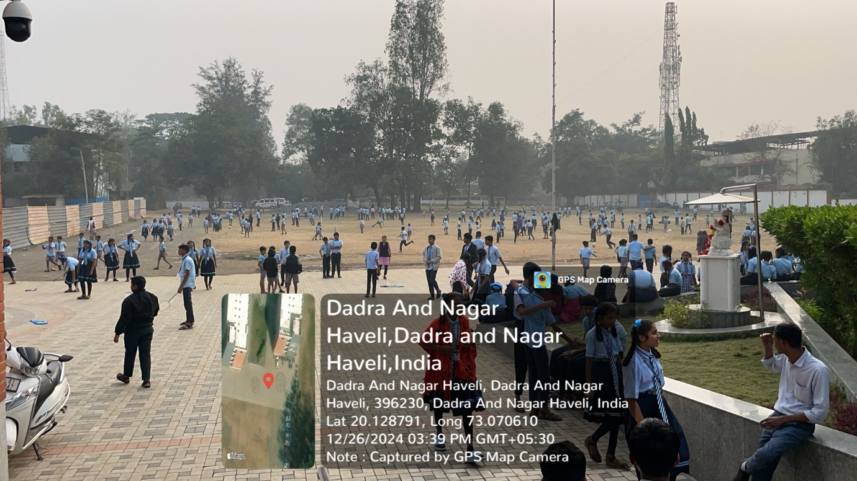

Image: 3. Private transportation facilities used by students.
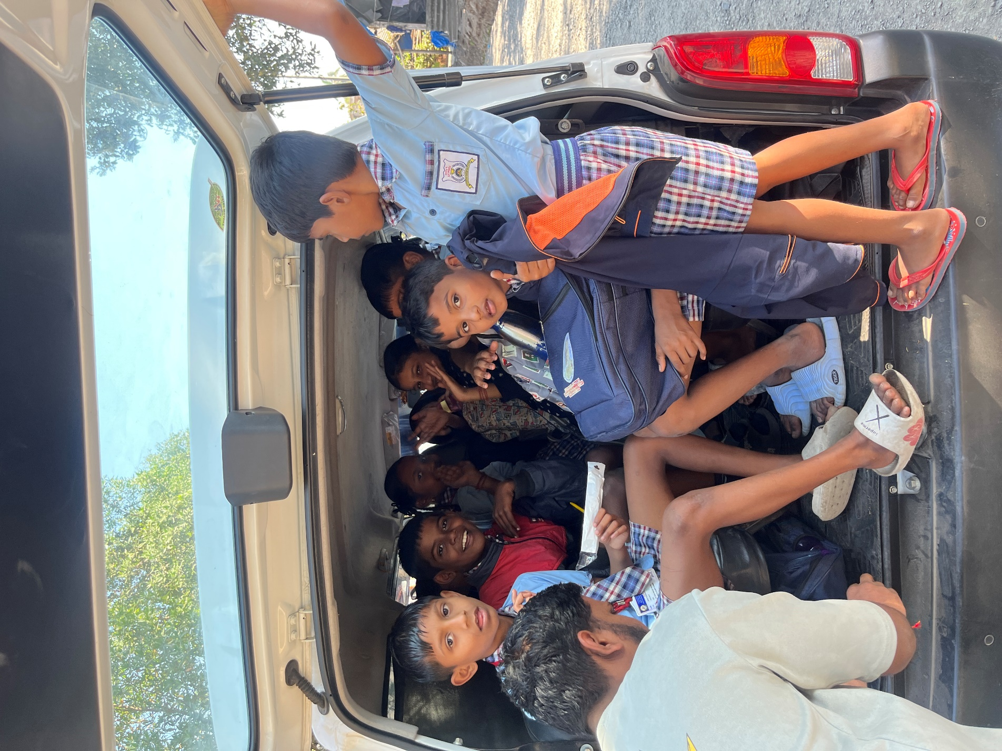

Image: 4. Sports equipment provided to the students.
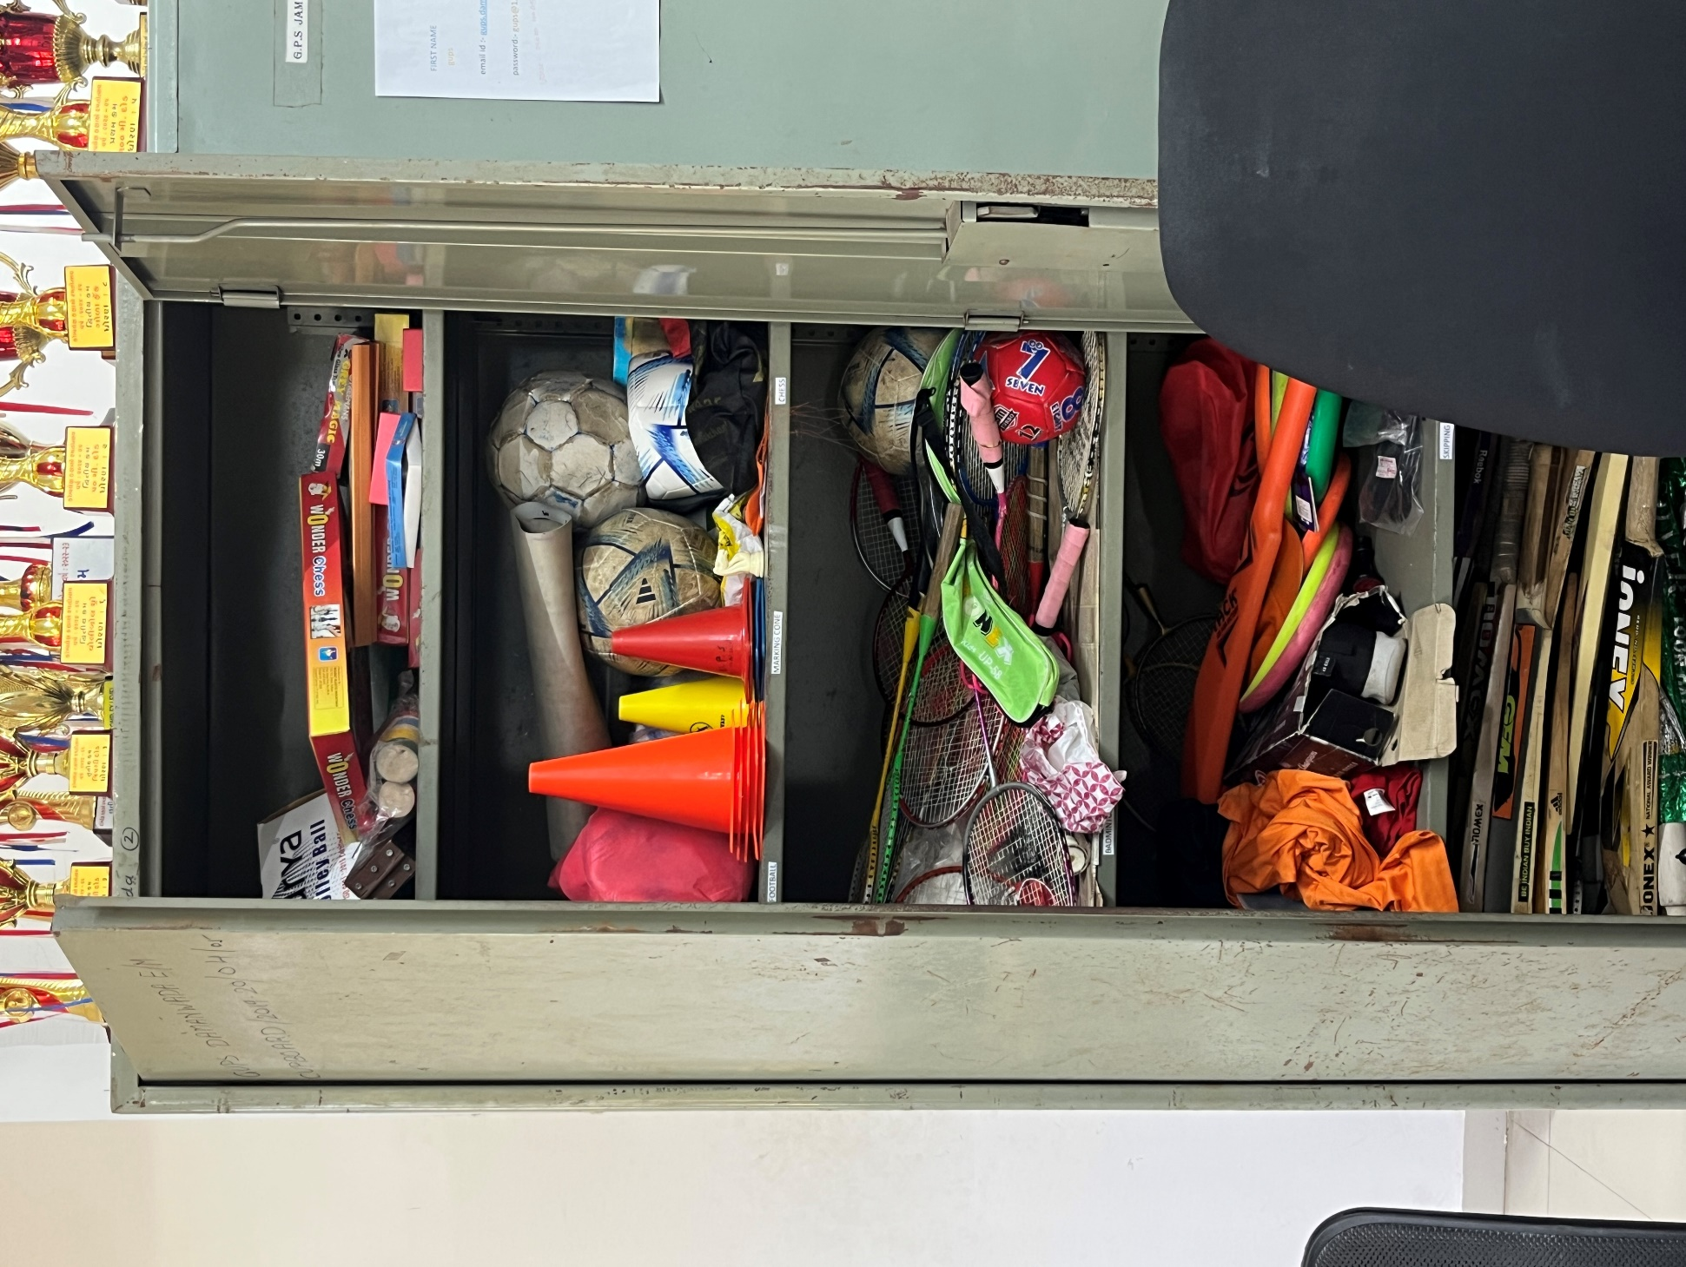
Image: 5. Overview of the library in the school.
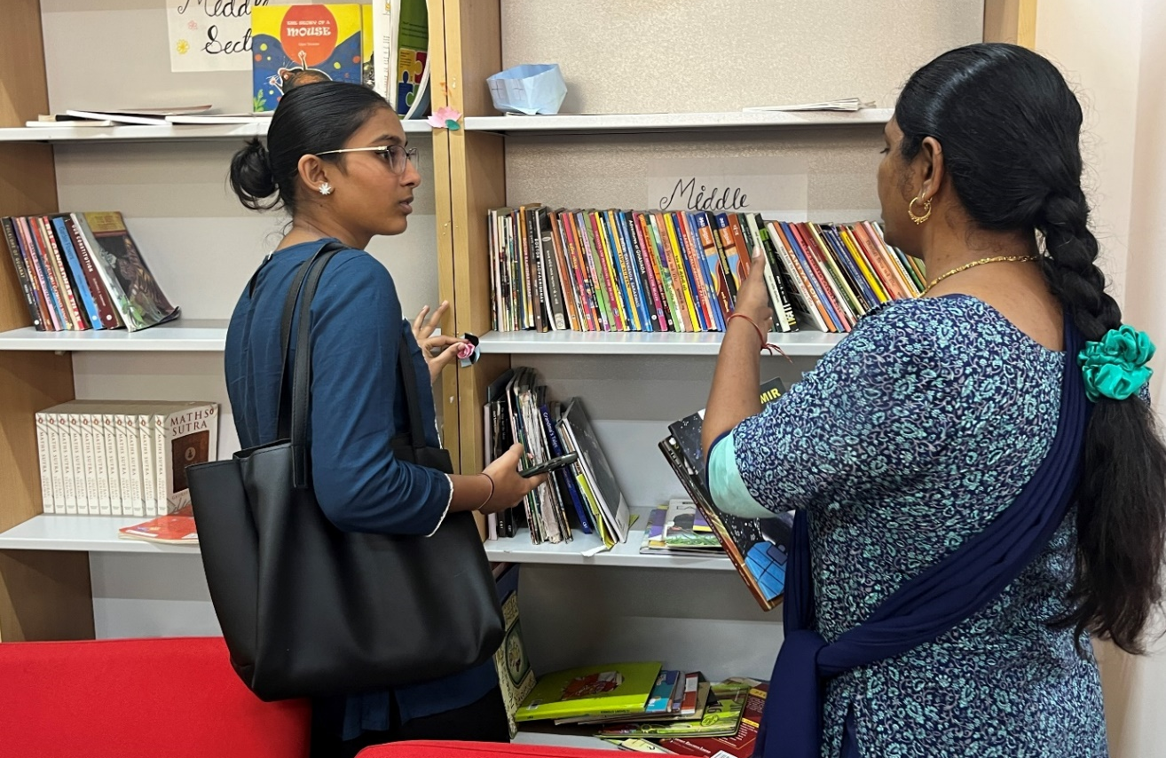
Image: 6. Indoor games played by the students.
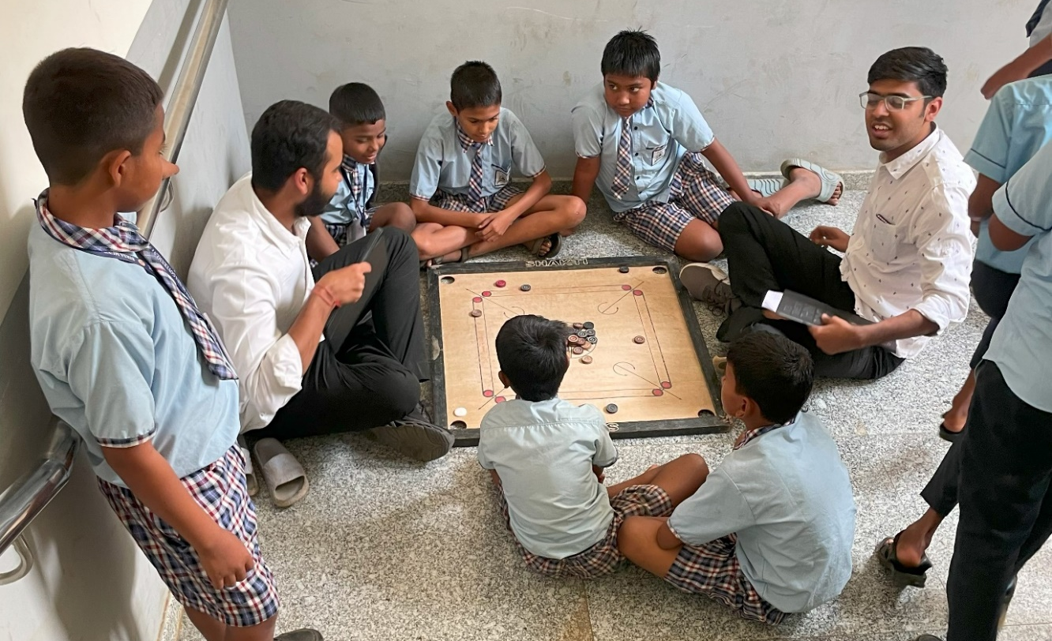
Image: 7. Interaction with the school children.
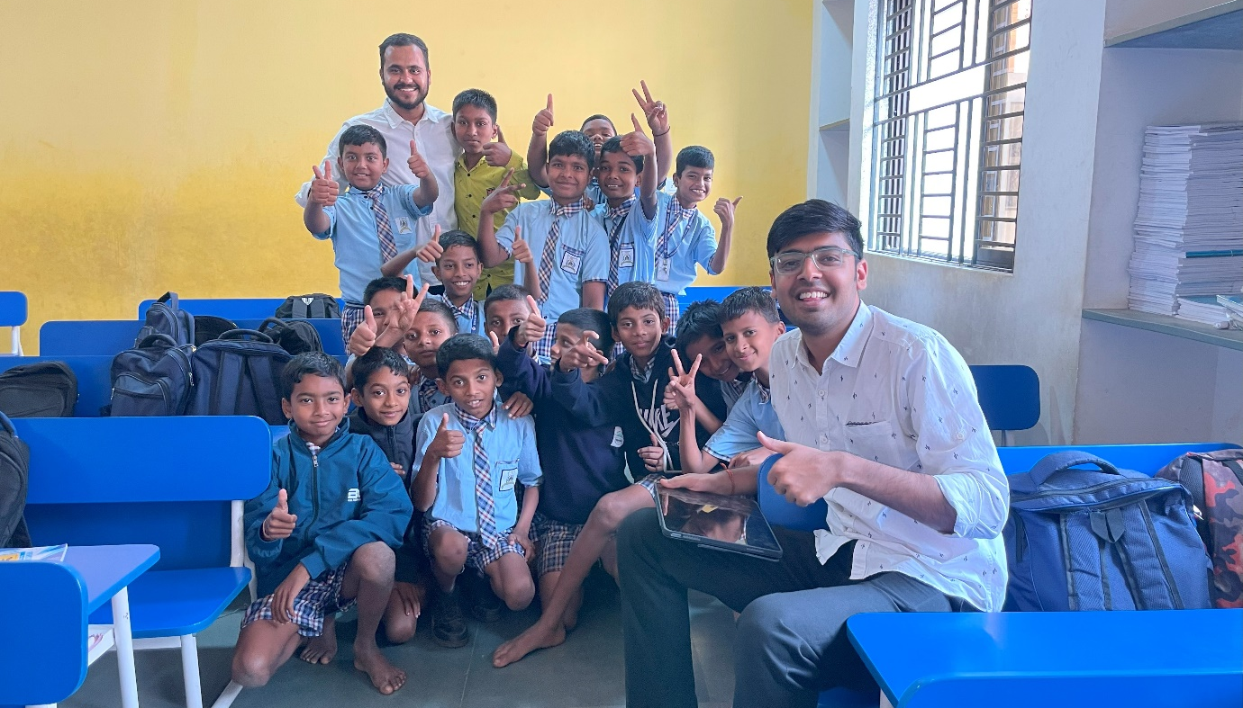
Image: 8. Best out of waste competition conducted for school children.
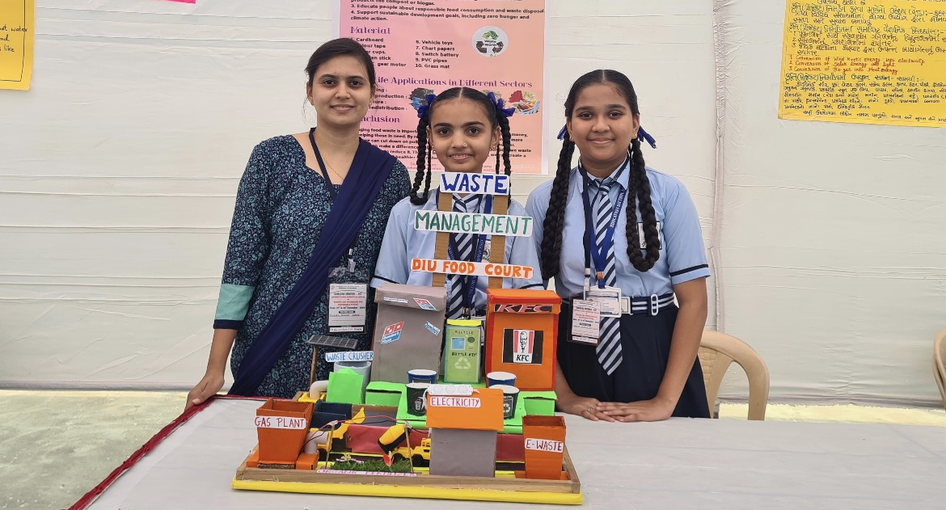
Image: 9. Mid-day meal provided by the government to students.
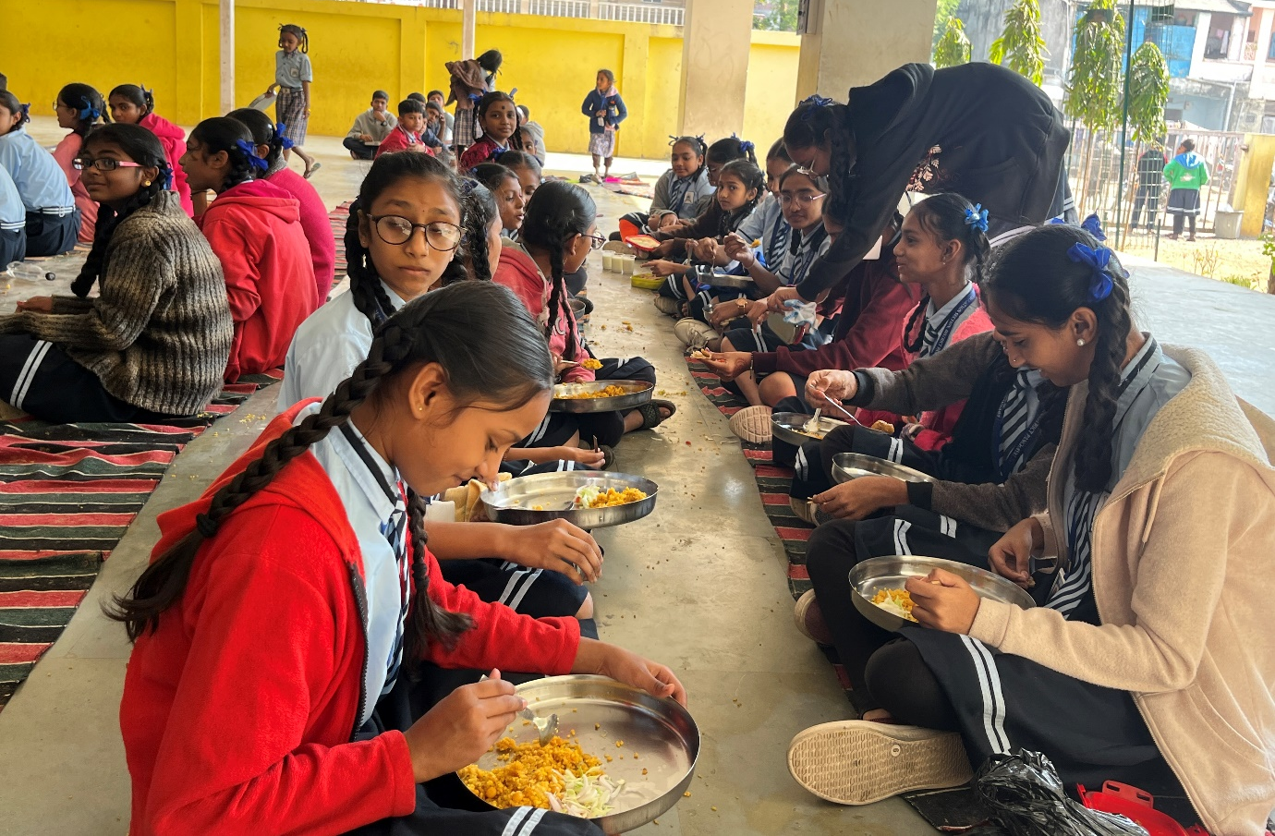
Image: 10. Mid-day meal scheme arrangement in the kitchen of the school.
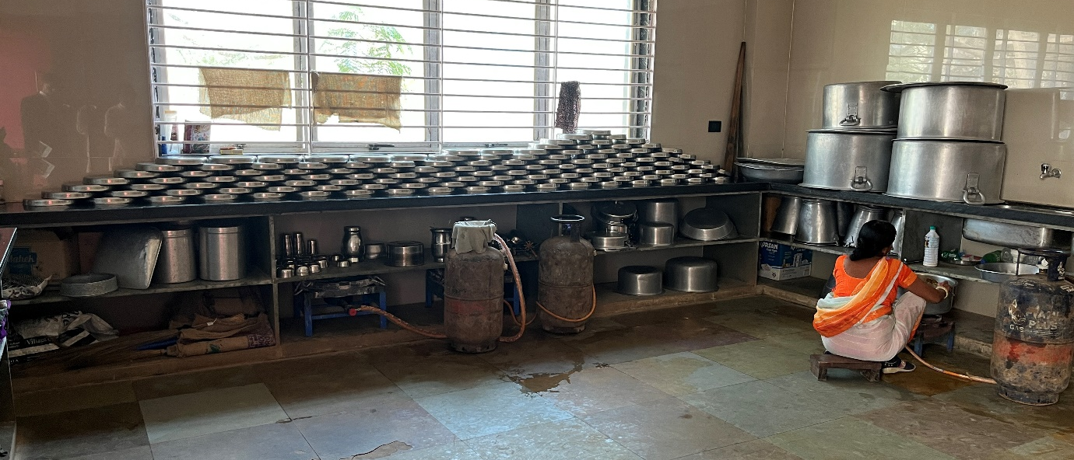
Image: 11. Interaction with the school children.
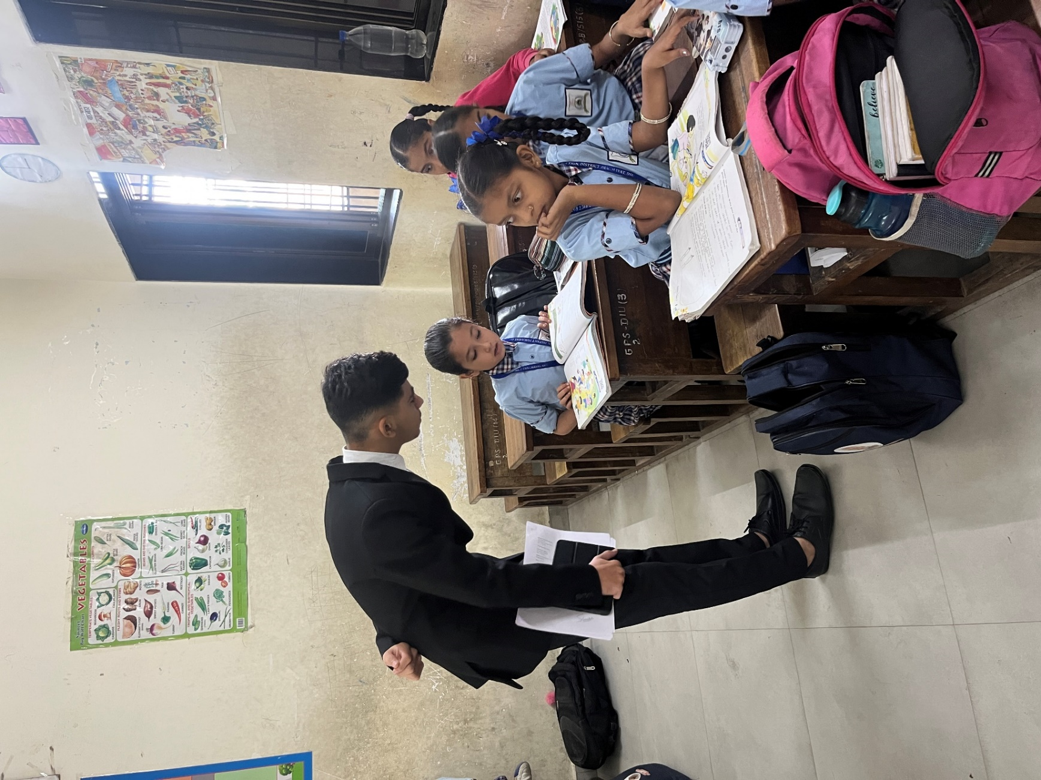
Image: 12. Overcrowded classroom in government school.
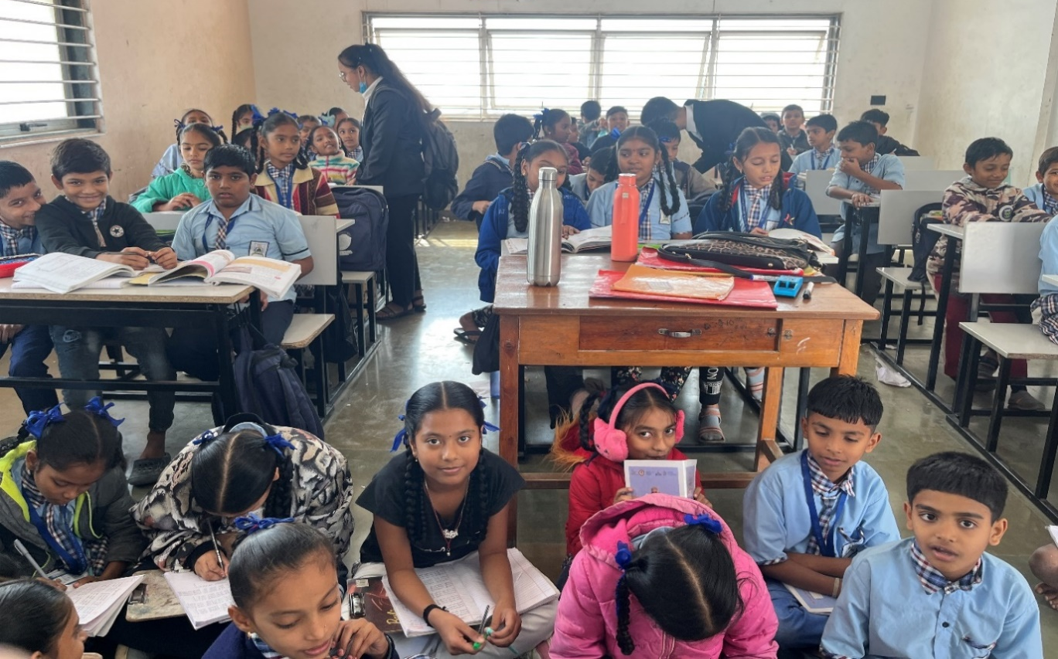
Image: 13. An Image depicting the drinking facilities provided by the school management.
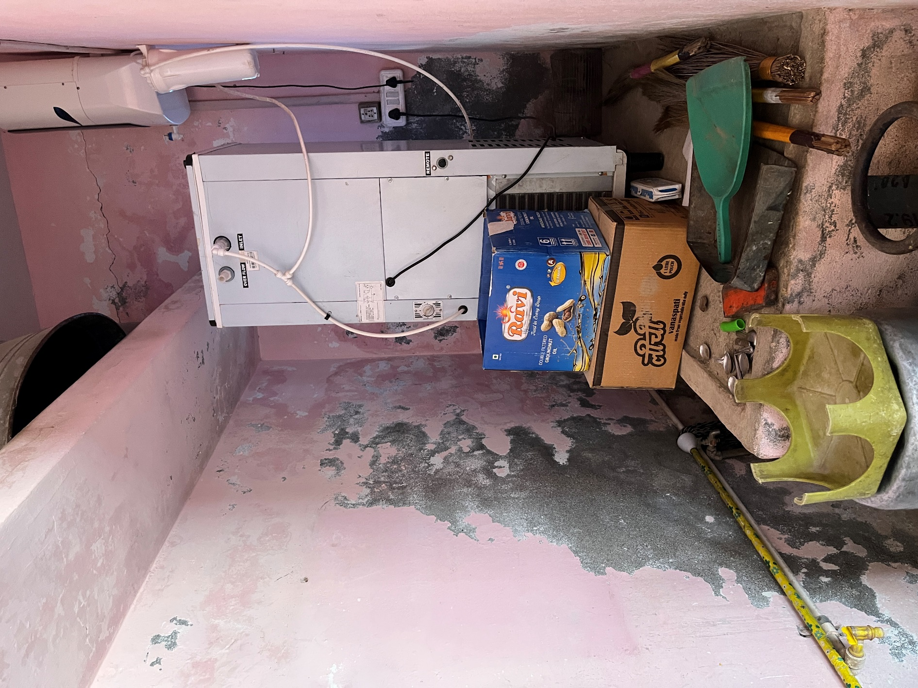

Image: 14. School building with only 2 classrooms.
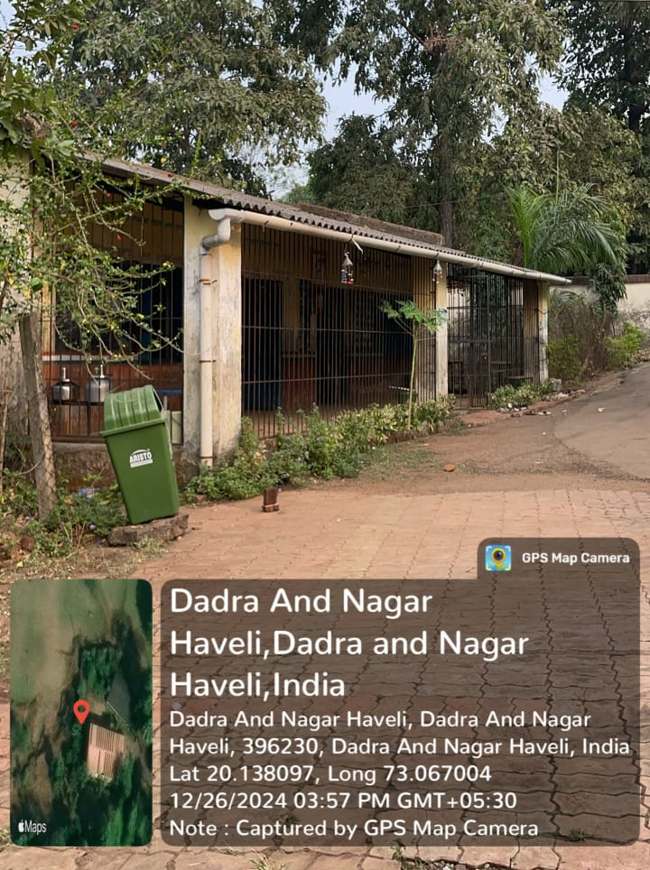

Image: 15. Treated water facilities provided to the students.
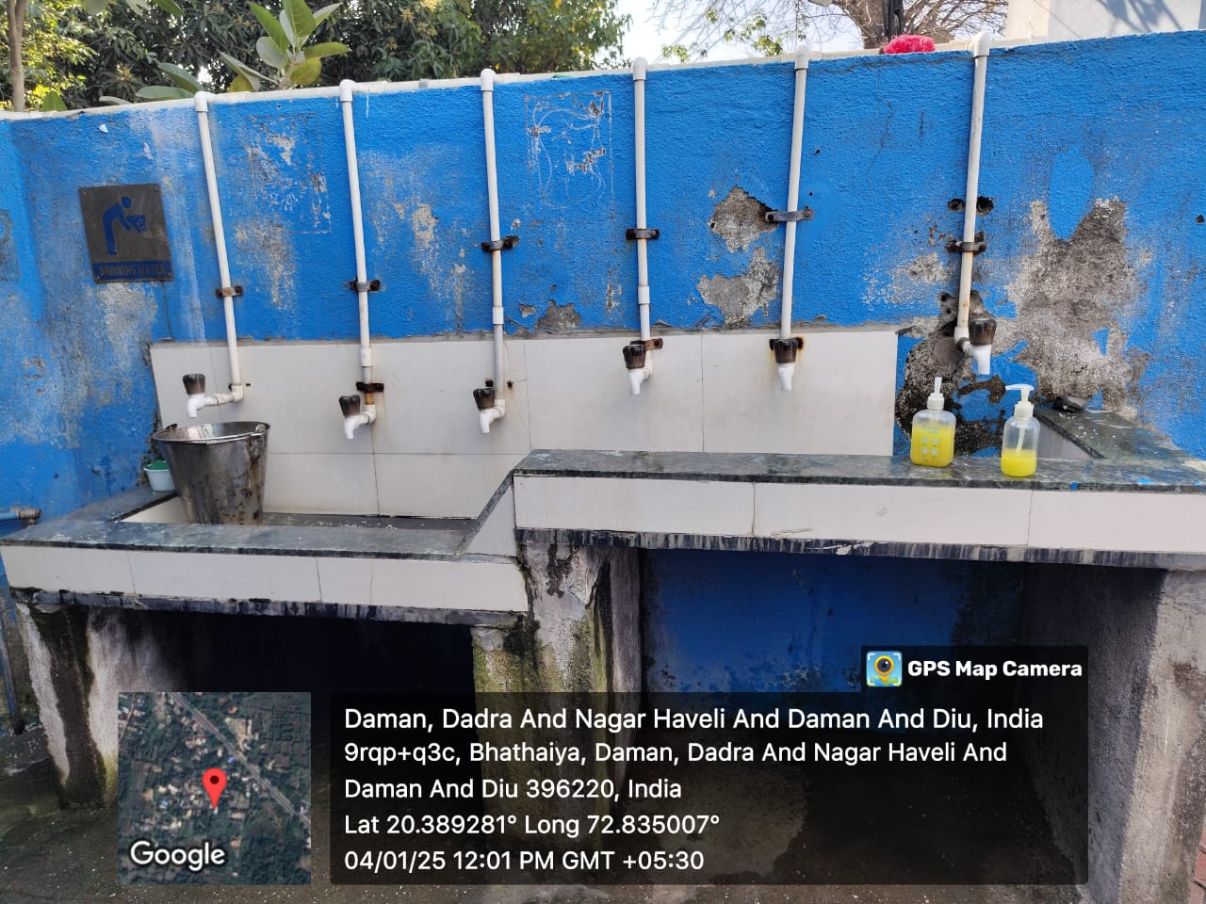
Image: 16. Cross checking of documents of the school by the team members.
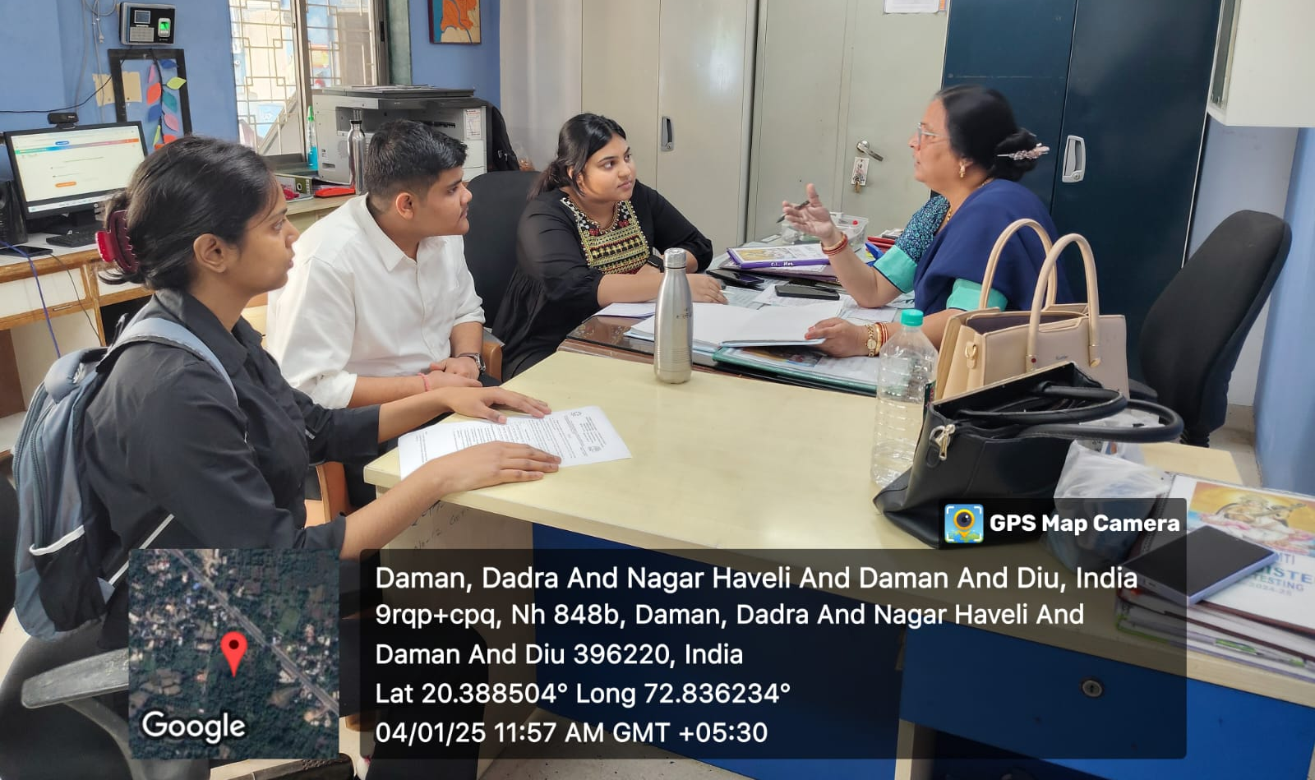
Image: 17. A meal provided to the students.
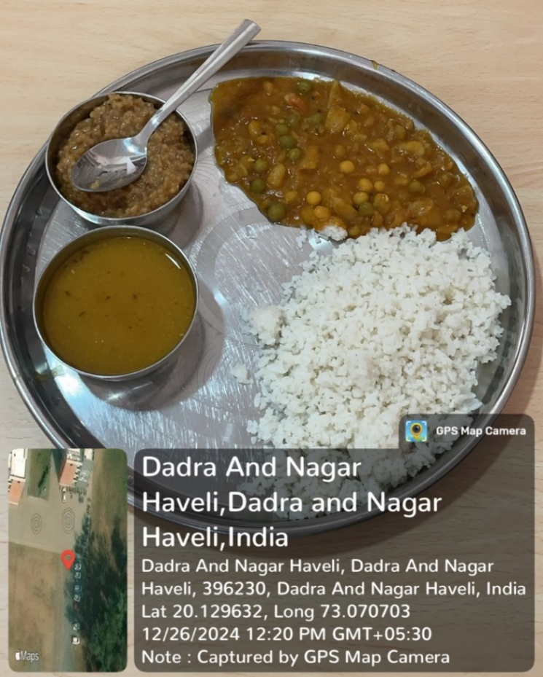
Image: 18. Testing the ability of the students to solve the maths problem.
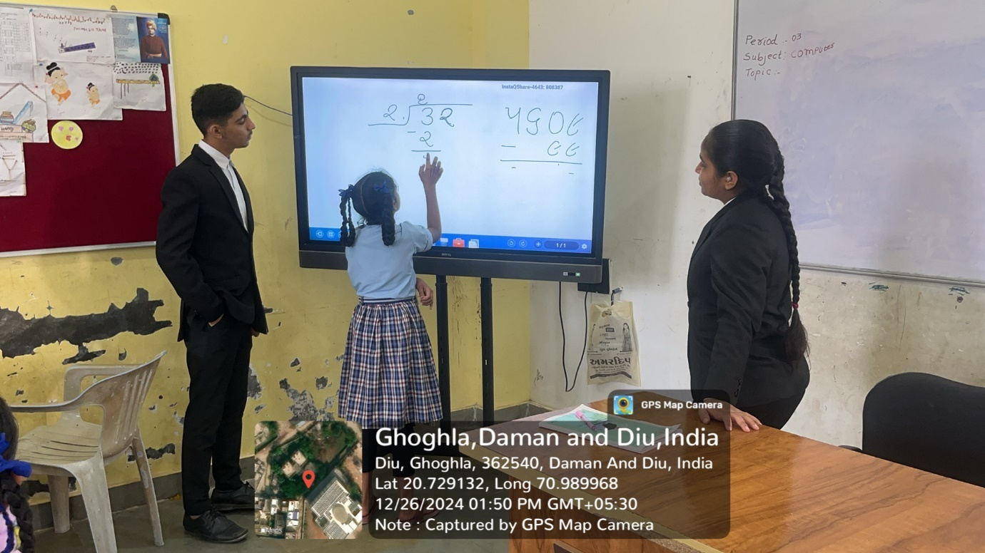
Image: 19. Mid-day meal is being served to the students.
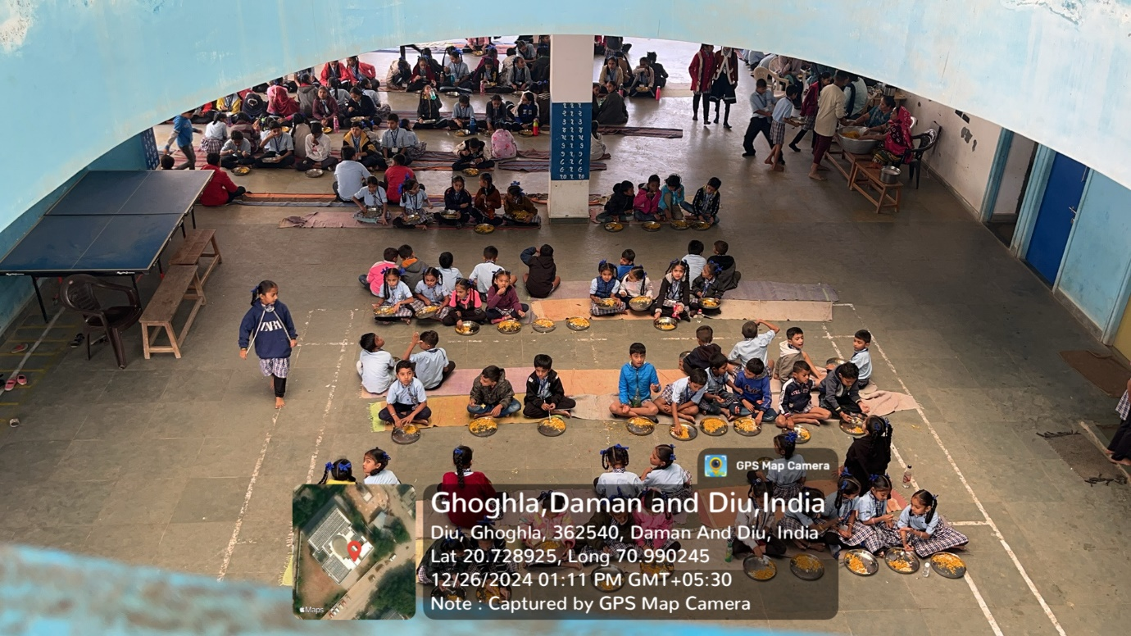

Image: 20. Trophies and awards won by little champions.
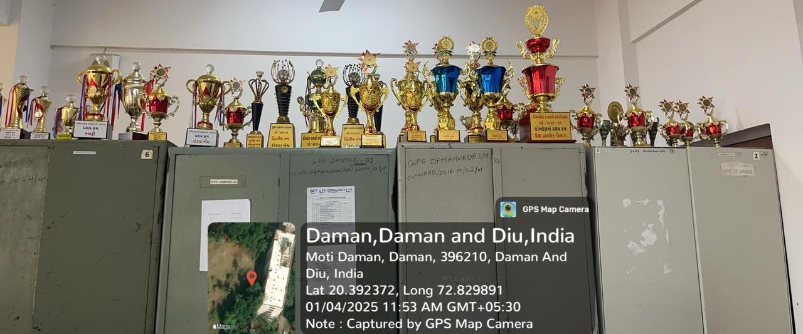

Image: 21. Students playing Basketball on the Basketball court.
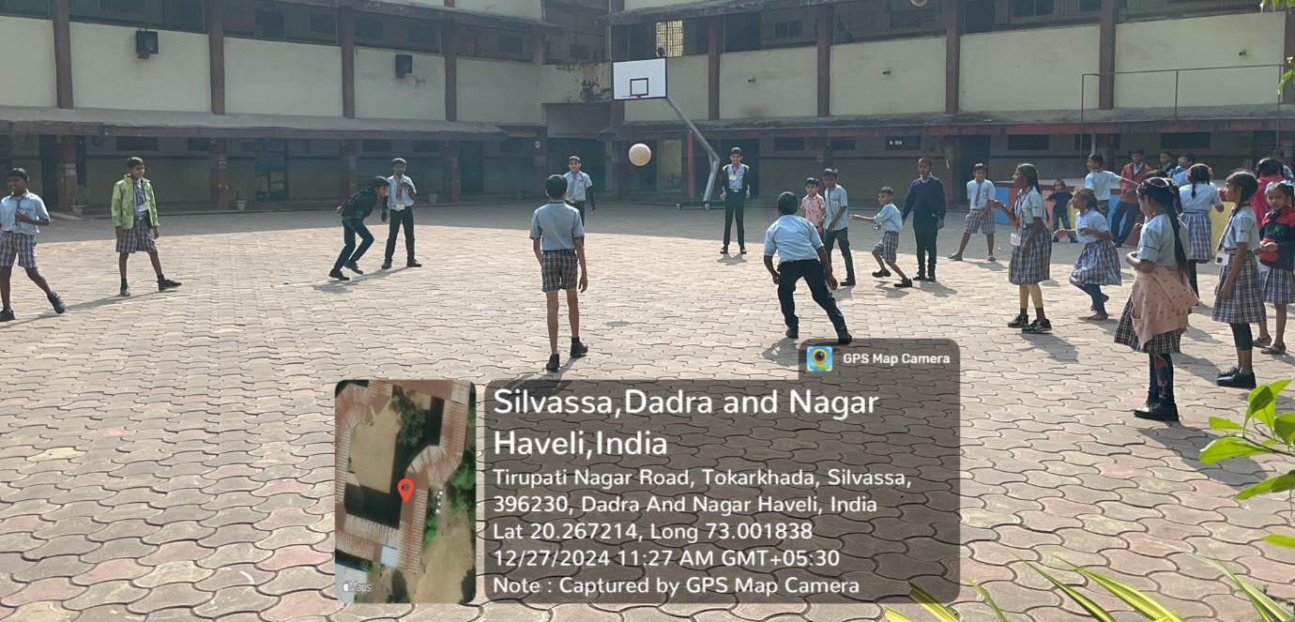
Image: 22. Classroom of the School.
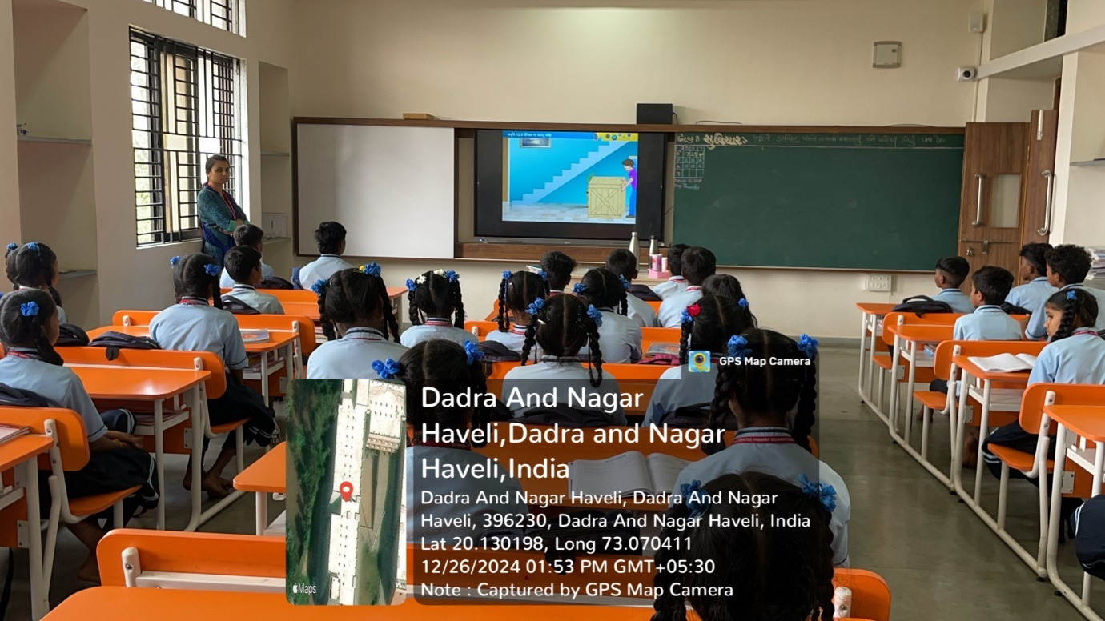

Image: 23. The water cooler and washroom are in the same corridor.
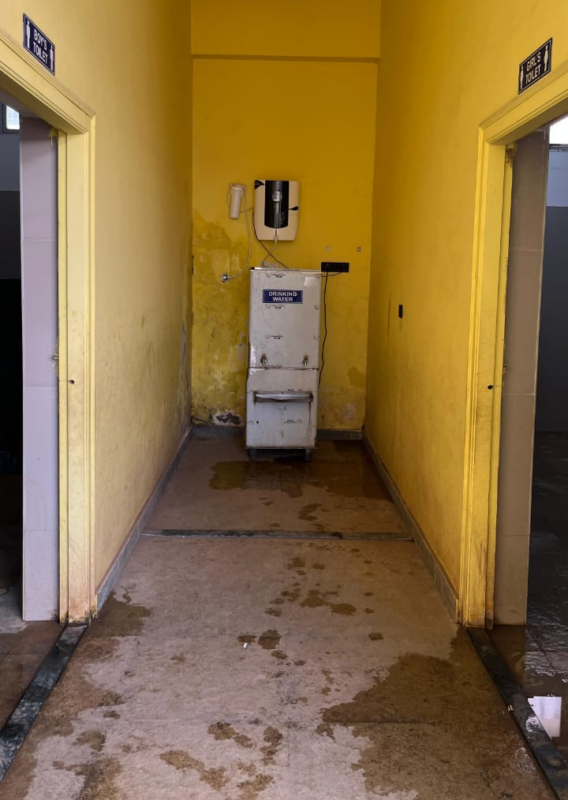

Image: 24. Students studying during the class.
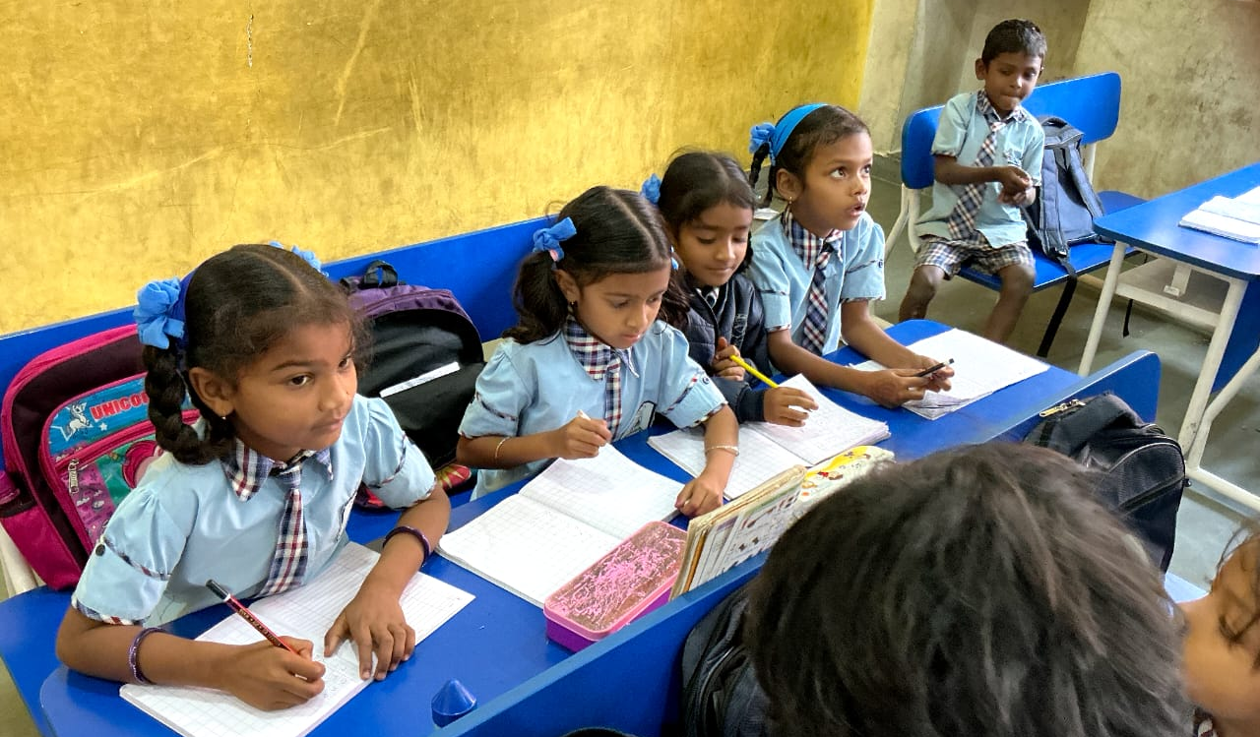

Image 25: Permission letter to conduct survey in Silvassa by the Department of Primary Education, DNH, Silvassa
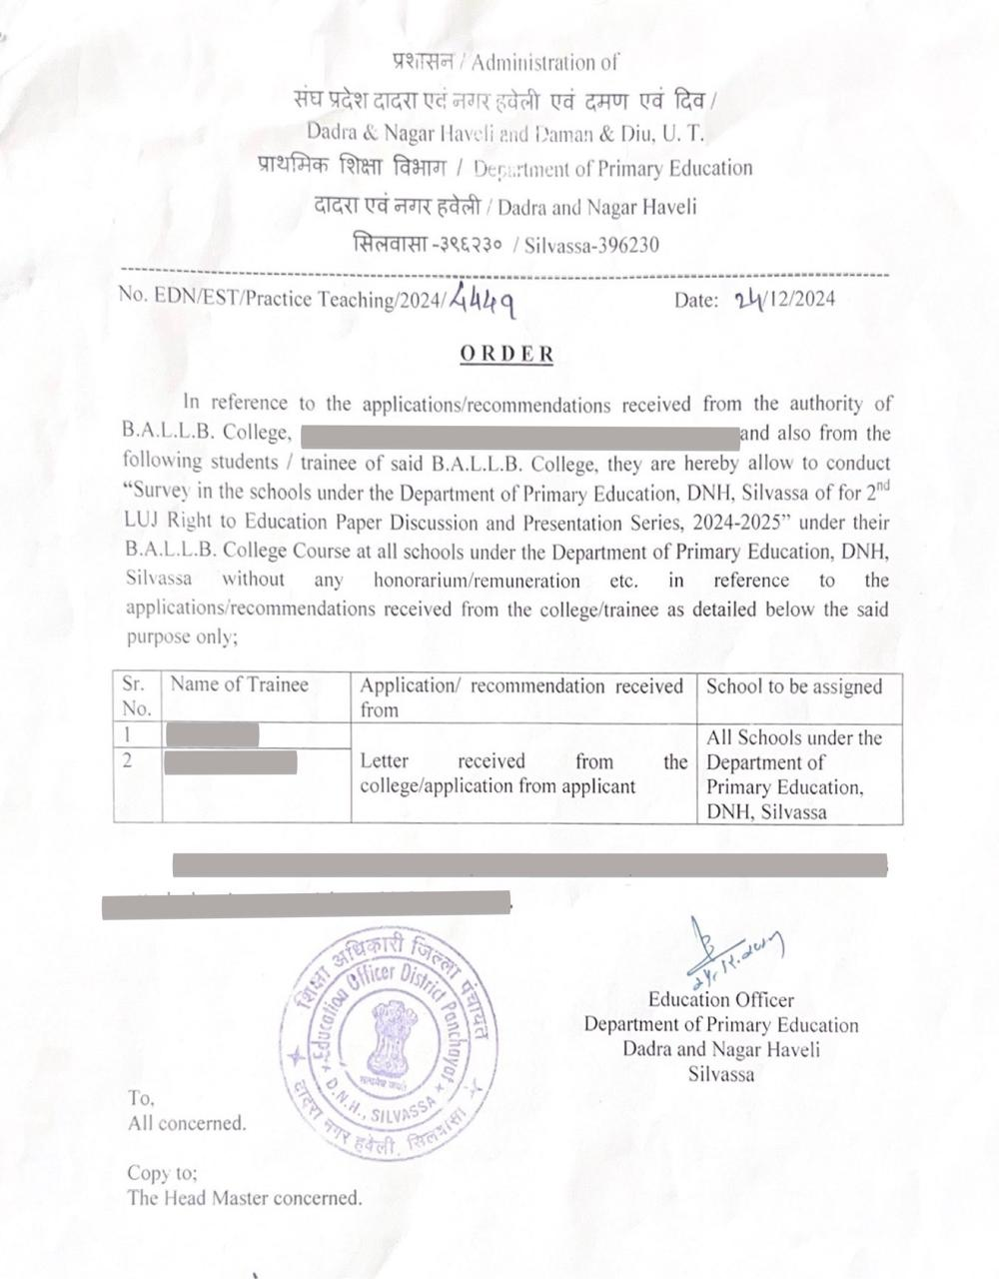

Image 26: Permission letter to conduct survey in Daman by the District Panchayat, Daman.
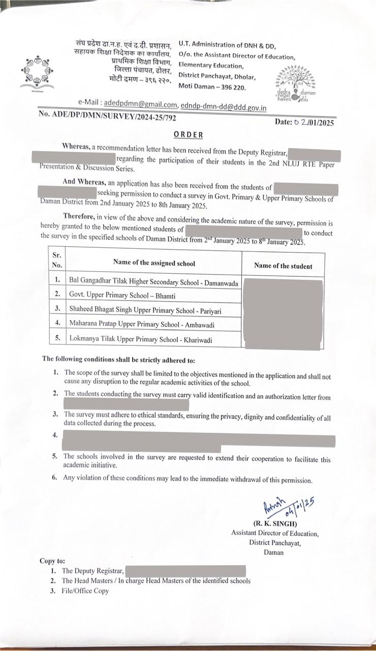

Image 27: Permission letter to conduct survey in Diu by the Education Department, Diu.

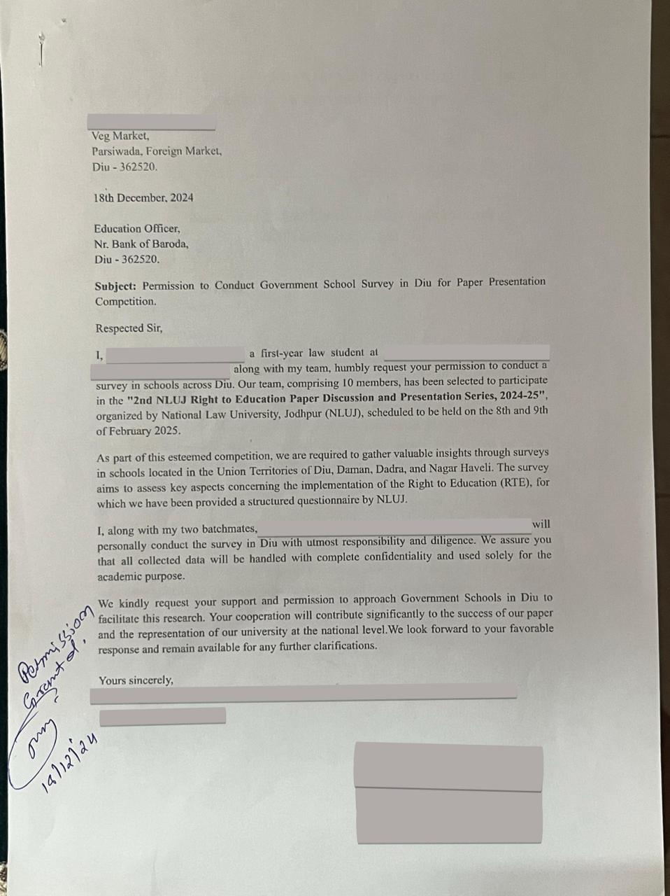

Right to Education Act, 2009, No. 35, Acts of Parliament, 2009 (India).
INDIA CONST. art. 45.
INDIA CONST. art. 39(f).
Right to Education Act, 2009, § 8, No. 35, Acts of Parliament, 2009 (India).
Right to Education Act, 2009, § 13, No. 35, Acts of Parliament, 2009 (India).
Right to Education Act, 2009, § 17, No. 35, Acts of Parliament, 2009 (India).
Right to Education Act, 2009, § 25(2), No. 35, Acts of Parliament, 2009 (India).
Right to Education Act, 2009, § 25(1), No. 35, Acts of Parliament, 2009 (India).
Right to Education Act, 2009, § 8, No. 35, Acts of Parliament, 2009 (India).
Right to Education Act, 2009, § 12(1), No. 35, Acts of Parliament, 2009 (India).
Right to Education Act, 2009, § 2, No. 35, Acts of Parliament, 2009 (India).
Right to Education Act, 2009, Sch. 2, No. 35, Acts of Parliament, 2009 (India).
Lok Sabha Secretariat (2023). Government Schools in the Country. Unstarred Question No.133. Retrieved December 4, 2023, from https://www.education.gov.in/parliament-type/lok-.
UDISE+, https://dashboard.udiseplus.gov.in (last visited Jan. 20, 2025).
Right to Education Act, 2009, § 16, No. 35, Acts of Parliament, 2009 (India).
Social & Rural Research Institute, National Sample Survey of Estimation of Out-of-School Children in the Age 6-13 in India: Draft Report (EdCIL (India) Ltd. & Rashtriya Madhyamik Shiksha Abhiyan (RMSA), Technical Support Group, [2014]).
Right to Education Act, 2009, § 21, No. 35, Acts of Parliament, 2009 (India).
Id.
Id.

