From Policy to Practice: A Survey-Based Analysis of RTE Act Implementation in Ahmedabad and Gandhinagar Schools
TABLE OF CONTENTS
Abstract 3
Introduction and significance of survey report 4
The Importance of Education as a Fundamental Right 4
Historical Evolution of Educational Policies in India 4
Judicial Interventions and Legislative Milestones 5
Objectives and Key Features of the RTE Act 5
Significance of the Survey Report 6
Methodology 7
Limitations of the Study 8
Facts and findings 8
Major issues in implementation 28
Pupil-Teacher Ratio and Staff Shortages 28
Overcrowded Classrooms 29
School Buildings and Classrooms 29
Libraries 29
Playgrounds 30
Drinking Water and Washrooms 30
Security Measures 30
Inclusivity and Gender-Specific Challenges 30
Broader Challenges in Implementation 31
Inadequate Funding 31
Policy Gaps 31
Urban-Rural Divide 32
Community Engagement 32
Suggestions 32
1. Infrastructure Improvements 32
2. Teacher Recruitment and Professional Development 33
3. Funding and Resource Optimization 33
4. Essential Facilities 34
5. Student Well-Being and Inclusivity 35
6. Community Involvement 36
Conclusion 36
ANNEXURES………………………………………………………………………………37

Abstract
This report investigates the implementation of the Right to Education (RTE) Act, 2009, in government and government-aided primary schools across Ahmedabad and Gandhinagar districts, Gujarat. Utilizing a structured survey methodology, data was collected through in-person visits and telephonic interviews across 20 schools. Quantitative findings were supplemented with qualitative insights from key stakeholders, including teachers, students, and community members. The study highlights significant challenges in compliance with RTE norms, particularly regarding pupil-teacher ratios (PTRs), infrastructure, and inclusivity. Over 72% of schools reported teacher shortages, resulting in PTRs exceeding the mandated 30:1 ratio. Urban schools faced issues of overcrowding, while rural schools grappled with insufficient classrooms, sanitation facilities, and libraries. Gender-specific barriers were prominent in rural areas, where cultural norms limited girls’ access to co-educational schools. The report also underscores gaps in essential facilities. While most schools had drinking water and sanitation infrastructure, their maintenance was often inadequate, affecting student well-being. Security concerns, such as incomplete boundary walls, were widespread. Despite these challenges, some schools demonstrated good practices, such as maintaining library issuance records and engaging in regular assemblies. To bridge these gaps, the report recommends targeted interventions, including increased funding, teacher recruitment drives, and infrastructure enhancements. Additionally, fostering community engagement through active School Management Committees (SMCs) can strengthen accountability and inclusivity. By addressing these systemic issues, this study advocates for a robust, equitable framework to fulfil the RTE Act’s vision of universal quality education, ensuring a conducive learning environment for every child.
KEYWORDS: Right to Education, infrastructure, pupil-to-teacher ratio, classrooms, Gujarat.

Introduction and significance of survey report
Education is the bedrock of human development, fostering individual empowerment and driving societal progress. Globally recognized as a fundamental right, education enables individuals to realize their potential, participate meaningfully in society, and contribute to national and global development. The Universal Declaration of Human Rights (1948) and the Convention on the Rights of the Child (1989) underscore the importance of education as a universal right. In India, this recognition has evolved through a rich tapestry of socio-political and legal developments, culminating in the enactment of the Right of Children to Free and Compulsory Education (RTE) Act, 2009.

The Importance of Education as a Fundamental Right
Education equips individuals with the tools to break the cycle of poverty, ensuring economic mobility, social inclusion, and enhanced civic participation. It directly correlates with improved health outcomes, gender equality, and sustainable development. For India—a diverse and populous democracy—universal access to quality education is critical for fostering national integration and addressing socio-economic disparities. Recognizing its transformative potential, the Indian Constitution and subsequent policy frameworks have continually emphasized the need to make education accessible and inclusive.

Historical Evolution of Educational Policies in India
The trajectory of education policies in India has been deeply influenced by the nation's socio-political and economic contexts. Historically, education was imparted through traditional institutions like Gurukuls and Madrasas, serving only limited sections of society. The colonial era introduced a formal education system tailored to meet British administrative requirements, sidelining broader educational aspirations of the masses.
Following independence in 1947, India undertook the monumental task of restructuring its education system to reflect democratic ideals and developmental priorities. Article 45 of the Directive Principles of State Policy directed the state to provide free and compulsory education for all children up to fourteen years of age. However, as a non-justiciable provision, its implementation relied on state discretion and faced challenges such as financial constraints, socio-cultural barriers, and inadequate infrastructure.
Over the years, several commissions, including the landmark Kothari Commission (1964–66), sought to reform education policies. The commission proposed a common school system to promote equity and national integration, emphasizing that education must transcend caste, class, and community divisions. Despite these progressive recommendations, universal elementary education remained an elusive goal due to persistent socio-economic challenges.

Judicial Interventions and Legislative Milestones
A significant turning point in India's education policy emerged with the Supreme Court’s judgment in Unni Krishnan J.P. v. State of Andhra Pradesh. The Court held that the right to education is implicit in the right to life under Article 21 of the Constitution, thus elevating education to the status of a fundamental right. This judicial recognition created a legal imperative for the state to take decisive action in ensuring universal access to education.
In response, the 86th Constitutional Amendment Act of 2002 was enacted, introducing Article 21A, which explicitly recognized the right to education as a fundamental right for children aged six to fourteen years. This amendment transformed education from a policy directive to a justiciable right, obligating the state to provide free and compulsory education. Additionally, Article 45 was revised to emphasize early childhood care and education for children below six years, while Article 51A(k) placed a duty on parents to ensure their children’s education.

Objectives and Key Features of the RTE Act
The Right of Children to Free and Compulsory Education (RTE) Act, 2009, operationalized Article 21A, marking a watershed moment in India's education history. Effective from April 1, 2010, the Act underscores the state’s commitment to universalizing elementary education. Its objectives extend beyond mere enrollment, aiming to ensure that every child receives quality education in a conducive environment.
Key features of the RTE Act include:
- Universal Access and Equity: The Act mandates free and compulsory education for children aged six to fourteen years in neighbourhood schools, eliminating barriers related to costs, geographical inaccessibility, or socio-economic status.
- Infrastructure and Norms: Minimum standards for infrastructure, including classrooms, sanitation facilities, drinking water, libraries, and playgrounds, are stipulated to ensure a supportive learning environment.
- Teacher-Student Ratios and Training: The Act prescribes specific pupil-teacher ratios and emphasizes teacher qualifications and professional development, ensuring effective pedagogy and personalized attention.
- Inclusive Practices: Private unaided and specified category schools are required to reserve 25% of seats at the entry level for children from disadvantaged groups, promoting social inclusion and equity.
- Prohibition of Discriminatory Practices: The Act prohibits capitation fees, screening procedures, physical punishment, and mental harassment, creating a child-friendly and inclusive educational experience.
- Continuous and Comprehensive Evaluation (CCE): The RTE Act advocates for a no-detention policy and regular assessments to foster holistic development rather than rote learning.
- Grievance Redressal: Mechanisms such as School Management Committees (SMCs) are established to involve parents and local communities in school governance, enhancing accountability and transparency.

Significance of the Survey Report
This survey report evaluates the implementation of the RTE Act in primary government and government-aided schools in Ahmedabad and Gandhinagar districts, focusing on pupil-teacher ratios, infrastructure, inclusivity, and governance. It highlights achievements, challenges, and provides actionable insights for informed policy-making to uphold universal education.
The report bridges legislative intent and ground realities, advocating targeted interventions to improve infrastructure, governance, and equitable access, ensuring every child’s right to quality education.

Methodology
The empirical research for this report was conducted using a structured survey-questionnaire approach. The primary focus was to gather first-hand data from primary government and government-aided schools in Ahmedabad and Gandhinagar districts of Gujarat. The methodology combined quantitative and qualitative techniques to ensure a comprehensive understanding of the implementation of the Right to Education Act, 2009.
The survey was conducted in person for the majority of schools, allowing for direct observation of infrastructural facilities, classroom environments, and interactions with key stakeholders. This on-ground engagement enabled a nuanced understanding of the school ecosystem and its alignment with the RTE mandates. However, due to logistical challenges, such as geographical inaccessibility and time constraints, a subset of schools was surveyed via telephonic conversations. These conversations followed a structured format to maintain consistency with the data collected during in-person visits.
In addition to the questionnaire-based data collection, personal interactions with various stakeholders were undertaken to supplement the quantitative findings. Teachers, students, non-teaching staff, and local community members were engaged in informal interviews and discussions. These interactions provided valuable qualitative insights into issues such as teacher availability, infrastructural adequacy, and community perceptions of school functioning. Focused group discussions were also organized where feasible, particularly with groups of students, to understand their experiences and challenges under the RTE framework.
To ensure the credibility and reliability of the data, efforts were made to cross-verify responses from different stakeholders. Observational notes taken during school visits further enriched the dataset, capturing details that might not have been explicitly mentioned in the responses.

Limitations of the Study
The study encountered limitations despite best efforts. Logistical challenges prevented physical access to some remote schools, requiring telephonic surveys, which, despite efforts to ensure accuracy, lacked the benefits of direct observation, potentially causing minor gaps in understanding. Additionally, time constraints restricted the scope of focused group discussions, limiting opportunities for deeper insights into specific issues that could have enhanced the study’s overall findings.
Overall, the methodology adopted reflects a balanced and rigorous approach, combining structured surveys with qualitative techniques to provide a holistic analysis of RTE implementation.

Facts and findings
As per Section 18 of the RTE Act, 2009, no school can be established without first obtaining a certificate of registration. Additionally, Section 19 stipulates that no school may be established or granted recognition under Section 18 unless it complies with the norms and standards specified in the Schedule of the Act. Furthermore, Section 25 requires the appropriate government and local authorities to ensure that the prescribed Pupil-Teacher Ratio, as outlined in the Schedule, is achieved within three years of the Act's commencement. The Schedule outlines key requirements, including specific Pupil-Teacher Ratios for various grade levels, the number of special education teachers necessary for students with special needs, infrastructure facilities, minimum working days, the establishment of libraries, and the provision of play materials.
The survey encompassed an evaluation of 20 schools within the sampling area, aiming to conduct an in-depth analysis of the general state of schools in the region and to examine the effectiveness of the RTE Act's implementation and its provisions. The schools included in the assessment were:
- Chenpur Primary School
- Sughad Primary School
- Tragad Primary School
- Ambapur Pay Centre (Paharkendra) School
- Jagatpur Primary School
- Madhuri Mansukhlal Vasa Primary School
- R.N. Patel Primary School
- Kudasan Primary School
- Juna Koba Primary School
- Makarba Primary School
- Randesan Primary School
- Hudko Bhatt Primary School
- S. V. English medium Primary School
- Zalana Muvada Primary School
- Por Primary School
- PM Sri Kendriya Vidyala
- Adalaj Kumar Primary School
- Adalaj Kanya Primary School
- Khoraj Primary School
- Adarsh Nivasi School
- Lowest Class in School :
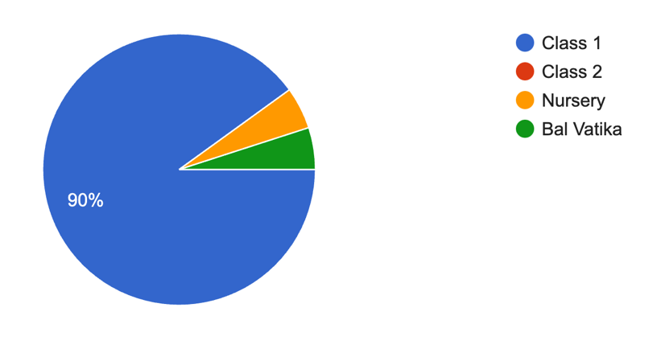
Out of the 20 schools surveyed, the majority started at Class 1, marking the beginning of primary education. However, two schools also included pre-primary sections—Juna Koba Primary School had a nursery section, and Madhuri Mansukhlal Vasa Primary School began at the Bal Vatika level. Except for these two cases, most schools began at Class 1, catering to students aged 6 years and above.
- Highest Class in School:
Class | Number of Schools
Class 6 | 1
Class 8 | 19
Out of the 20 schools surveyed, 19 offered education up to Class 8, while Madhuri Mansukhlal Vasa Primary School had its highest grade at Class 6. Discussions with students from secondary sections highlighted challenges faced by those transitioning to higher grades when their schools only provided education up to Class 6 or Class 8. For students from economically weaker backgrounds, moving to a new school for higher education proved particularly difficult, as it often involved financial and logistical constraints. This transition was especially challenging in areas with limited options for nearby schools offering secondary education. However, in schools that offered both primary and secondary grades under the same institution, students reported a much smoother transition. They did not face the same disruptions or challenges as those who needed to switch schools, which underscores the importance of providing secondary education within the same school wherever possible.
- Location of School:
Location | Number of Schools
Rural | 11
Semi-Urban | 6
Urban | 3
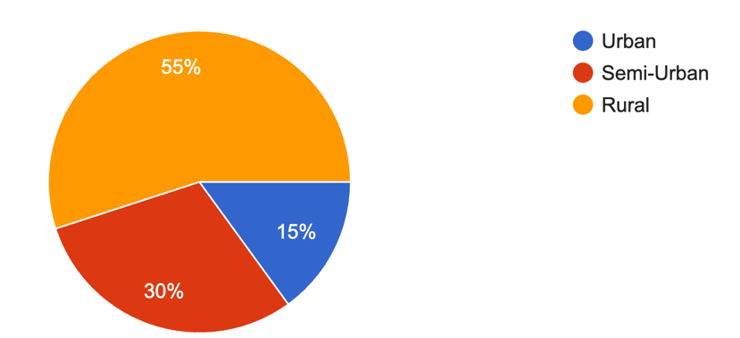
In the survey conducted across Ahmedabad and Gandhinagar, 11 schools were selected from rural areas, 6 from semi-urban regions, and 3 from urban localities. This distribution was deliberately designed to prioritize rural schools, recognizing that they often face the most significant challenges in implementing RTE Act, 2009.
- Clientele of School:
Clientele | Number of Schools
Co-ed | 16
Girls Only | 2
Boys Only | 2
The survey revealed that out of 20 schools, 16 were co-educational, 2 catered exclusively to girls, and 2 were boys-only schools. While the dominance of co-ed schools promotes inclusivity and resource sharing, the limited number of single-gender schools, particularly in rural areas, raises concerns.
- Accessibility to School by means of an All-Weather Road
Accessibility | Number of Schools
Accessible by means of an All-Weather Road | 17
Not accessible by means of an All-Weather Road | 3
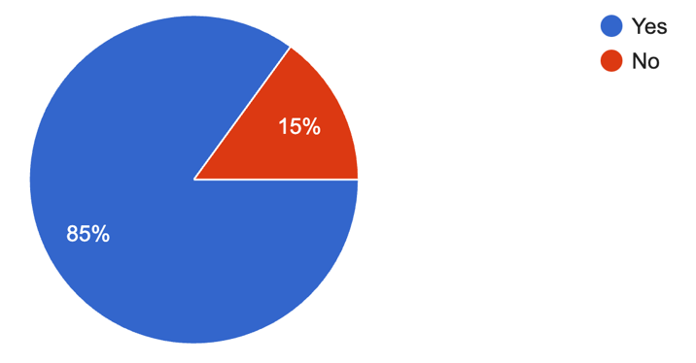
- Shift system in Schools
Shift System | Number of Schools
Runs in shifts | 5
Does not run in shifts | 15
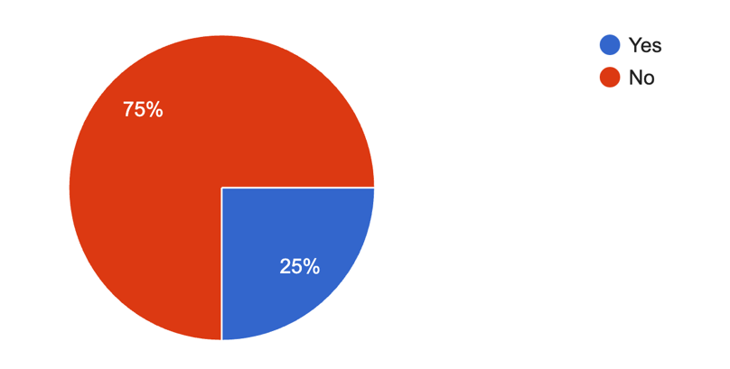
- Number of Students in Grades 1 to 5 present on the day of visit
No. of Students Present (Grades 1-5) | Attendance Category | Reason/Observation
210 | Over 80% | Regular attendance and local engagement
160 | Over 80% | Regular attendance and community support
78 | Below 80% | seasonal illnesses (severe winters)
398 | Over 80% | High awareness of the importance of education
249 | Over 80% | Strong school infrastructure
226 | Over 80% | Positive parent-school collaboration
300 | Over 80% | Accessible transportation to school
68 | Below 80% | Uttarayan Celebrations
100 | Over 80% | Active school management
918 | Below 80% | Low attendance due to Uttarayan holidays
150 | Over 80% | Supportive learning environment
171 | Over 80% | Favourable academic culture
653 | Over 80% | Effective school administration
Most schools maintained over 80% attendance, driven by factors like strong infrastructure, community involvement, and effective administration. Lower attendance was primarily linked to seasonal holidays or health-related issues.
- Number of Teachers for Grades 1 to 5
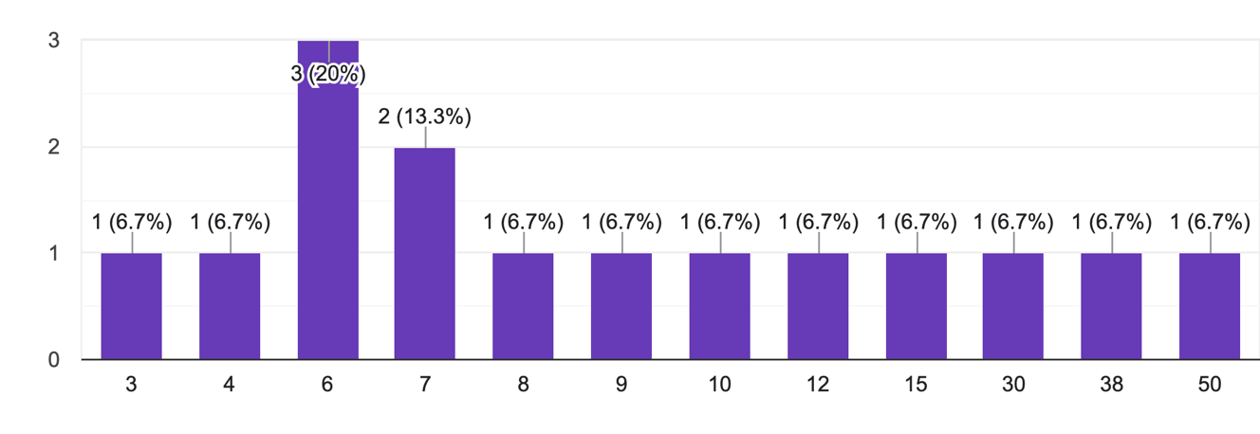
The distribution indicates that most schools (20%) have six teachers, while a few have significantly fewer or more, highlighting disparities in teacher allocation.
- Number of Teachers present on day of visit as per school statement
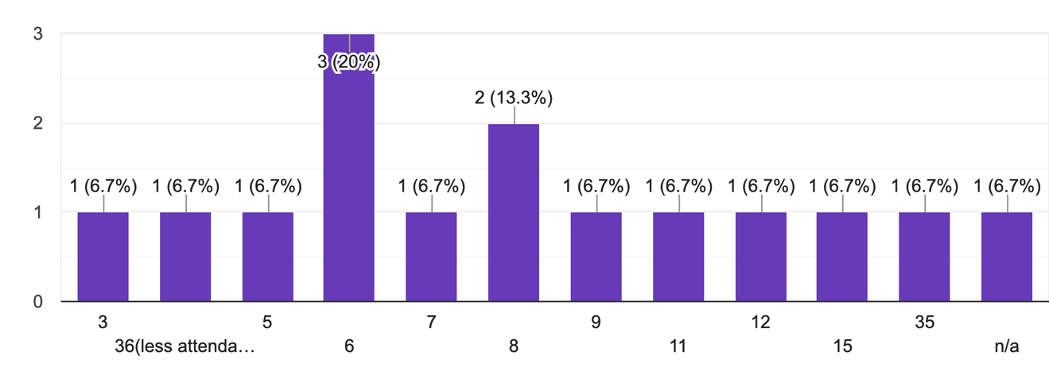
The majority (20%) reported six teachers present, with variations in attendance across other categories, indicating inconsistencies in daily teacher presence.
- Number of students enrolled in the school
Number of students | Number of Schools
Less than 60 | 1
Between 61-90 | 4
Between 91-120 | 1
Between 120-200 | 1
Above 150 | -
Above 200 | 11
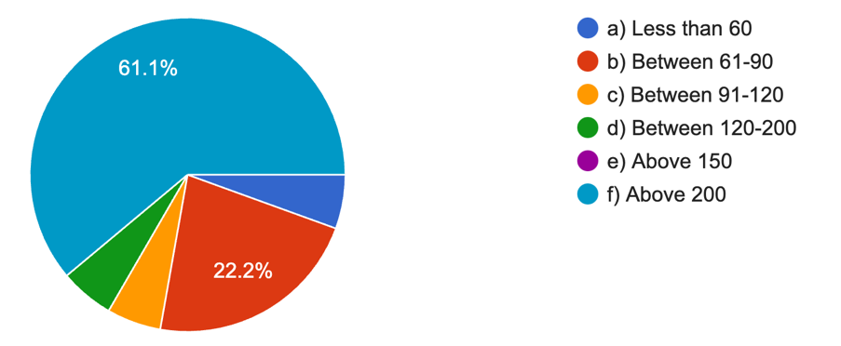
- Teacher-Pupil Ratio from Classes 1 to 5
Appropriate Teacher-Pupil Ratio | Number of Schools
Yes | 13
No | 5
Data unavailable | 2
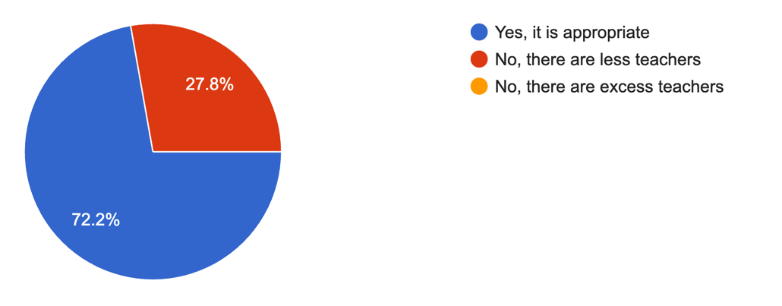
- Number of Non-teaching staff
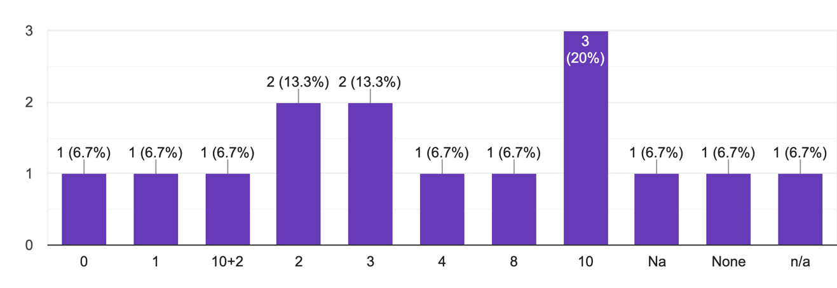
Three schools reported having around 10 non-teaching staff, while one had 12. Two schools had three, another two had two, and most others either had only one or lacked available data on non-teaching staff.
- Payment of salary of Non-teaching staff
Source of Salary Payment | Number of Schools
Paid by the government | 3
Paid by the state government | 1
Paid using a school grant | 2
Paid through a trust mandal system | 2
Paid via internal contracts | 1
Paid by the school itself | 1
Data unavailable | 10
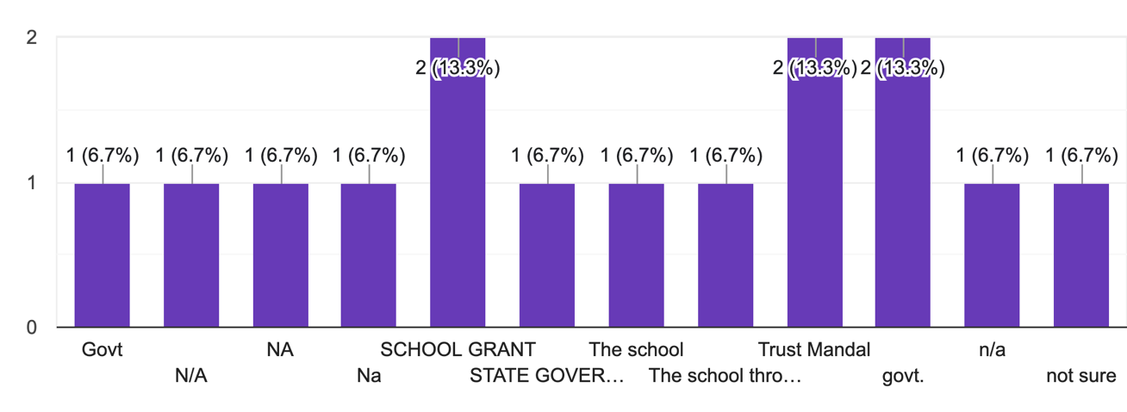
- Duties assigned to the Non-teaching Staff
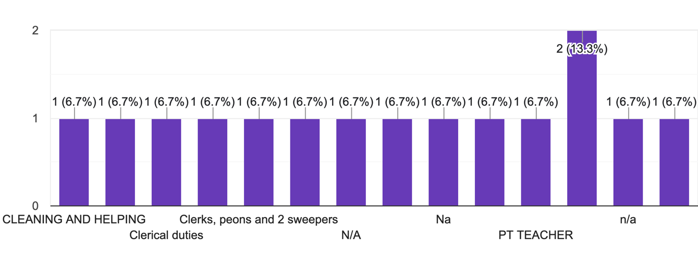
Most of the non-teaching staff primarily handled responsibilities such as cleaning, assisting with clerical tasks, serving as peons, and working as physical education (PT) instructors.
- Type of Building
Source of Salary Payment | Number of Schools
Pucca | 16
Partially Pucca | 3
Kaccha | N/A
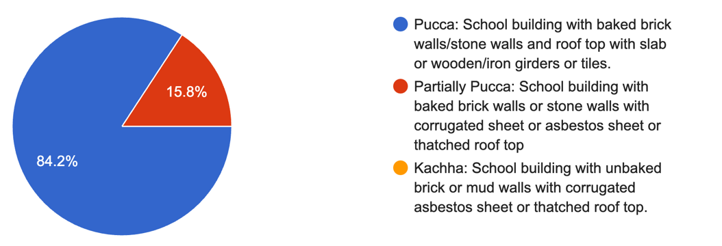
- Number of Rooms in the School Building
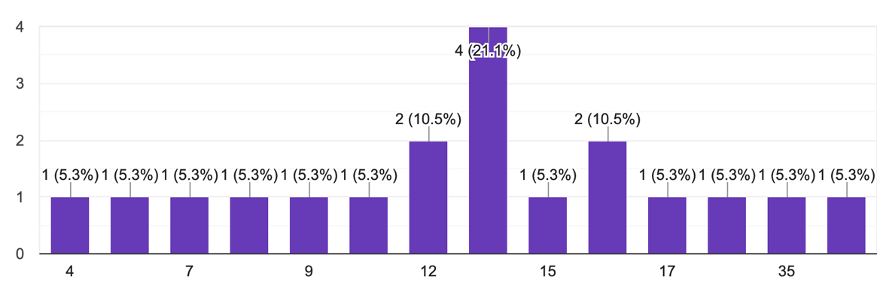
Notably, seven schools had approximately 12 to 15 rooms, while two schools had 16 rooms. One school had 35 rooms, and the remaining schools had the number of rooms as indicated in the graph.
- Total Number of Classrooms
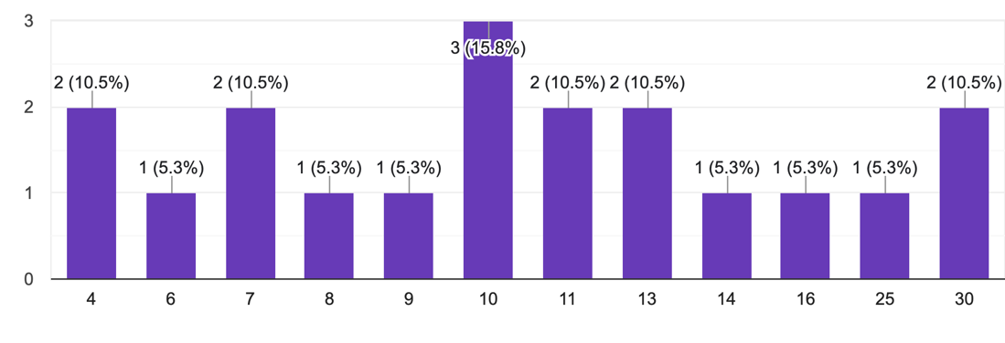
- Existence of one classroom per teacher
Existence of teachers who have classrooms | Number of schools
Yes | 12
No | 7

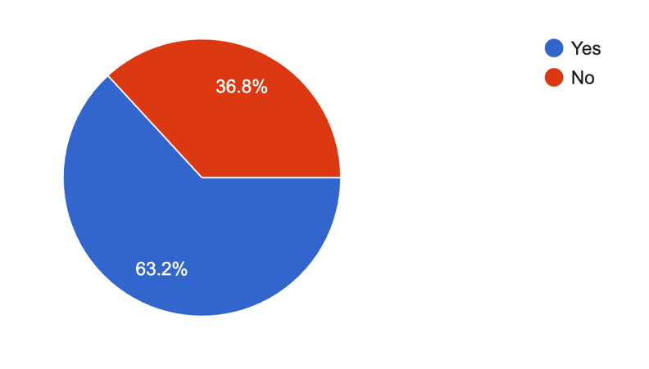
This implies that the teachers as a resource are not being utilized enough and we need better capitalization of our human resources through advanced infrastructure
- Availability of Head Teacher in case of pupils being more than 150
Availability of Head Teachers | Number of schools
Yes | 13
No | 2
N/A | 3

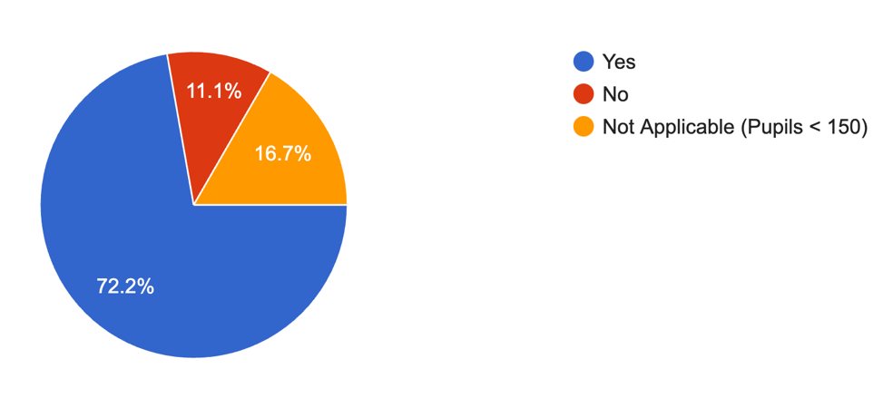
- In case of a Head Teacher, the availability of a room for them
Availability of Rooms for Head Teachers | Number of schools
Yes | 9
No | 5

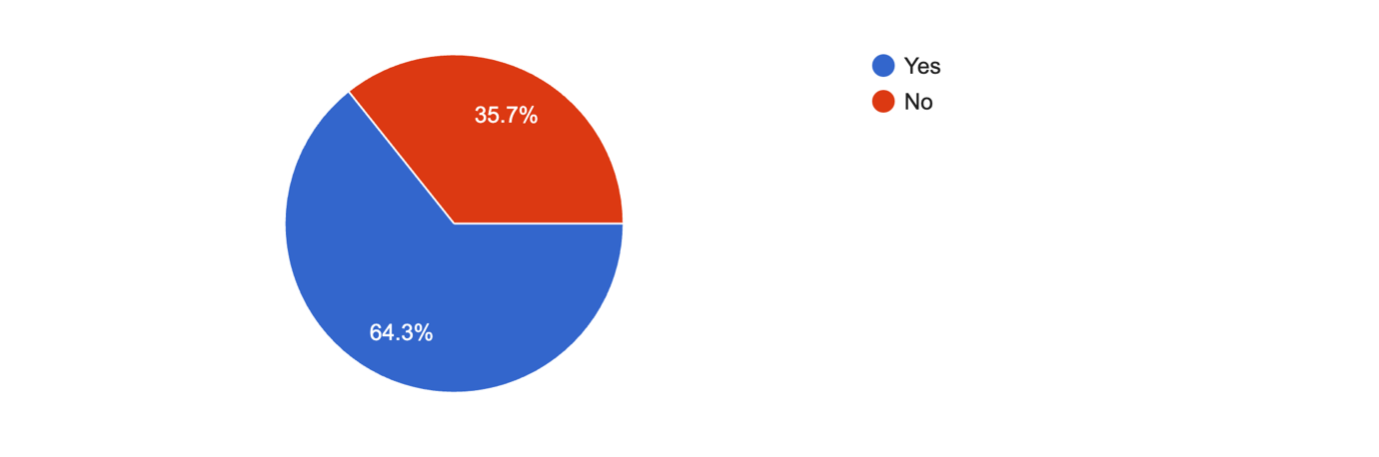
Schools with more than 150 pupils generally have a Head Teacher present, reflecting compliance with administrative standards.
- Classrooms in need of Minor Repair
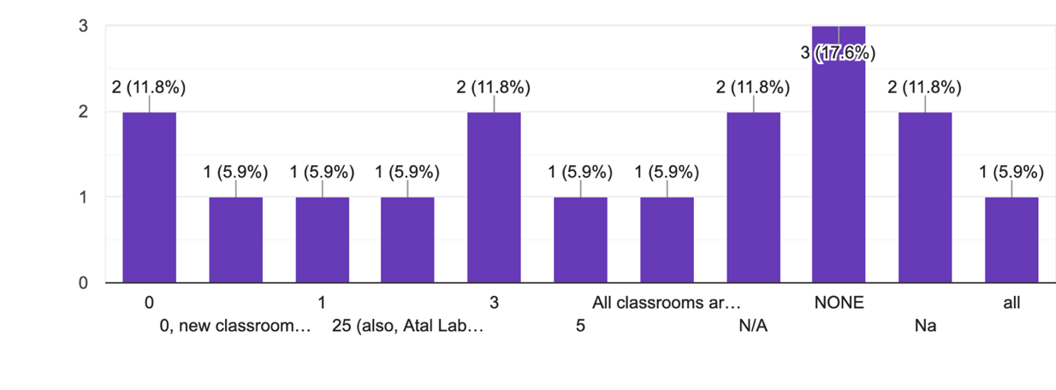
A significant percentage of classrooms require minor repairs, suggesting maintenance needs.
- Number of Classrooms in need of Major Repair
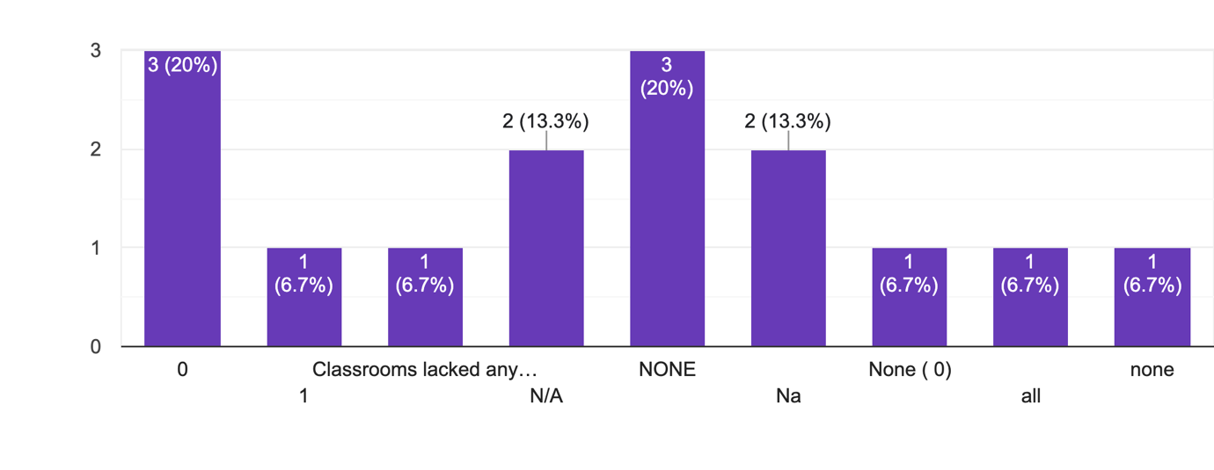
The number of classrooms needing major repairs is relatively low, indicating moderate infrastructure challenges.
- Number of other rooms needing repair
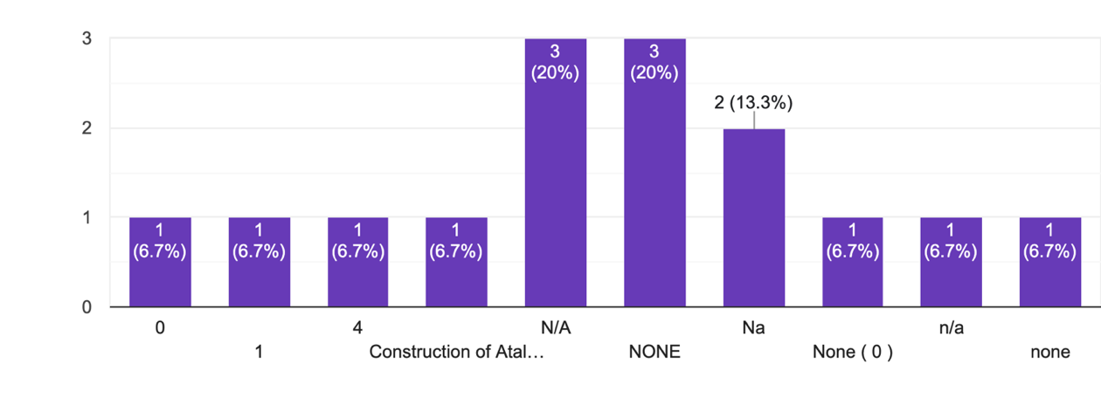
The number of classrooms needing major repairs is relatively low, indicating moderate infrastructure challenges.
- Availability of a Library
Availability of Library | Number of schools
Yes | 11
No | 2
A different space | 7

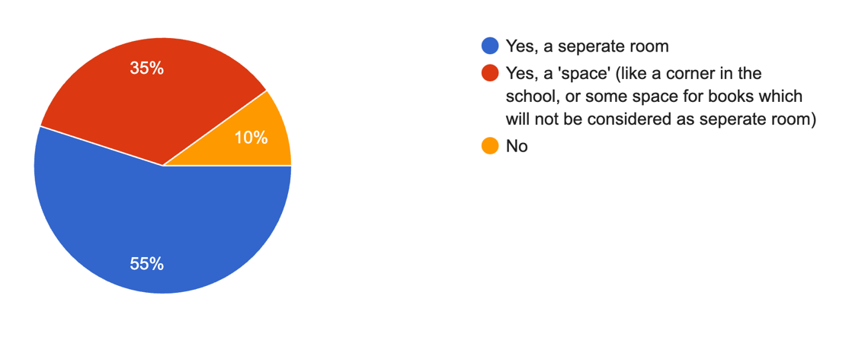
The majority of schools have a library, demonstrating a focus on learning resources.
- Availability of Newspapers in the library
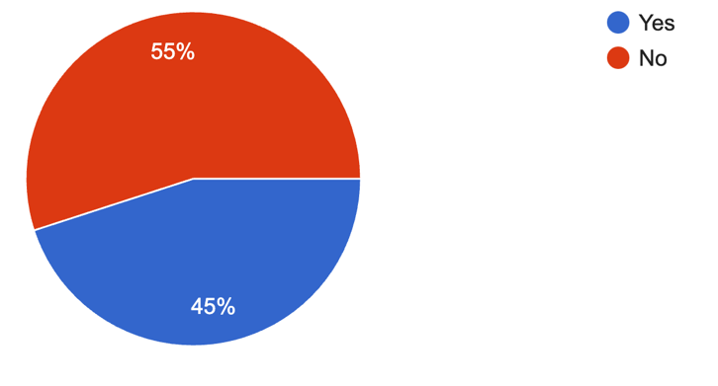
A considerable number of libraries lack newspapers, showing a gap in access to current events and reading materials.
- Availability of Magazines at the Library
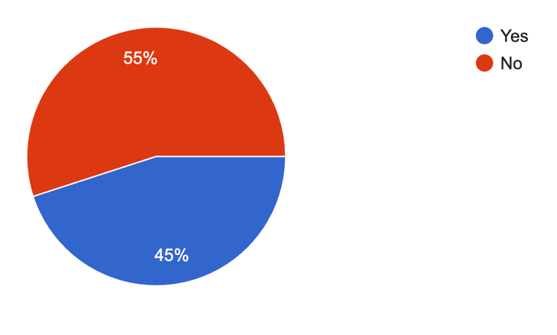
Few libraries provide magazines, suggesting limited access to diverse reading options.
- Availability of course-curriculum books in the library
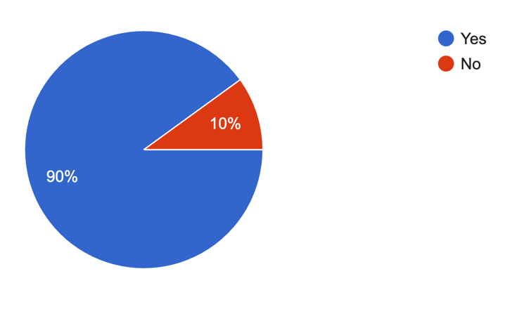
Most libraries are well-stocked with curriculum books, ensuring alignment with educational needs.
- The record of whether the books are issued and the last date of issuance

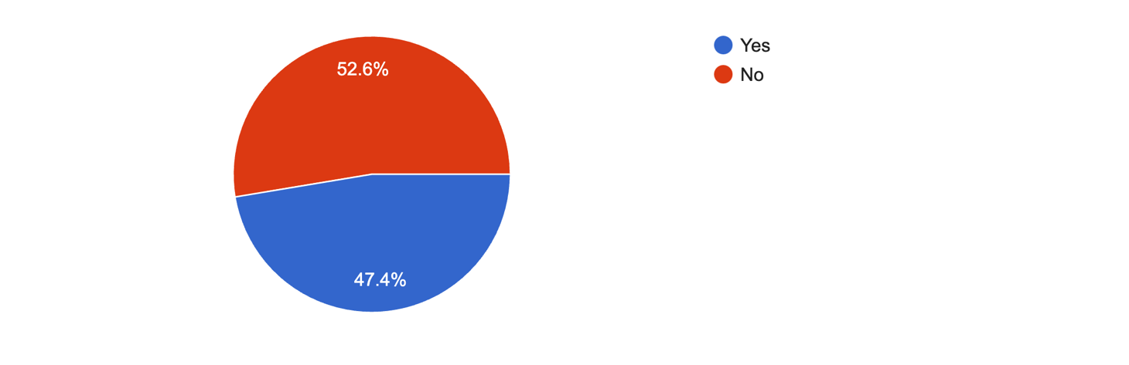

Libraries maintain issuance records effectively, showcasing good management practices.
- Availability of Playground in the School

Availability of Playground | Number of schools
Yes | 16
No | 4

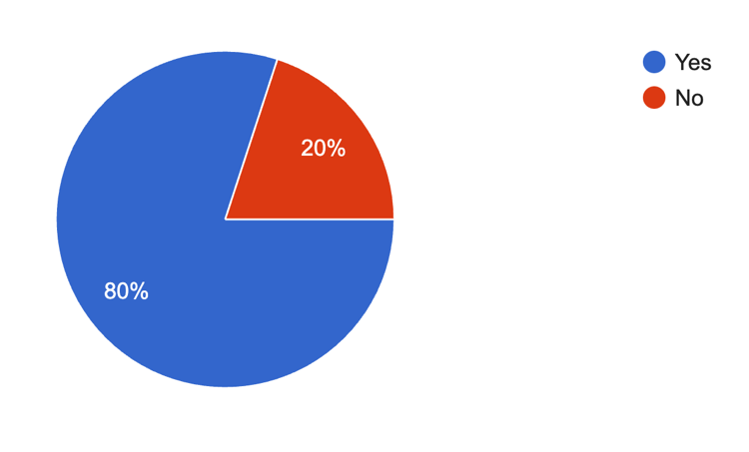
Playgrounds were generally available; however, some were repurposed for other activities and were not adequately maintained.

- Availability of play materials, sport, equipment, for school
Availability of Materials | Number of schools
Yes | 15
No | 5

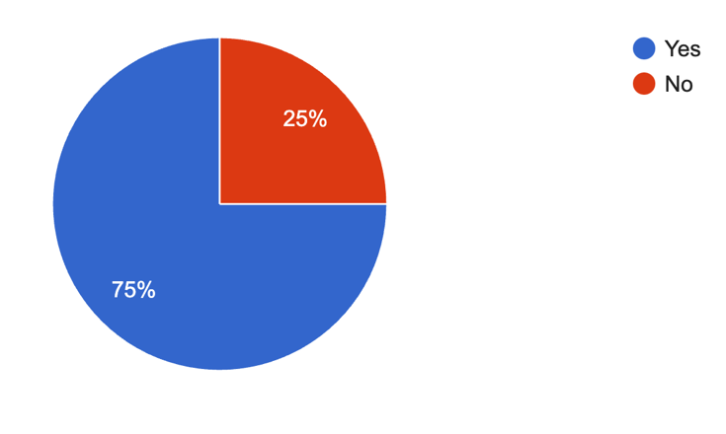
Many schools provide play materials and sports equipment, enhancing physical education. However, the amount of the play materials were not proportional to the number of students that were enrolled in the schools, evidencing an insufficiency of the same.
- Total Number of Girls Toilet available

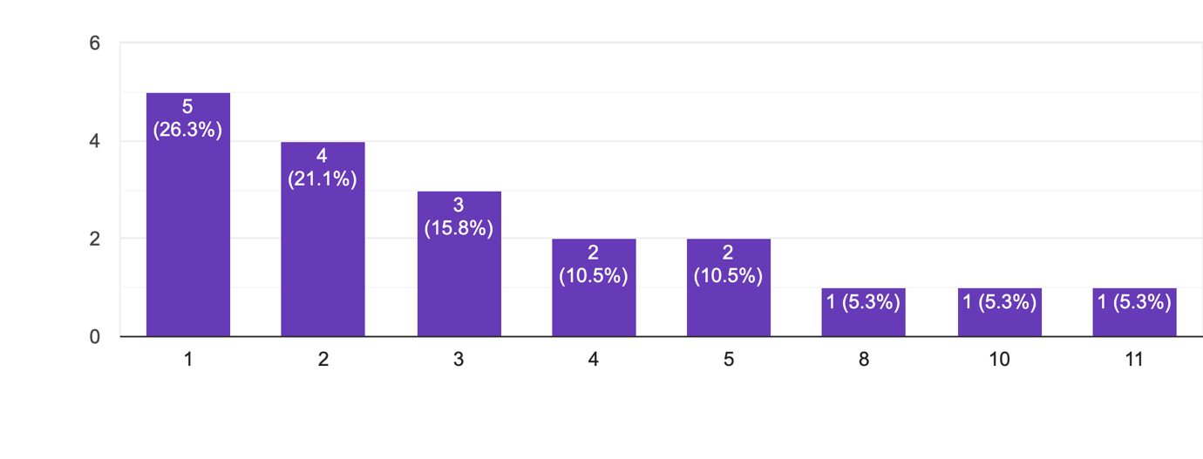
The availability of girls' toilets is substantial, indicating gender-sensitive facilities.
- Total Number of Boys Toilet Available
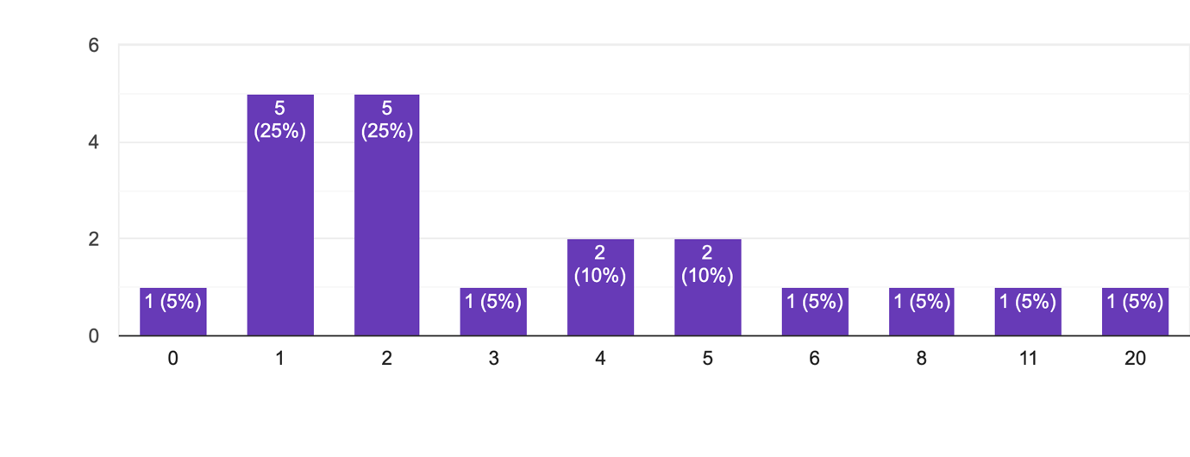
Boys' toilets are sufficiently available, mirroring gender parity in infrastructure.
- Number of toilets for girls that are functional and usable
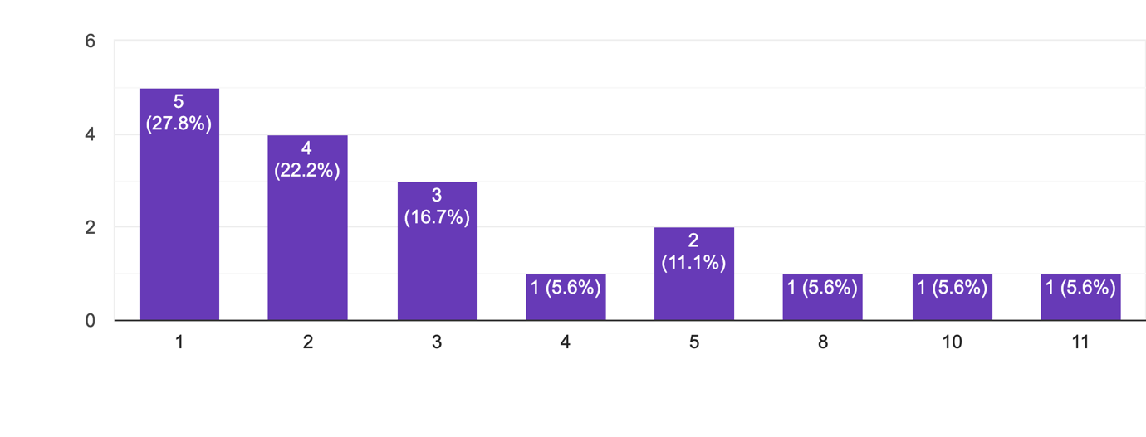
While the majority of girls' toilets were functional and accessible, their numbers were insufficient to meet the needs of the student population, highlighting a gap in ensuring adequate hygiene facilities.
- Number of toilets for boys that are functional and usable
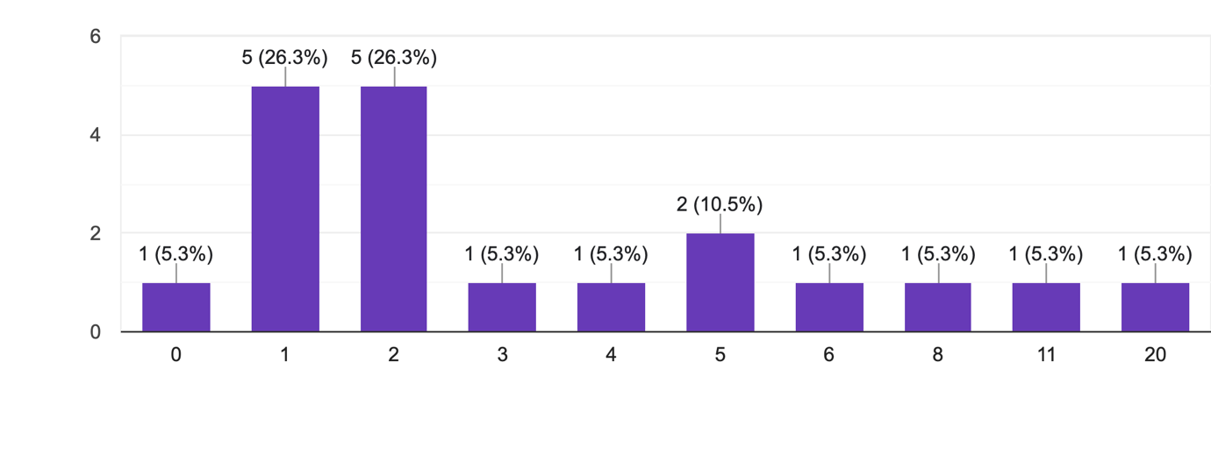Most boys' toilets were functional, contributing to basic sanitation standards. However, the number of toilets was insufficient to accommodate the large student population, and some facilities were observed to be inadequately maintained.
- Existence of Separate Toilets for Teachers
Existence of Separate Toilets for Teachers | Number of schools
Yes | 14
No | 5

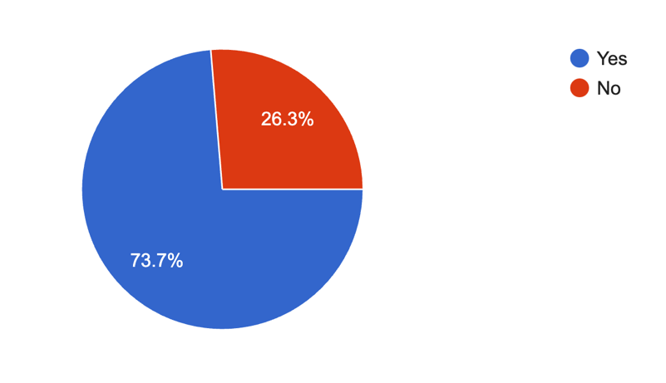
Separate toilets for teachers exist in most schools, emphasizing staff needs.
- The number of toilets that have locks
Existence of Locks in the Toilets | Number of schools
Yes | 1
No | 17

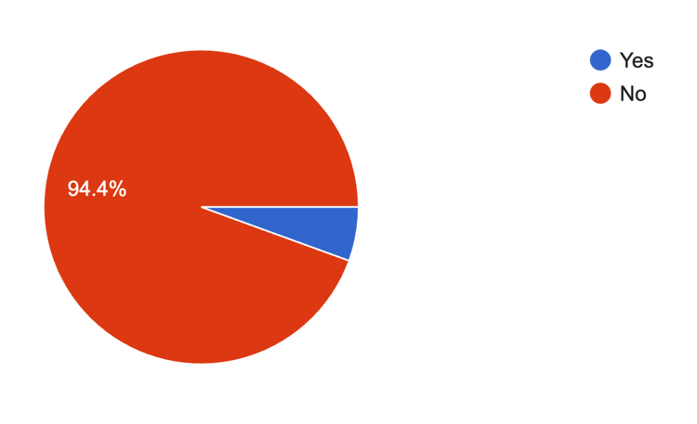
Lockable toilets are not prevalent, putting in danger the privacy and security.
- Availability of Safe Drinking Water
Availability of Safe Drinking Water | Number of schools
Yes | 17
No | 3

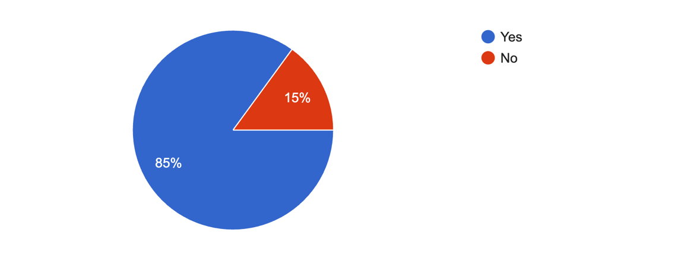
Safe drinking water is available in a majority of schools, addressing a critical health requirement.
- Availability of Hand Washing Facilities
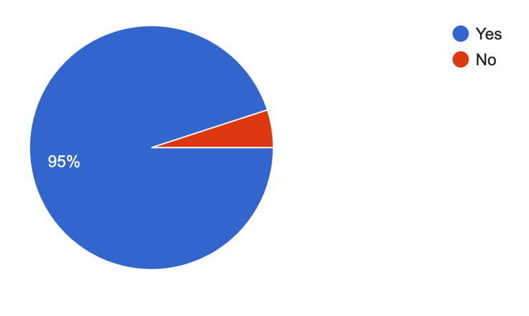
Hand washing facilities are common, supporting hygiene practices.
- Sufficiency and functionality of the hand wash facility
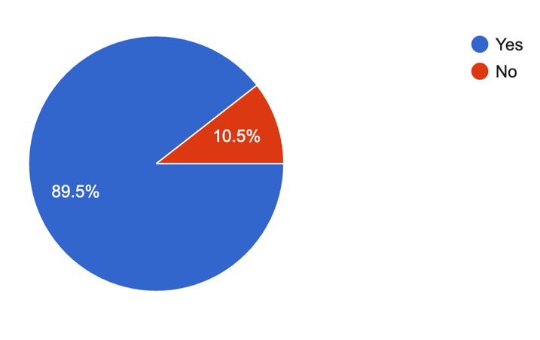
Hand washing facilities are generally sufficient and functional, promoting regular use.
- Mode of Provision of Drinking Water
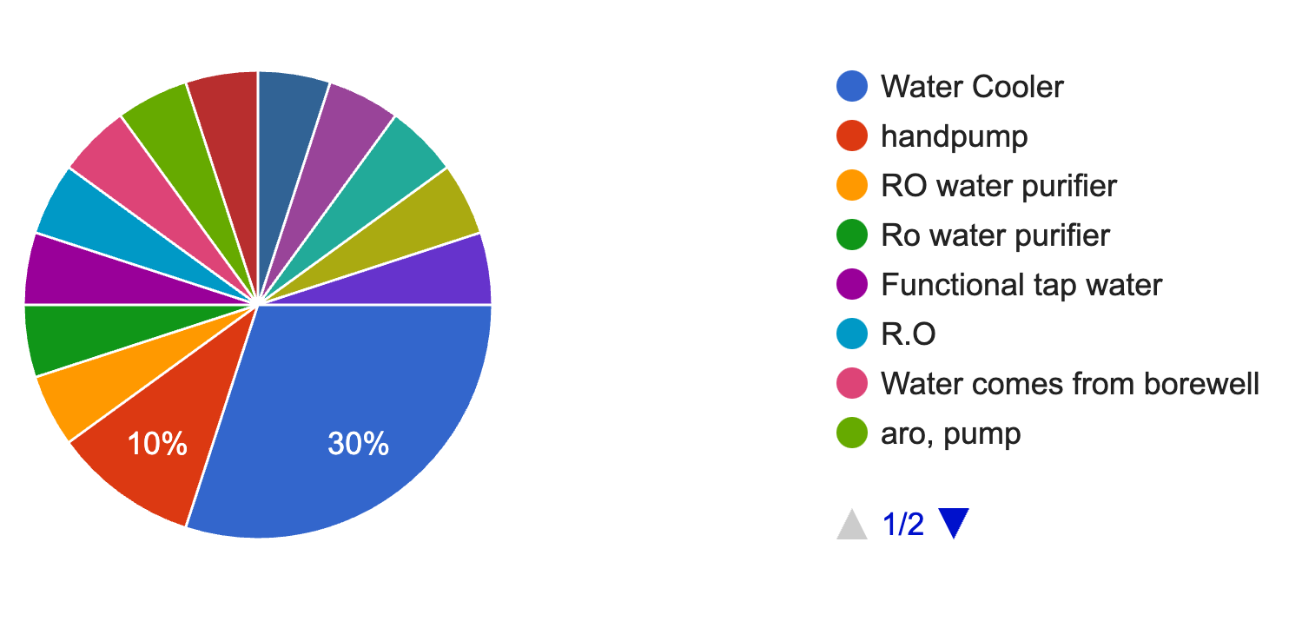
Drinking water is provided through various means, demonstrating adaptability in resource management. However, in several schools, the water was found to be unusable.
- Existence of a boundary wall thing for the security of the school
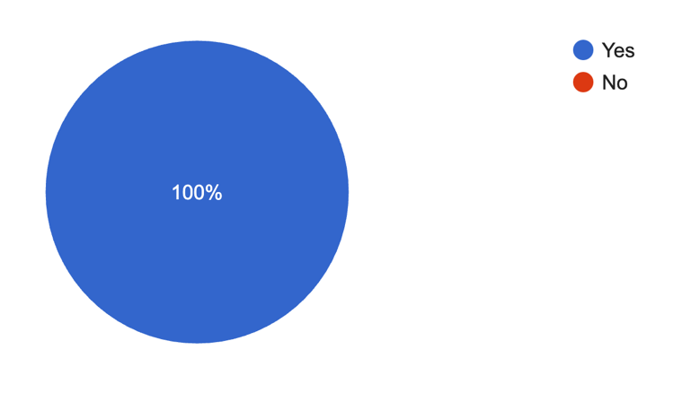
Boundary walls are present in most schools, enhancing security measures.
- Sufficiency of the Boundary Wall for the security of School

Sufficiency of Boundary Walls | Number of schools
Yes | 16
No | 4

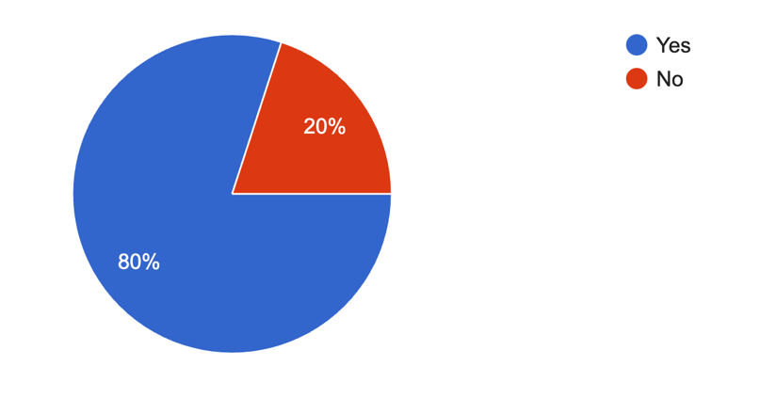
The sufficiency of boundary walls is largely satisfactory, indicating effective protection.
- Conduction of School- Assembly
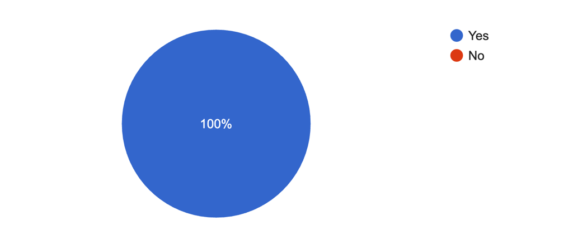
School assemblies are a regular practice, fostering discipline and collective engagement.

Major issues in implementation

The effective implementation of the Right to Education (RTE) Act, 2009, depends on key factors such as adherence to infrastructural mandates, maintaining prescribed pupil-teacher ratios (PTR), and ensuring essential facilities are in place. However, the survey conducted across primary government and government-aided schools in Ahmedabad and Gandhinagar districts revealed several systemic challenges that hinder the Act’s full realization. This section provides an analysis of the key issues identified during the study.

Pupil-Teacher Ratio and Staff Shortages
One of the critical findings was the widespread non-compliance with the RTE-mandated PTR of 30:1. A staggering 72.2% of schools surveyed did not have the required number of teachers. For instance, in a school with 450 students, only six teachers were available, leading to a PTR of 75:1—more than double the prescribed ratio. This significant shortfall places immense pressure on teachers, reduces the quality of education, and limits individual attention to students.
In schools with more than 150 students, the RTE Act mandates the presence of a head teacher, yet this was not implemented consistently. For example, in a school with 210 students, a head teacher was absent, leaving administrative and teaching responsibilities unstructured. This lack of leadership affects overall school management and hampers the effective coordination of teaching staff.
Teacher attendance was another major concern, with some schools reporting attendance rates as low as 36.67% on the day of the survey. Teachers cited involvement in administrative tasks or other non-teaching responsibilities as reasons for their irregularity, further disrupting classroom learning.

Overcrowded Classrooms
Overcrowding in classrooms was particularly evident in urban and semi-urban schools, where high enrollment numbers strained the available infrastructure. In one school with 500 students, only eight classrooms were available, resulting in an average of over 60 students per classroom. This not only violates RTE norms but also creates an environment unsuitable for effective teaching and learning. Teachers noted difficulties in maintaining discipline and implementing participatory teaching methods due to overcrowding.
In contrast, students in smaller classrooms shared that it was easier to engage with teachers and peers. This emphasizes the importance of ensuring one classroom per teacher, a requirement often unmet in the surveyed schools.

School Buildings and Classrooms
Although 84.2% of schools had pucca buildings, many of these required repairs. Approximately 20% of classrooms needed minor repairs, while another 13.3% required major renovations. For students, broken windows, cracked walls, and leaky roofs were common issues. In one rural school, students shared how they had to move classrooms during the monsoon season because of water leakage, disrupting their studies and making them feel unsafe. Such conditions not only affect the learning experience but also the overall morale of students and teachers.

Libraries
Libraries were found to be lacking in both availability and resources. Only 45% of schools had a designated library room, while others used makeshift spaces. Even in schools with libraries, 55% lacked essential materials like newspapers or magazines. Students often expressed their disappointment about outdated and limited book collections. In one school, a student shared that their favorite storybook had been borrowed for weeks because there weren’t enough copies to meet demand. Access to well-equipped libraries is critical for fostering a reading culture, yet this remains a neglected aspect in many schools.

Playgrounds
Playgrounds were available in 52.6% of the schools surveyed, but most were poorly maintained and unsuitable for sports or recreational activities. Many schools in rural areas relied on shared anganwadi grounds, which were often small and barren. A teacher in one school noted that the lack of proper play areas affected students’ physical and social development, as they had limited opportunities for structured physical activities.

Drinking Water and Washrooms
While 85% of schools claimed to have a drinking water facility, hygiene and maintenance issues were prevalent. In one school, students reported that the borewell water often tasted salty, forcing many to bring water from home.
Sanitation facilities were also inadequate. Although 73.7% of schools had toilets for boys and girls, many were either non-functional or poorly maintained. One school with over 200 students had just two operational toilets, leading to long queues and frustration among students. In another case, a girl shared that she often avoided using the school toilets because they were dirty and lacked privacy. This highlights the urgent need for better maintenance and monitoring of sanitation facilities to ensure student well-being.

Security Measures
While all schools surveyed had boundary walls, only 20% of these were considered sufficient for ensuring safety. Incomplete or damaged fencing was frequently observed, leaving schools vulnerable to intrusions. The absence of basic security measures, such as gates or watchmen, was also a common issue. A teacher in one school shared concerns about stray animals entering the premises due to broken walls, posing safety risks for younger children.

Inclusivity and Gender-Specific Challenges
Among the 20 schools surveyed, 16 were co-educational, while 2 each catered exclusively to boys or girls. While co-ed schools promote inclusivity, the limited number of single-gender schools, particularly in rural areas, poses challenges. Families in conservative rural communities often hesitate to send girls to co-ed schools due to safety concerns and cultural norms, leading to lower enrollment rates for girls. In one rural school, a mother shared that she would have preferred to send her daughter to a girls-only school if one had been available nearby.
Addressing this gap by increasing single-gender school options in rural areas could help mitigate socio-cultural barriers and improve enrollment and retention rates for both boys and girls.

Broader Challenges in Implementation
The issues identified through the survey reveal deeper systemic shortcomings that undermine the successful implementation of the Right to Education (RTE) Act. These challenges go beyond logistical constraints and point to structural and policy-level deficiencies that require immediate attention.

Inadequate Funding
A recurring challenge across the surveyed schools is insufficient funding to meet the infrastructural and operational demands mandated by the RTE Act. Many schools lack basic facilities such as well-maintained classrooms, libraries, and playgrounds due to budgetary constraints. Funding shortages also affect the recruitment of adequate teaching staff, resulting in high pupil-teacher ratios that compromise educational quality. Schools in rural areas, in particular, struggle to procure resources such as updated textbooks, laboratory equipment, and sports materials. For example, one rural school shared that they had not received funds for necessary classroom repairs in over two years, leaving students to study in unsafe and uncomfortable conditions.

Policy Gaps
Despite the clear guidelines provided by the RTE Act, weak monitoring and enforcement mechanisms significantly hinder its implementation. Schools often fail to meet infrastructure norms or adhere to prescribed pupil-teacher ratios due to a lack of accountability frameworks. Additionally, there is a gap in coordination between state and local authorities, which leads to delays in fund allocation, resource distribution, and grievance redressal. For instance, a school principal shared frustrations over the time it took to get approval for essential repairs, which negatively impacted the school’s ability to meet basic standards.

Urban-Rural Divide
The disparities between urban and rural schools remain stark, as observed in the survey. While urban schools often benefit from better funding and infrastructure, they struggle with issues like overcrowding due to high demand. In contrast, rural schools face acute shortages of staff, classrooms, and teaching materials, leaving them ill-equipped to provide quality education. For example, a rural school with 120 students had only three classrooms and two teachers, making it impossible to maintain the prescribed pupil-teacher ratio. This urban-rural divide exacerbates educational inequities, with children in remote areas being disproportionately affected.

Community Engagement
Minimal involvement of parents and the local community in school management weakens the support system needed for effective implementation of the RTE Act. School Management Committees (SMCs), which are mandated to include parents, often exist only on paper, with little active participation or decision-making power. In one semi-urban school, teachers mentioned that parents rarely attended meetings, citing lack of time or interest. The absence of strong community engagement leads to missed opportunities for collaborative problem-solving, advocacy for better facilities, and monitoring of school performance.
These systemic challenges highlight the need for coordinated efforts by the government, local authorities, and communities to address funding deficits, strengthen accountability, reduce disparities, and foster greater engagement in school management. Without such measures, achieving the universal education goals envisioned by the RTE Act will remain an elusive target.

Suggestions

Infrastructure Improvements
To address the shortage of classrooms in many schools, a phased approach for constructing additional classrooms should be implemented, prioritizing schools with high enrolment and inadequate space. Modular, pre-fabricated structures can serve as temporary solutions in overcrowded schools while permanent facilities are constructed. Schools with classrooms requiring major repairs should be identified through a centralized reporting mechanism, and decentralized repair teams should be deployed for timely action. Preventive maintenance schedules must also be introduced to reduce long-term costs.
Improved infrastructure ensures that students learn in a safe, comfortable environment conducive to academic success. Properly maintained classrooms reduce disruptions caused by structural issues and encourage regular attendance. Enhancing infrastructure also directly supports compliance with RTE norms, fostering trust among students, parents, and the community.

Teacher Recruitment and Professional Development
To bridge the teacher-student ratio gap, immediate recruitment drives should be launched, focusing on underrepresented rural areas. Offering special incentives like housing allowances, travel reimbursements, and professional growth opportunities can attract qualified teachers to remote locations. Additionally, local teacher training programs can recruit candidates from within the community, reducing issues of absenteeism caused by long commutes.
Regular training programs should focus on innovative pedagogical methods and inclusive teaching strategies, equipping teachers to handle large class sizes and diverse learning needs effectively. Incorporating digital tools into teaching methods can also enhance learning outcomes.
Increasing the number of trained teachers ensures that students receive adequate attention, enhancing the quality of education. Encouraging community-based recruitment fosters consistency and builds trust between teachers and local communities. Improved teaching quality also helps retain students and reduce dropouts, fulfilling the RTE’s goals.

Funding and Resource Optimization
Dedicated funds should be allocated to schools, particularly in rural and semi-urban areas, to address infrastructure gaps, procure teaching aids, and hire additional staff. Schools should be empowered to use these funds flexibly, with oversight from SMCs to ensure accountability. Partnering with private organizations under Corporate Social Responsibility (CSR) initiatives can also supplement funding for specific projects, such as building libraries or playgrounds.
Increased funding enables schools to address pressing needs effectively, creating a positive learning environment for students. Partnerships with private entities and NGOs bring in additional expertise and resources, accelerating improvements and ensuring that financial constraints do not impede compliance with RTE mandates.

Essential Facilities
Water Supply
Schools must ensure the availability of clean and safe drinking water through water filtration systems or rainwater harvesting setups, particularly in rural areas. Regular testing of water quality should be mandatory to maintain safety standards.
Access to clean water directly impacts students’ health, attendance, and focus in the classroom. Ensuring water safety also builds parental trust in the school system, encouraging regular enrolment.
Electricity and Digital Infrastructure
Installing solar panels can provide a sustainable and cost-effective solution to electricity shortages in rural schools. With reliable electricity, digital tools such as projectors and tablets can be introduced to enhance teaching and learning processes.
Electricity and digital tools can bridge the urban-rural divide, enabling rural schools to offer the same quality of education as their urban counterparts. Digital infrastructure also fosters student engagement and prepares them for a technology-driven future.
Washroom and Sanitation
Expanding and maintaining sanitation facilities should be a priority. Toilets must have running water, soap, and proper waste management systems. Schools should ensure that separate, functional toilets are available for boys, girls, and teachers. Maintenance contracts should be introduced to guarantee hygiene year-round.
Improved sanitation facilities ensure dignity and privacy, particularly for girls, reducing dropouts caused by inadequate amenities. Functional washrooms promote regular attendance and create a healthier school environment.
Playgrounds and Recreational Facilities
Schools without playgrounds should collaborate with local authorities to convert unused public land into recreational spaces. Basic sports equipment should be provided to all schools, and physical education activities must be integrated into daily schedules.
Recreational facilities contribute to students’ physical and mental well-being, fostering teamwork, discipline, and social skills. Access to playgrounds also encourages students to attend school regularly.
Libraries and Learning Spaces
Libraries must be established in every school and equipped with age-appropriate books, newspapers, and supplementary materials. Schools with limited space can use multi-purpose rooms as library spaces. Regular book donation drives in partnership with NGOs or community groups can supplement resources.
Libraries foster a culture of reading and lifelong learning, enhancing literacy and critical thinking skills. Properly equipped libraries provide students with opportunities for self-directed learning and enrichment beyond the classroom.

Student Well-Being and Inclusivity
To address cultural and social barriers, single-gender schools should be established in rural areas where families may hesitate to send girls to co-ed institutions. In existing co-ed schools, gender-sensitization programs should be introduced for students, parents, and staff to create an inclusive environment.
Mid-day meal programs should be regularly monitored to ensure they meet nutritional and hygiene standards. Introducing mental health support programs, such as workshops and counselling services, can also improve the overall well-being of students.
Improving student well-being and inclusivity ensures that no child is excluded from receiving a quality education. Addressing cultural barriers through single-gender schools or gender-sensitization workshops helps increase enrolment and retention rates. Providing mental health and nutritional support creates a holistic environment for student growth and success.

Community Involvement
Parents and local communities must play an active role in school management through regular engagement in SMCs. Awareness campaigns should be organized to highlight the importance of parental involvement in improving school quality. Community members can also contribute through voluntary programs, such as mentoring or skill-building sessions.
Active community involvement strengthens the school ecosystem by fostering accountability and providing additional support for students. Engaged communities are better equipped to advocate for improvements and ensure the long-term sustainability of educational initiatives.

Conclusion
The survey of primary government and government-aided schools in Ahmedabad and Gandhinagar districts has brought to light several pressing challenges in implementing the Right to Education (RTE) Act, 2009. These include an acute shortage of teachers, poor pupil-teacher ratios, inadequate and poorly maintained infrastructure, and a lack of basic amenities like functional washrooms, safe drinking water, and libraries. The findings highlight disparities between urban, semi-urban, and rural schools, with rural schools facing the most significant challenges. Issues such as overcrowded classrooms and insufficient security measures further exacerbate the problems, creating a less-than-ideal learning environment for students.
Education is a fundamental right, and the objectives of the RTE Act go beyond mere enrolment—they envision a holistic, inclusive, and equitable education system. Fulfilling this vision is not just a legal obligation but a moral imperative to empower every child and shape India’s future. Addressing these challenges requires focused action from all stakeholders, including the government, local authorities, communities, and private entities.
It is time for urgent and meaningful intervention. Increased funding, stronger accountability frameworks, innovative infrastructural solutions, and community-driven initiatives are critical. With sustained efforts and a shared commitment, the goals of the RTE Act can be realized, ensuring that every child receives the quality education they deserve.

Ministry of Education, Government of India, Right to Education (RTE) Portal, available at https://dsel.education.gov.in/rte (last visited Jan. 20, 2025)
What is the Right to Education Act?- Importance and Responsibilities, Child Rights and You (2024), https://www.cry.org/blog/what-is-the-right-to-education-act/ (last visited Jan 20, 2025).
Francis Assisi Almeida, Right to Education in India - A Dream or a Reality?, 5 International Journal of Law and Social Sciences (2019).
Unni Krishnan, J.P. v. State of A.P., (1993) 4 SCC 111.
India Const. art 21.
Dr. Sanjay Sindhu, Fundamental Right to Education in India: An Overview, Global Institute for Research & Education, available at https://www.walshmedicalmedia.com/open-access/fundamental-right-to-education-in-india-an-overview.pdf (last visited Jan. 20, 2025).
India Const. art 21 A., amended by The Constitution (Eighty-Sixth Amendment) Act, 2002.
India Const. art 45.
India Const. art 51A.
Dr. Sanjay Sindhu, Fundamental Right to Education in India: An Overview, Global Institute for Research & Education, available at https://www.walshmedicalmedia.com/open-access/fundamental-right-to-education-in-india-an-overview.pdf (last visited Jan. 20, 2025).
Right to Education Act, 2009, § 18, No. 35, Acts of Parliament, 2009 (India).
Right to Education Act, 2009, § 19, No. 35, Acts of Parliament, 2009 (India).
Right to Education Act, 2009, Schedule, No. 35, Acts of Parliament, 2009 (India).

